CHAPTER-1
INTRODUCTION
Building construction is a core branch of civil engineering dedicated to creating safe, functional, and durable structures. While shelter remains a fundamental human necessity, modern construction demands a rigorous balance of architectural spatial planning, structural stability, and economic feasibility. The primary objective of a structural engineer is not merely to build, but to design a structure that can safely withstand all anticipated loads throughout its lifespan while remaining highly cost-effective and constructible.
This major project presents a complete, end-to-end engineering execution of a multi-story residential building. Instead of relying on disconnected theoretical calculations or arbitrary manual approximations, this project adopts a rigorous, industry-aligned computational workflow integrating computer-aided drafting, physical geotechnical testing, finite element structural analysis, and automated concrete design detailing. The engineering pipeline progresses from strict architectural planning in AutoCAD to direct physical geotechnical testing in the laboratory to establish the site-specific Safe Bearing Capacity (SBC). Following this, a comprehensive computational structural workflow is executed: Bentley STAAD.Pro CONNECT Edition is utilized for 3D finite element spatial modeling and rigorous static and dynamic/seismic structural analysis of the space frame. The resulting force envelopes are subsequently passed directly into STAAD Advanced Concrete Design (RCDC) for complete limit state design, interactive reinforcement optimization, ductile detailing as per IS 13920:2016 and SP 34, and automated generation of structural drawings and Bar Bending Schedules (BBS) for all footings, columns, beams, and slabs. This comprehensive methodology ensures every single structural member is rigorously validated for both statutory structural safety and real-world constructability.
1.1 OVERVIEW OF THE PROJECT AND WHY G+2
The core focus of this project is the comprehensive planning, structural analysis, design, and cost estimation of a multi-story residential building. To maximize the utility of the available 33' x 65' (2145 sq. ft. or 199.27 sq. m.) plot while ensuring strict statutory compliance, the architectural layout was deliberately engineered as a G+2 structure.
In civil engineering, practical design is heavily governed by state building codes. According to Telangana Government Order (G.O.) 168 (Table III), for a plot size falling in the 100–200 sq. m. category, the maximum permissible building height is 10 meters. The front setback must be a minimum of 1.5 meters, and all remaining setbacks must be 1.0 meter. A meticulous review of these guidelines confirmed that a G+2 configuration represents the optimal maximum height allowable for this specific 2145 sq. ft. footprint, keeping the building under the 10m height limit. Concurrently, the required open spaces and boundaries around the structure are maintained by strictly applying these mandatory setbacks.

By designing a G+2 structure, the project achieves two critical goals: it maximizes the vertical living space for the occupants without compromising natural ventilation, and it guarantees that the building is fully compliant with the state's height regulations and setback requirements. This strategic, rule-bound approach ensures the final building is architecturally comfortable, structurally robust, and immediately viable for real-world construction.
1.2 OBJECTIVES OF THE PROJECT
The primary goal of this project is to bridge the gap between theoretical structural principles and practical construction execution. By executing the full engineering lifecycle of the building, the specific objectives include:
- Architectural Compliance: To plan an optimized G+2 layout on a 33' x 65' plot, adhering strictly to Telangana G.O. 168, which mandates a maximum building height of 10m, a front setback of 1.5m, and remaining setbacks of 1.0m.
- Geotechnical Accuracy: To experimentally determine the actual Safe Bearing Capacity (SBC) through physical soil testing in the laboratory, replacing assumed theoretical values with site-specific data.
- Computational Analysis: To model the skeletal frame in STAAD.Pro to effectively evaluate structural behavior, extract base support reactions, and analyze bending moments and shear forces under critical loads.
- Advanced Computational RCC Design & Detailing: To execute a seamless, automated Limit State Design and detailing pipeline conforming strictly to IS 456:2000 and IS 13920:2016. By integrating Bentley STAAD.Pro with STAAD Advanced Concrete Design (RCDC), this objective focuses on directly utilizing software-derived critical force envelopes to design, size, optimize, and detail the complete reinforced concrete substructure and superstructure (isolated pad footings, continuous columns, plinth and floor beams, and floor slabs) without relying on cumbersome manual shortcuts.
- Economic Feasibility: To formulate a realistic construction cost estimate utilizing precise concrete and steel quantity take-offs based on current local rates.
1.3 METHODOLOGY
The execution of this project follows a systematic, step-by-step engineering workflow designed to integrate theoretical analysis with practical, site-specific data:
- Site Survey & Architectural Planning: Drafting the initial G+2 architectural layout in AutoCAD based on the 33' x 65' (2145 sq. ft.) East-facing plot footprint. This phase ensures the floor plans strictly apply G.O. 168 (1.5m front setback and 1.0m on remaining sides) while maintaining compliance for the overall building height (under 10m).
- Geotechnical Investigation: Extracting site-specific soil samples and conducting physical laboratory tests. This empirical data is used to calculate the precise Safe Bearing Capacity (SBC), eliminating the need for assumed foundation parameters.
- Computational Structural Analysis (STAAD.Pro): Modeling the vertical skeletal structure (beams and columns) in 3D. Dead, live, and wind loads are applied in accordance with IS 875 (Parts 1, 2, and 3) to determine critical internal forces, bending moment diagrams, shear force diagrams, and exact base support reactions.
- Automated Structural Design & Ductile Detailing (RCDC): Transferring the analyzed 3D space frame geometry, boundary conditions, and 16 ultimate load combination force envelopes directly from STAAD.Pro into STAAD Advanced Concrete Design (RCDC). Every structural component—isolated pad footings, bi-axially loaded rectangular columns, continuous floor/plinth beams, and two-way/one-way floor slabs—is designed in accordance with the Limit State Method of IS 456:2000. Rebar detailing is performed to satisfy the ductile detailing requirements of IS 13920:2016 and SP 34, producing uniform, practical reinforcement cages that eliminate constructability conflicts such as congestion and excessive mid-span splices.
- Automated Quantity Take-off & Cost Estimation: Extracting precise concrete volumes (m³) and diametric steel bar bending schedules (BBS in metric tons) directly from RCDC's automated reporting module. Current local market rates are then applied to establish a reliable, highly accurate material cost estimate and Bill of Quantities (BOQ) for the complete structural framework.
- Structural Detailing: Generating comprehensive AutoCAD construction drawings, including the site plan, floor layouts, and precise reinforcement detailing for all RCC components.
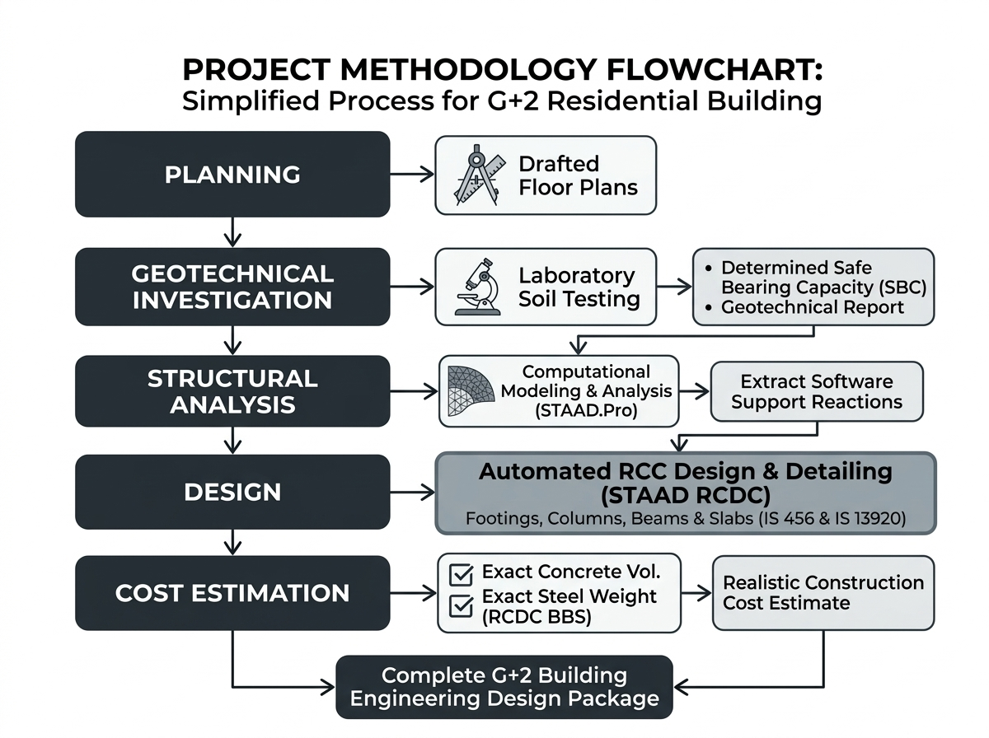
Figure 1.1: Methodology flowchart

1.4 SITE DETAILS & BUILDING PARAMETERS
The project is proposed on a defined residential plot. To establish a precise structural and architectural boundary, the following site parameters and framing dimensions were finalized prior to the commencement of the analysis and design phases:
- Plot Dimensions: The site measures 33 feet in width and 65 feet in depth, yielding a total gross plot area of 2145 sq. ft. (199.27 sq. m.).
- Orientation & Access: The plot is East-facing, with the primary access abutting a wide main road along its eastern boundary.
- Proposed Elevation: The structure is planned as a G+2 (Ground plus two floors) residential building.
- Structural Sizing & Grid: A standardized structural marking plan has been established across the layout. The primary vertical load-bearing elements (columns) are optimized with sizes of 230 mm × 450 mm (9" × 18") and 230 mm × 530 mm (9" × 21") for critical interior supports. The horizontal framing elements (plinth and main floor beams) are sized at 230 mm × 430 mm (9" × 17"), strategically positioned to safely support the G+2 skeletal frame while resisting the calculated bending moments and integrating seamlessly with the architectural walls. All floor slabs are uniformly designed with a robust thickness of 125 mm.
- Setback Clearances: The final built-up footprint is derived by deducting the mandatory open spaces from the gross plot area. The front setback (1.5m) and the rear and side setbacks (1.0m) are applied in strict compliance with Telangana G.O. 168 for a plot size between 100–200 sq. m.
1.5 CLASSIFICATION OF BUILDINGS
According to the National Building Code (NBC) of India, all buildings are classified based on the character of their occupancy.
The primary classifications include
Group-A (Residential)
Group-B (Educational)
Group-C (Institutional), etc.
In this project, the proposed G+2 structure falls strictly under GROUP-A: Residential Buildings.
Subdivision A-2 (One- or two-family private dwelling): These include any private dwelling which is occupied by members of a single family having sleeping accommodation for not more than 20 persons. The G+2 layout is specifically designed to accommodate extended family living while maintaining independent floor accessibility.

1.6 PROJECT EXECUTION AND MATERIAL SPECIFICATIONS
Unlike single-story structures, the execution of a G+2 residential building requires rigorous phase-wise project management. As the building extends vertically, the foundation and lower-tier columns must safely transfer the compounded dead and live loads of the upper floors. To ensure structural safety and avoid cost overruns, the execution strategy is divided into strict material procurement and phase-wise construction stages.
1.6.1 MATERIAL SPECIFICATIONS AND PROCUREMENT
To maintain structural integrity while optimizing the budget, the following standardized materials are specified for the project:
- Concrete Grade: M25 grade design mix concrete (characteristic compressive strength fck = 25 N/mm²) is specified and utilized for all primary RCC structural elements (isolated footings, columns, beams, and slabs) to ensure superior durability, high shear resistance, and adequate crack control for the multi-story frame.
- Steel Reinforcement: High-Yield Strength Deformed Thermo-Mechanically Treated (TMT) Fe550 grade steel bars (characteristic yield strength fy = 550 N/mm²) are specified for all longitudinal and transverse reinforcement to ensure high tensile capacity, optimal steel economy, and enhanced ductility.
- Cement: Ordinary Portland Cement (OPC) 53 Grade is specified for all RCC framing to achieve rapid early strength, while Portland Pozzolana Cement (PPC) is used for masonry and plastering to prevent shrinkage cracks.
- Aggregates: 20mm downsize crushed granite is used as coarse aggregate. For fine aggregate, manufactured sand (M-Sand) is used for structural concrete, while river sand is preferred for plastering to achieve a smooth finish.
- Masonry: To significantly reduce the dead load acting on the skeletal frame, lightweight AAC (Autoclaved Aerated Concrete) blocks or high-quality fly ash bricks are preferred over traditional solid red clay bricks for the 9-inch exterior and 4.5-inch interior partition walls.
1.6.2 PHASE-WISE CONSTRUCTION AND QUALITY CHECKS
Because this is an RCC Framed Structure, the concrete skeleton is constructed first to carry all loads, and the masonry is added later as non-load-bearing filler walls. The execution is planned in sequential stages:
Stage 1 (Earthwork & Foundation Level):
- Action: Excavation of foundation trenches to a depth of 1.5m, laying a leveled Plain Cement Concrete (PCC) bed, and casting the isolated RCC footings.
- Quality Check: Verification of trench dimensions, ensuring minimum clear cover (50mm) for footing reinforcement, and checking the alignment of starter columns.
Stage 2 (Plinth & Column Framework):
- Action: Casting the continuous plinth beam, backfilling the foundation with compacted soil, and raising the RCC columns floor-by-floor to the roof level.
- Quality Check: Anti-termite treatment of the soil before backfilling, and strict checking of column verticality (using a plumb bob) to prevent eccentric loading on the structural frame.
Stage 3 (RCC Beams & Slabs):
- Action: Erecting centering and shuttering, tying the beam and two-way slab reinforcement mesh, and continuously pouring the M25 concrete. This is repeated for the Ground, First, and Second floors.
- Quality Check: Conducting concrete slump tests on-site for proper workability, ensuring mandatory use of needle vibrators to eliminate air voids, and enforcing strict pond curing on the slabs for 14 to 21 days before removing the props.
Stage 4 (Masonry & Brickwork):
- Action: Once the RCC frame is fully cured and formwork is removed, the exterior and interior AAC block / fly ash brick walls are constructed.
- Quality Check: Ensuring proper mortar ratios, checking wall plumbness, and curing the masonry joints to prevent shrinkage cracks.
Stage 5 (Finishing & MEP):
- Action: Internal and external plastering, laying concealed electrical conduits and plumbing lines, flooring, and final painting.
- Quality Check: Conducting hydraulic pressure tests on plumbing lines to prevent concealed leakage, and ensuring proper slopes in bathrooms and balconies for water drainage
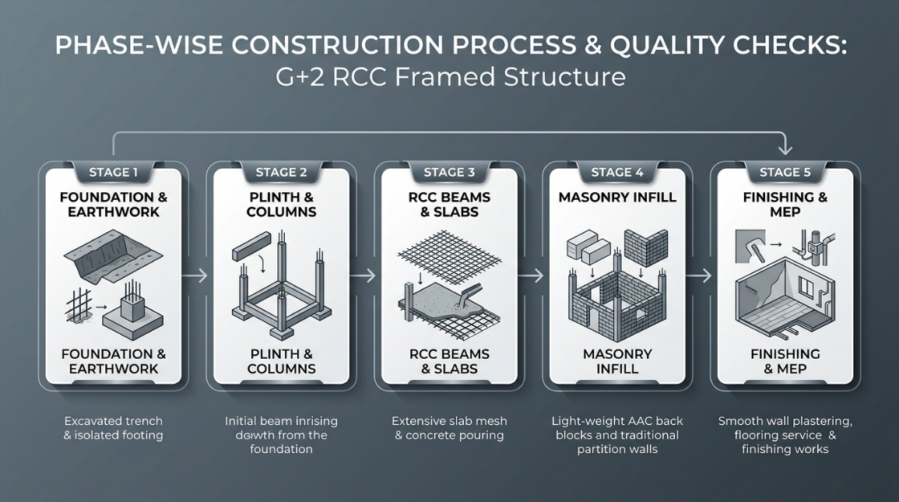
Figure 1.2: Phase-Wise Construction Process and Quality Checks
for the G+2 RCC Framed Structure.
1.7 STATUTORY CODES & GUIDELINES
The structural analysis, design, and detailing of this project are executed in strict accordance with the relevant Indian Standard (IS) codes established by the Bureau of Indian Standards (BIS). The primary codes utilized throughout the various project stages include:
- IS 456: 2000: Code of Practice for Plain and Reinforced Concrete (governing Limit State Design philosophy, material safety factors, and structural serviceability).
- IS 13920: 2016: Ductile Design and Detailing of Reinforced Concrete Structures Subject to Seismic Forces (strictly implemented in RCDC for confining links, column stirrup spacing, and beam curtailment).
- IS 1893 (Part 1): 2016: Criteria for Earthquake Resistant Design of Structures (utilized for Equivalent Static lateral seismic force distribution and base shear calculations).
- IS 875 (Part 1): 1987: Code of Practice for Design Loads (Dead Loads - unit weights of structural building materials and stored components).
- IS 875 (Part 2): 1987: Code of Practice for Design Loads (Imposed / Live Loads for residential buildings and common service zones).
IS 875 (Part 3): 1987: Code of Practice for Design Loads (Wind Loads and basic wind pressure calculations).
SP 34 (S&T): 1987: Handbook on Concrete Reinforcement and Detailing (standard reference for bent-up bar configurations, lap lengths, and development lengths).
National Building Code of India (NBC 2016): General guideline for residential development control rules, minimum room dimensions, and spatial planning standards.
1.8 SOFTWARE & TOOLS USED
The execution of this project relies on industry-standard engineering software and tools to streamline the design, drafting, and documentation workflows:
- AutoCAD: Utilized for 2D architectural spatial drafting, floor plans, column grid layouts, municipal setback compliance drawings, and final compilation of structural CAD sheets into production-ready presentations.
- STAAD.Pro (CONNECT Edition): Employed as the primary 3D Finite Element Analysis (FEA) engine to model the skeletal space frame, generate geometric grids, apply material properties, define gravity and lateral seismic load cases (IS 1893:2016), formulate ultimate load combinations, and compute member force envelopes (axial loads, shear forces, bending moments, and nodal displacements).

- STAAD Advanced Concrete Design (RCDC CONNECT Edition): Employed as the dedicated reinforced concrete design, optimization, and automated detailing engine. RCDC directly reads the analyzed 3D frame geometry and member force envelopes from the STAAD.Pro analysis file (.std). It executes comprehensive Limit State Design conforming to IS 456:2000 and ductile detailing to IS 13920:2016 across all major structural modules:
  - Isolated Pad Footings: Sizing footing depth and plan dimensions based on the lab-tested SBC ($209.15{\text{ kN/m}}^{2}$), performing checks for soil pressure, overturning, sliding, one-way shear, and two-way punching shear, and generating economical reinforcement meshes.
  - Columns & Pedestals: Analyzing bi-axial bending interactions ($P$-$M$-$M$ interaction curves), designing optimal longitudinal rebar arrangements, establishing uniform multi-tier cages to prevent constructability stepping issues, and detailing ductile confining shear links.
  - Continuous Beams: Designing flexural top and bottom longitudinal steel across all floor levels (Plinth to Mumty), calculating shear and torsional stirrups, eliminating awkward mid-span splices, and detailing buildable single-layer rebar configurations.
  - Floor & Roof Slabs: Designing two-way and one-way slabs across all levels (Floor 1, Floor 2, Main Roof) for 125 mm thickness, ensuring deflection control as per span-to-depth ratios, and generating traditional bent-up (cranked) bar detailing as per IS 456 / SP 34.
  - Bar Bending Schedules (BBS) & CAD Outputs: Automatically generating detailed bar bending schedules with bar marks, shapes, cutting lengths, and steel tonnage into Microsoft Excel, and exporting production-grade reinforcement layout plans, longitudinal elevations, and cross-sections into AutoCAD DXF format.
- Microsoft Excel: Utilized for processing geotechnical laboratory test data (Atterberg limits, Proctor compaction curves, direct shear envelopes, SBC calculations) and synthesizing RCDC Bar Bending Schedules into an overall structural Bill of Quantities (BOQ) and cost estimation sheet.
- Microsoft Word: Utilized for compiling, formatting, and generating the comprehensive major project engineering documentation in accordance with university academic standards.

CHAPTER-2
PLANNING
2.1 GENERAL PRINCIPLES OF PLANNING
The term "planning" in building construction refers to the strategic arrangement of all building units across all floors to optimize space, utility, and comfort. For a multi-story (G+2) residential building, planning must carefully balance the horizontal floor layout with efficient vertical circulation. The primary architectural principles guiding the drafting of this project include:
- Orientation: As the plot is East-facing, the layout was deliberately designed to capture morning sunlight in the primary living areas and bedrooms. This ensures maximum natural illumination, improves hygiene, and creates a positive psychological environment.
- Privacy and Roominess: The G+2 vertical configuration allows for a clear distinction between public or guest spaces (typically restricted to the ground floor) and private family spaces (upper floors). Internal partition walls are positioned to maximize the perception of space (roominess) without violating minimum statutory dimensions.
- Circulation: Efficient horizontal and vertical movement is paramount. A strategically placed staircase ensures seamless vertical circulation across the three floors without creating dead corridors or obstructing natural airflow.
- Sanitation and Ventilation: Strict adherence to cross-ventilation principles was maintained. Every habitable room, kitchen, and sanitary facility is equipped with adequate windows or ventilators opening to the exterior setbacks, drastically reducing the reliance on artificial cooling and lighting.
2.2 STATUTORY REQUIREMENTS (Telangana G.O. 168)
To ensure adequate natural light, ventilation, and fire safety access, the building footprint is carefully restricted within the plot boundaries. According to Table III of G.O. 168 for a plot size between 100-200 sq.m (2145 sq. ft.):
- 2.2.1 Road Widening and Access: The plot abuts a 33-foot (approx. 10m) wide road, providing ample access for the ground-floor parking facility.
- 2.2.2 Setbacks: The statutory setbacks have been strictly implemented in the AutoCAD drafting:
  - Front Setback: 5'-0" (1.52m) wide open space for a garden, successfully meeting the 1.5m minimum requirement.
  - Rear Setback: 4'-0" (1.21m) open space, exceeding the 1.0m requirement.
  - Side Setbacks: Provided at 4'-6" (1.37m) and 2'-0" (0.6m) to optimize the internal floor space while ensuring continuous external circulation.
- 2.2.3 Maximum Permissible Height: The structure is restricted to G+2 floors, keeping the total building height well within the mandatory 10m limit.
2.3 SPATIAL REQUIREMENTS AS PER NBC 2016
The internal dimensions of the building have been planned to ensure maximum livability and compliance with the National Building Code (NBC) for residential dwellings.
- 2.3.1 Habitable Rooms: The primary living spaces (Halls) are generously sized at 12'-2" x 15'-11" for the 2BHK units, and 12'-2" x 14'-0" for the 1BHK units. Master bedrooms are drafted at 12'-6" x 12'-2", far exceeding the NBC minimum requirement of 9.5 sq.m.
- 2.3.2 Kitchen & Dining: Dedicated kitchen spaces are provided. The 2BHK units feature a massive 12'-6" x 7'-9" kitchen attached to an identical 12'-6" x 7'-9" dining space, ensuring excellent utility and cross-ventilation through the 4'-0" rear utility balcony.
- 2.3.3 Bathrooms and Water-Closets: Standardized independent sanitary facilities measuring 7.0' x 4.0' are provided throughout the building, exceeding the 1.8 sq.m NBC minimum.
- 2.3.4 Vertical Circulation (Staircase & Lift): To facilitate movement across the G+2 structure, a standardized dog-legged staircase is provided at the front left of the building. Additionally, a dedicated Lift shaft measuring 3'-9" x 4'-6" is incorporated to ensure modern accessibility for all three floors.
2.4 AREA CALCULATIONS
2.4.1 Plinth Area (Built-up Area) The plinth area represents the total covered built-up area of the building on each floor. It is derived by subtracting the mandatory exterior open spaces (setbacks) from the gross plot dimensions.
- Gross Plot Area: 33'-0" x 65'-0" = 2145 sq. ft.
- Building Width: 33' (Plot Width) – 4.5' (Left Setback) – 2.0' (Right Setback) = 26'-6" (26.5 ft)
- Building Length: 65' (Plot Length) – 5.0' (Front Setback) – 4.0' (Rear Setback) = 56'-0" (56.0 ft)
- Plinth Area per Floor: 26.5 ft × 56.0 ft = 1484 sq. ft.
- Total Built-up Area (G+2): 1484 sq. ft. × 3 Floors = 4452 sq. ft.
2.4.2 Carpet Area The carpet area is the actual usable and livable floor area enclosed within the walls. It is calculated by deducting the footprint of the 9-inch exterior load-bearing walls, the 4.5-inch interior partition walls, the common staircase, and the lift shaft from the total plinth area.
- Carpet Area Efficiency: For a highly optimized residential layout like this, the usable carpet area typically yields about 75% to 80% of the plinth area.
- Net Carpet Area per Floor: Approximately 1150 sq. ft. of highly functional living space, strategically divided between the 2BHK and 1BHK units on the upper floors, and split between the residential unit and the 820 sq. ft. parking facility on the ground floor.
CHAPTER-3
GEOTECHNICAL INVESTIGATION

3.1 INTRODUCTION TO GEOTECHNICAL INVESTIGATION
The foundation serves as the most critical structural component of any building, responsible for safely transferring the total dead, live, and wind loads of the superstructure into the underlying earth. The overall stability and structural integrity of the G+2 residential building depend directly on the physical properties and load-bearing capacity of the site's soil.
In many standard low-rise residential projects, the Safe Bearing Capacity (SBC) is often assumed based on local experience or visual inspection. However, to maintain rigorous engineering standards and ensure structural safety without over-designing the foundations, this project employs an empirical approach. A systematic geotechnical investigation was conducted to scientifically analyze the soil parameters of the 33' x 65' plot. By determining the exact physical and mechanical properties of the soil through laboratory testing, an accurate, site-specific SBC can be established. This tested data forms the fundamental basis for the automated structural design of the isolated footings, ensuring the foundation is both economically optimized and structurally reliable.
3.2 SITE INSPECTION AND SOIL SAMPLING
The initial phase of the geotechnical investigation began with a comprehensive, on-the-ground inspection of the 33' x 65' site. The project team conducted a physical walk-through to evaluate the surface topography, existing vegetation, and natural drainage patterns, establishing a practical understanding of the site's baseline conditions.
Rather than excavating independent trial pits, the soil sampling process was efficiently integrated into the preliminary construction phase. During the actual earthwork excavation for the building's foundation, soil specimens were collected directly from the open trenches at a precise depth of 1.5 meters—the designated resting depth for the isolated footings. This approach allowed the team to visually inspect the exact soil strata that will support the structure.
At this 1.5-meter depth, both disturbed and undisturbed soil samples were carefully extracted. To ensure the soil's in-situ density and natural water content remained completely intact, cylindrical metal core cutters were driven directly into the undisturbed earth at the base of the excavation. Simultaneously, disturbed bulk samples were gathered to perform Atterberg limits, compaction testing, and general classification. To prevent any environmental exposure or moisture loss, every specimen was immediately sealed in airtight polythene, clearly labeled on-site, and securely transported back to the geotechnical laboratory for formal empirical testing.

3.3 LABORATORY TESTING PROCEDURES
To evaluate the mechanical and physical characteristics of the soil retrieved from the 1.5 m excavation depth, four standardized laboratory experiments were conducted in accordance with the relevant Bureau of Indian Standards (BIS) specifications.
3.3.1 DETERMINATION OF ATTERBERG LIMITS
Aim:To determine the Liquid Limit ($w_{L}$) and Plastic Limit ($w_{P}$) of the excavated soil sample. These limits are essential for understanding the consistency, plasticity, and settlement characteristics of the foundation soil under varying moisture conditions.
Apparatus Used: Casagrande’s liquid limit device, standard Type-A grooving tool, 425-micron IS sieve, porcelain evaporating dish, spatula, moisture determination containers, and a temperature-controlled drying oven.
Theory: The liquid limit is defined as the minimum water content at which the soil is in a liquid state but has small shear strength against flow. The plastic limit is defined as the water content at which a soil rolled into a thread of 3 mm diameter begins to crumble. The liquid limit and the plastic limit are used as index properties for fine-grained soil, and the tests are conducted on soil passing 425 microns. In the Casagrande's method, the liquid limit is defined as the water content at which the soil placed in the brass cup and cut into a groove of standard dimension will flow together for a length of 12 mm under the impact of 25 blows. For sandy soils, the Casagrande grooving tool is not useful to cut a groove.
Graph (Flow Curve): Plot the semi-log graph between water content on the y-axis with an arithmetical scale and the number of blows on the x-axis with a log scale. Draw a straight line as close as possible between the experimental points, which is known as the flow curve. The water content corresponding to 25 blows can be read, which gives the liquid limit (LL) of the soil. Determine the slope of the flow curve, known as the flow index ($I_{f}$).
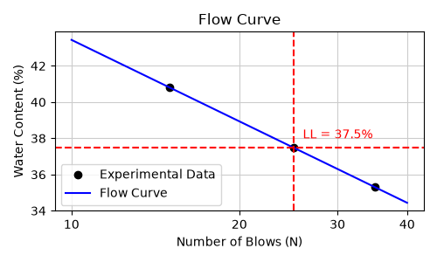
Figure 3.1: Flow Curve for Determination of Liquid Limit (LL = 37.5% at N = 25 blows)
- Take a portion of soil weighing about 120g, thoroughly mixed, passing through 425 microns.
- Mix the sample with a sufficient quantity of water in an evaporatory dish to form a thin paste. The paste shall be of sufficient consistency that will require 30 to 35 blows for the closure of the standard groove.
- In the case of clayey soils, the wet soil paste shall be left undisturbed for uniform distribution of moisture. Remix the soil thoroughly before the test.
- Place a portion of the paste in the brass cup above the spot where the cup rests on the base, squeeze down, and spread into position. The maximum depth of the soil in the cup must be 10 mm and the surface of the soil should be level and horizontal.
- Take the grooving tool and cut a groove in the soil placed in the brass cup by moving the tool along the direction of the diameter of the cup. Keep the tool normal to the surface of the cup during the rotation.
- Apply blows by rotating the handle of the liquid limit apparatus until the groove closes at the bottom for a length of 12 mm and record the corresponding number of blows.
- Determine the water content of the soil for this stage and repeat the steps with varying moisture to plot the flow curve.
Table 3.1: Observations for Liquid Limit Test
Determination No. | Trial 1 | Trial 2 | Trial 3
Number of Blows ($N$) | 15 | 25 | 35
Moisture Container No. | 1 | 2 | 3
Mass of Container ($M_{1}$) (g) | 15 | 10 | 15
Mass of Container + Wet Soil ($M_{2}$) (g) | 36.12 | 32.0 | 38.0
Mass of Container + Dry Soil ($M_{3}$) (g) | 30 | 26 | 32
Mass of Water $(M_{w}) (M_{2} -{ M}_{3})$(g) | 6.12 | 6.0 | 6.0
Mass of Dry Soil ($M_{d}$) $(M_{3} -{ M}_{1})$ (g) | 15 | 16 | 17
Water Content ($w$) $\left(\frac{M_{d}}{M_{d}}×100\right)$ (%) | 40.8% | 37.5% | 35.3%
Liquid Limit (wL):
The liquid limit is defined as the water content at exactly 25 blows. Since there wasn't a trial that landed right on 25, the value was found using logarithmic interpolation between the two nearest data points: 15 blows (at 40.8% moisture) and 35 blows (at 35.3% moisture).
The formula used was:
$$w_{25}=40.8-\frac{40.8-35.3}{\log_{10}\left(35/15\right)}×\log_{10}\left(25/15\right)$$
The liquid limit of the Soil Sample is 37.5%
PROCEDURE FOR PLASTIC LIMIT ($w_{P}$):
- Take about 20g of oven-dried soil passing a 425-micron IS sieve and mix with a sufficient quantity of distilled water until the soil mass becomes plastic enough to be easily moulded into a ball with the fingers.
- Form a ball with about 8g of this soil and roll it with fingers on a glass plate with just sufficient pressure to form a thread of uniform diameter.
- When a diameter of 3 mm is reached, remould the thread into a ball. Repeat this process of rolling and remoulding until the thread just begins to crumble and cracks appear on the surface of the thread at a diameter of 3 mm.
- Determine the water content of the soil at this stage. Repeat the test with one more sample. The average of the two water contents is taken as the plastic limit.
Table 3.2: Observations for Plastic Limit Test
Determination No. | Trial 1 | Trial 2
Moisture Container No. | 4 | 5
Mass of Container ($M_{1}$) (g) | 40 | 40
Mass of Container + Wet Soil ($M_{2}$) (g) | 84.9 | 85.1
Mass of Container + Dry Soil ($M_{3}$) (g) | 75.0 | 75.0
Mass of Water ($M_{w}$) $(M_{2} -{ M}_{3})$ (g) | 9.9 | 10.1
Mass of Dry Soil ($M_{d}$) $(M_{3} -{ M}_{1})$(g) | 35.0 | 35.0
Water Content ($w$) $\left(\frac{M_{d}}{M_{d}}×100\right)$ (%) | 28.28% | 28.86%
Plastic Limit (wP):
This calculation was a simple average of the water content from the two separate crumbled-thread trials.
- Trial 1: 28.28%
- Trial 2: 28.86%
$$w_{p}=\frac{28.28+28.86}{2}=28.57\%$$
The plastic limit of the Soil Sample is 28.57%
Final Results:
Based on the observations and the flow curve, the final limits for the soil sample are:
- Liquid Limit (wL): 37.5%
- Plastic Limit (wP): 28.57%
- Plasticity Index (IP): 9.0%
- Flow Index (If): 14.95
3.3.2 DETERMINATION OF IN-SITU DENSITY BY CORE CUTTER METHOD
Aim: To determine the in-situ density of soil.
Apparatus Used: Core Cutter, steel rammer, steel dolly, balance, steel rule, straight edge, and drying oven.
Theory: Knowledge of the in-situ density of soil is necessary for calculating borrow or cut and fill quantities in addition to its use for compaction control. Field density tests may be direct by collecting soil in a fixed volume, and determining density from weight and volume. A core cutter is a cylindrical metallic tube, open at the top and bottom, with a collar at the top. The core cutter method is suitable for soft to medium stiff soils. The method is not suitable for cohesionless soils as they cannot be sampled, nor is it suitable for hard soils.
Procedure:
- Measure the height ($H$) and internal diameter ($D_{c}$) of the core cutter.
- Determine the mass of the clean core cutter ($M_{1}$).
- Clean and level the ground where the actual field density of the soil is required.
- The cutter is driven vertically into the soil to its full depth with the help of a steel hammer.
- The soil around the outside of the cutter is removed and the cutter is lifted up carefully.
- The top and bottom surfaces of the sample in the core cutter are carefully trimmed and leveled.
- The outside surface of the cutter is cleaned, and the mass of the core cutter with the soil is determined ($M_{2}$).
- The soil core from the cutter is removed and a representative sample is taken in the crucible to determine the moisture content.
Table 3.3: Observations for Core Cutter Field Density Test
Description | Trial 1 | Trial 2
Mass of Cutter ($M_{1}$) (g) | 845 | 845
Mass of Cutter + Soil ($M_{2}$) (g) | 2910 | 2960
Mass of Wet Soil ($M_{3}=M_{2}-M_{1}$) (g) | 2065 | 2115
Volume of Cutter ($V$) (${\text{cm}}^{3}$) | 1021.01 | 1021.01
Bulk Density of Soil ($ρ=\frac{M_{3}}{V}$) ($\text{g/cc}$) | 2.02 | 2.07
Container No. | 1 | 2
Mass of Container ($M_{4}$) (g) | 40 | 40
Mass of Container + Wet Soil ($M_{5}$) (g) | 170 | 155
Mass of Container + Dry Soil ($M_{6}$) (g) | 155 | 145
Mass of Water ($M_{w}=M_{5}-M_{6}$) (g) | 15 | 10
Mass of Dry Soil ($M_{d}=M_{6}-M_{4}$) (g) | 115 | 105
Water Content ($w=\frac{M_{w}}{M_{d}}×100$) (%) | 13.04 | 9.52
Dry Density ($ρ_{d}=\frac{ρ}{1+w}$) ($\text{g/cc}$) | 1.78 | 1.89

Final Results: Based on the field extraction and laboratory analysis, the in-situ properties of the foundation soil are:
- 1. In-Situ Density of Soil ($ρ$): 2.045 g/cc
- 2. In-Situ Moisture Content (w): 11.28%
- 3. In-Situ Dry Density of Soil ($ρ_{d}$): 1.835 g/cc

3.3.3 STANDARD PROCTOR COMPACTION TEST
Aim: To determine the optimum water content and maximum dry density of a soil by standard proctor test.
Apparatus Used: Compaction mould with base plate and collar, compaction hammer, sample ejector, mixing pan, balance, oven, and measuring jar.
Theory: Many types of earth constructions such as dams, embankments, highways and airports require soil which is placed in layers and compacted. The compacted soil will have high compressive strength and high resistance to deformation. The purpose of a laboratory compaction test is to determine the proper amount of mixing water to use when compacting the soil in the field and the resulting degree of denseness which can be expected from compaction at this water content. The standard method for light compaction was developed by Proctor in 1933. As field equipment became heavier and more efficient, the standard proctor test gave a relatively low density in between the laboratory test. Hence distinction has to be made between light compaction and heavy compaction tests. The standard proctor test is used for most light applications.

Procedure:
- Determine the weight of the clean empty mould ($W_{1}$). Grease the inside of the mould. Fit the mould with the collar on the base plate and place it on the solid base.
- Weigh about 3 kg of soil passing through a 4.75 mm sieve into a mixture pan and spread it.
- Add enough water to the soil to bring its moisture content to about 4 or 6% and mix the soil thoroughly to ensure uniform distribution of moisture.
- Place the moist soil in the mould in three layers of about equal thickness and compact each layer by 25 blows. Scarify the surface of each layer before the next layer is added.
- Remove the collar by rotating slightly and pulling it upwards. Trim the soil with a straight edge to the top level of the mould.
- Remove the mould from the base and get its weight ($W_{2}$).
- Eject the cylinder of soil from the mould, split it and take a representative sample of soil for water content determination.
- Break up the sample and mix it with the unused portion, add sufficient water to raise the water content by about 2-3%. Carefully remix and repeat the experiment until the peak density is followed by two slightly lesser compacted weights.
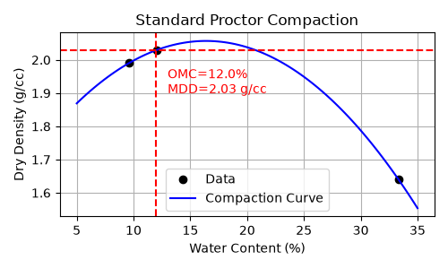
Figure 3.2: Standard Proctor Compaction Curve showing Max. Dry Density (MDD = 2.03 g/cc) and Optimum Moisture Content (OMC = 12.0%)
Graph (Compaction Curve): Plot a graph with moisture content as ordinate (x-axis) and dry density as abscissa (y-axis). Draw a smooth curve through the points and read the maximum dry density and the optimum moisture content.

Observation Table for Standard Proctor Test
Constants:
- Diameter of mould ($D$) = 10 cm
- Height of mould ($h$) = 12.5 cm
- Volume of mould ($V$) = 981.74 ${\text{cm}}^{3}$
- Weight of empty mould (W1) = 4070 g
Table 3.4: Observations for Standard Proctor Compaction Test
Determination No. | Trial 1 | Trial 2 | Trial 3
Weight of mould + compacted soil ($W_{2}$) (g) | 6220 | 6315 | 6225
Weight of compacted soil ($W=W_{2}-W_{1}$) (g) | 2150 | 2245 | 2155
Wet density ($ρ_{wet}=\frac{W}{V}$) ($\text{g/cc}$) | 2.18 | 2.28 | 2.19
Container No. | A | B | C
Weight of Container ($W_{3}$) (g) | 40 | 35 | 30
Weight of Container + Wet Soil ($W_{4}$) (g) | 120 | 100 | 110
Weight of Container + Dry Soil ($W_{5}$) (g) | 113 | 93 | 90
Weight of Water ($W_{w}=W_{4}-W_{5}$) (g) | 7 | 7 | 20
Weight of Dry Soil ($W_{d}=W_{5}-W_{3}$) (g) | 73 | 58 | 60
Water Content ($w=\frac{W_{w}}{W_{d}}×100$) (%) | 9.58 | 12.06 | 33.33
Dry Density ($ρ_{d}=\frac{ρ_{wet}}{1+w}$) ($\text{g/cc}$) | 1.99 | 2.03 | 1.64

Final Results: Based on the standard Proctor compaction curve, the optimal compaction characteristics for the foundation soil are:
- Maximum Dry Density (MDD): 2.03 g/cc
- Optimum Moisture Content (OMC): 12.0%

3.3.4 DIRECT SHEAR TEST
Aim: To determine the shear parameter of a soil with the help of a shear box apparatus.
Apparatus Used: Direct Shear apparatus, Balance.
Theory: Shear strength evaluation is necessary in most stability problems. Soil tests commonly employed to obtain the strength parameters include the unconfined compression test, direct shear test, and triaxial test. The direct shear test is a simple test made by placing a soil sample into the shear box. The shear box is made in two halves. The top half slides over the bottom half and is fitted with two removable pins. The normal loads are applied through a loading yoke connected to a lever arm by a weight. A horizontal force is applied to the upper part and the resistance is measured using a proving ring. The sample is sheared through the planes between two parts of the shear box. Volume changes of the sample during the test can be observed by means of a dial gauge.
• Angle of Internal Friction (ϕ): 25°
Procedure:
- Measure the inside dimensions of the shear box. Place the lower half of the shear box on a level base.
- Place the bottom plate in the lower half and place the gripper plate with its grooves facing up. Place the top half of the shear box over the bottom half and connect the two halves by locking pins.
- Place the soil sample of known weight, say 200gm, in a shear box and level the soil surface.
- Put the upper gripper plates with grooves facing the sample and a pressure pad on top of the gripper plate.
- Place the shear box in the loading unit and the loading yoke on the ball of the top pressure pad.
- Apply the desired normal load.
- Remove the locking pins connecting the two halves of the box and attach the dial gauge to measure the normal and shear displacement.
- Start the motor to apply the shear load.
- Note the maximum reading on the proving ring dial gauge before the failure of the specimen.
- Repeat the test with a fresh sample for other normal loads. A minimum of three tests should be made on separate samples of the same density.
- Calculate the normal and shear stresses on the specimen.
- Draw the graph of shear stress on the y-axis versus normal stress on the x-axis, joining all points by an average straight line.
- Measure the inclination of the straight line with the horizontal to find the angle of internal friction, and the y-intercept to find the cohesion.

Observation Table for Direct Shear Test
Constants:
- Width of shear box = 6 cm
- Length of shear box = 6 cm
- Area of shear box ($A$) = 36 ${\text{cm}}^{2}$
- Proving ring constant = 0.694 kg/division
Table 3.5: Maximum Shear Values from Direct Shear Test
Normal Stress (σ) (kg/cm2) | Max Proving Ring Dial Gauge Reading (divisions) | Max Shear Force (Ph​) (kg) | Shear Stress (τ) (kg/cm2)
0.5 | 28 | 19.43 | 0.54
1.0 | 35 | 24.29 | 0.67
1.5 | 55 | 38.17 | 1.06

Calculations:
- $\text{Shear Stress }\left(τ\right)=\frac{\text{Horizontal Load }\left(P_{h}\right)}{\text{Area }\left(A\right)}$
- $\text{Normal Stress }\left(σ\right)=\frac{\text{Normal Load }\left(P_{v}\right)}{\text{Area }\left(A\right)}$
Final Results: Based on the shear box testing and the plotted failure envelope, the shear strength parameters of the soil sample are:
- 1. Angle of internal friction (ϕ): 25°
- 2. Cohesion (C): 0.32 kg/cm²

3.4 Calculation of Safe Bearing Capacity (SBC)
Aim:
To determine the Safe Bearing Capacity (SBC) of the foundation soil at an excavation depth of 1.5 meters, utilizing the shear strength parameters and in-situ density established during the laboratory testing phase.
Given Soil Parameters:
Based on the results from the Geotechnical Laboratory tests, the following parameters have been established for the footing level:
- Depth of Foundation ($D_{f}$): 1.5 m
- Width of Footing (B): 1.5 m
- Bulk Unit Weight of Soil (γ): 20.06 kN/m³
- Cohesion (c): 31.4 kN/m²
- Angle of Internal Friction (ϕ): 25°
Methodology (Terzaghi's Bearing Capacity Theory):
To calculate the Safe Bearing Capacity (SBC) for the foundation supporting the G+2 structure, Terzaghi's ultimate bearing capacity equation for a square foundation is utilized:
$$q_{u}=1.3cN_{c}+γD_{f}N_{q}+0.4γBN_{γ}$$
Where:
- $q_{u}$ = Ultimate Bearing Capacity (${\text{kN/m}}^{2}$)
- $c$ = Cohesion intercept (${\text{kN/m}}^{2}$)
- $γ$ = Unit weight of soil (${\text{kN/m}}^{3}$)
- $D_{f}$ = Depth of foundation (1.5 m)
- $B$ = Width of the square footing (m)
- $N_{c},N_{q},N_{γ}$ = Terzaghi’s bearing capacity factors (dependent on the derived value of $ϕ$)
Once the ultimate bearing capacity (q_{u}) is calculated, the Safe Bearing Capacity (SBC) is determined by applying an appropriate Factor of Safety (FS), which will be taken as 3.0 for this residential structure:
$$SBC=\frac{q_{u}}{FS}$$

Considering Local Shear Failure (since friction angle ϕ < 28°):
Because your soil's Angle of Internal Friction is $ϕ={25}^{∘}$.
Since ${25}^{∘}$is less than ${28}^{∘}$, geotechnical engineering codes strictly dictate that we must assume the soil will undergo Local Shear Failure.
Because this type of soil is a bit "spongy" and fails gradually, it is unsafe to use its full laboratory strength. Therefore, the rules require us to reduce the soil's strength parameters to two-thirds (2/3) of their original value to ensure the design is completely safe:
- We reduced the Cohesion: $c^{'}=\frac{2}{3}c$
- We reduced the Friction Angle: $tan⁡\left(ϕ^{'}\right)=\frac{2}{3}tan⁡\left(ϕ\right)$
Modified Cohesion, c' = $\left(\frac{2}{3}\right)$ c = 20.93 kN/m²
Modified Friction Angle, ϕ' = tan⁻¹((2/3)tan(25°)) = 17.27°
From Terzaghi's Bearing Capacity Tables for ϕ' = 17.27°:
Nc' = 15.08, Nq' = 5.76, Nγ' = 3.64
qu = $1.3c'Nc'+γ×Df×Nq'+0.4γBNγ'$
qu = $\left(1.3×20.93×15.08\right)+\left(20.06×1.5×5.76\right)+\left(0.4×20.06×1.5×3.64\right)$
qu = 410.31 + 173.32 + 43.81 = 627.44 kN/m²

Safe Bearing Capacity (SBC) = $\frac{qu}{3.0}$ = $\frac{627.44}{3.0}$ = 209.15 kN/m²

CHAPTER-4
STRUCTURAL ANALYSIS
4.1 INTRODUCTION TO ANALYTICAL MODELING
In modern structural engineering, translating a 2D architectural layout into a mathematical 3D model is the most critical step in predicting how a building will behave under real-world forces. For this G+2 residential project, the structural analysis was carried out using Bentley STAAD.Pro CONNECT Edition.
The building was modelled as a continuous 3D space frame (Ordinary Moment Resisting Frame). Unlike traditional manual 2D calculations, utilizing a full 3D space frame approach ensures that complex structural interactions are captured accurately. This is especially important for this specific project, as it allows the software's stiffness matrix to correctly calculate the torsional (twisting) effects caused by the 7'-0" front and 4'-6" side cantilever balconies, as well as the localized heavy loads from the roof mumties.
The primary objective of this analytical phase is to construct the physical geometry, assign material properties, and apply all statutory dead, live, and seismic loads to the frame. By doing so, we can extract the absolute maximum bending moments, shear forces, and deflections acting on every single beam and column. These analytical results will serve as the direct foundation for calculating the required Fe550 steel reinforcement in the subsequent design phase.
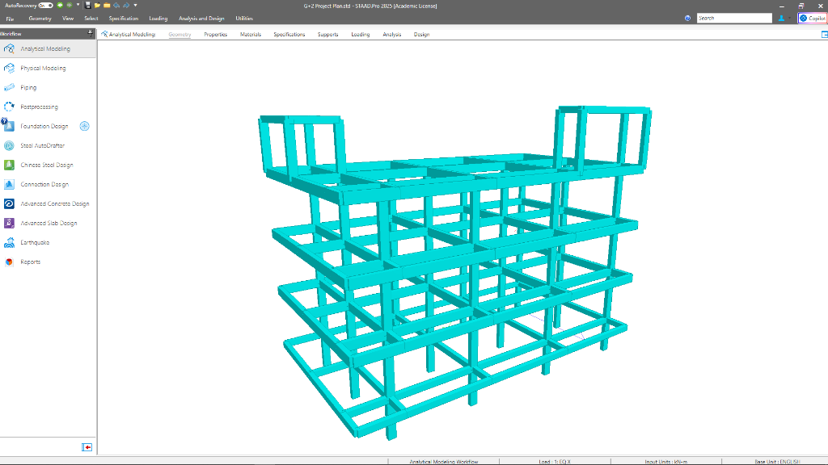
Figure 4.1: 3D Isometric View of the G+2 Space Frame in STAAD.Pro
4.2 GEOMETRICAL CONFIGURATION
The structural center-line plan was derived from the architectural Column Marking Plan provided in Chapter 2. The overall plot dimensions are 33'-0" × 65'-0", with setbacks of 4'-0" at the rear and 2'-0" on the left side as mandated by G.O. 168 for a 30-foot wide road. The resulting structural footprint measures 25'-9" (7.849 m) along the X-axis and 47'-9" (14.554 m) along the Z-axis.

4.2.1 COLUMN GRID LAYOUT
The building frame is supported by a total of 12 main columns arranged in a 3 × 4 orthogonal grid. The column lines are designated as Grids A through D along the depth (Z-axis) and Grids 1 through 3 along the width (X-axis). The bay spacing is as follows:
Direction | Bay | Between Grids | Spacing
X-axis (Width) | Bay 1 | Grid 1 – Grid 2 | 12'-10½" (3.924 m)
X-axis (Width) | Bay 2 | Grid 2 – Grid 3 | 12'-10½" (3.924 m)
Z-axis (Depth) | Bay 1 | Grid A – Grid B | 16'-4½" (4.991 m)
Z-axis (Depth) | Bay 2 | Grid B – Grid C | 16'-7½" (5.067 m)
Z-axis (Depth) | Bay 3 | Grid C – Grid D | 14'-9" (4.496 m)
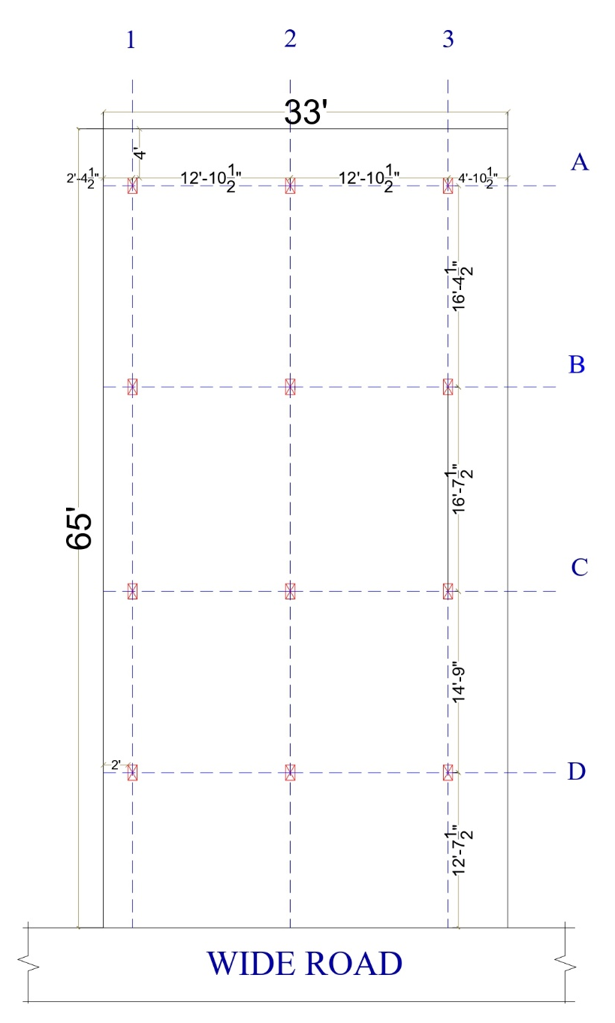
Figure 4.2: Column Grid Layout with Bay Dimensions
4.2.2 VERTICAL CONFIGURATION
The building consists of five distinct horizontal levels, measured from the underside of the foundation:
Level | Description | Height from Ground | Cumulative Height
Plinth Level | Top of plinth beam | 6'-6" (1.981 m) | 1.981 m
First Floor | Top of 1st floor slab | 10'-0" (3.048 m) | 5.029 m
Second Floor | Top of 2nd floor slab | 10'-0" (3.048 m) | 8.077 m
Roof Level | Top of roof slab | 10'-0" (3.048 m) | 11.125 m
Staircase Mumty | Top of headroom slab | 8'-2" (2.500 m) | 13.625 m
Lift Machine Room | Top of machine room slab | 9'-10" (3.000 m) | 14.125 m
The foundation depth was taken as 1.5 m (approximately 5 feet) below the existing ground level, based on the safe bearing capacity established in the geotechnical investigation presented in Chapter 3.
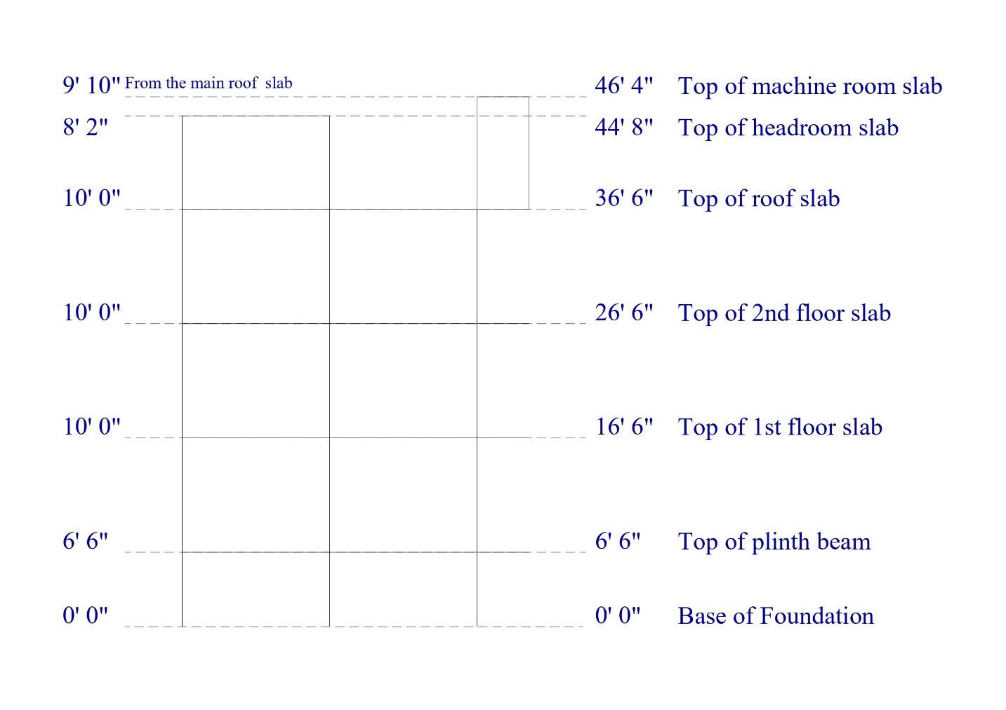
Figure 4.3: Front Elevation of the Frame showing Floor Heights

4.2.3 CANTILEVER PROJECTIONS
Two sets of cantilever beams were explicitly modeled in the space frame to accurately capture the bending moments and deflections at the balcony overhangs:
- Front Cantilever (7'-0" / 2.134 m): Projecting outward from Grid A along the +Z direction at the 1st Floor, 2nd Floor, and Roof levels. This cantilever supports the front balcony and the mid-landing of the dog-legged staircase. At the Roof level, the cantilever nodes were raised by 2.5 m to form the staircase headroom (mumty).
- Right Side Cantilever (4'-6" / 1.372 m): Projecting outward from Grid 3 along the +X direction at the 1st Floor, 2nd Floor, and Roof levels. This cantilever supports the side passage balcony. At the Roof level, the rear-most cantilever nodes were raised by 3.0 m to form the lift machine room.
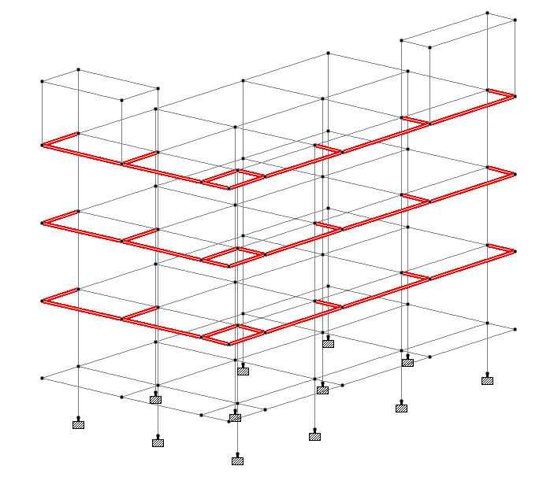
Figure 4.4: 3D View highlighting the Cantilever Beams and Tip Connections

4.3 MATERIAL AND SECTION PROPERTIES
The structural space frame was assigned material properties corresponding to standard Indian construction practices as per IS 456:2000. Isotropic concrete was selected as the primary material for the software's stiffness matrix calculations.
- Grade of Concrete: M25 (Compressive strength = 25 N/mm²)
- Grade of Steel: Fe550 (Yield strength = 550 N/mm²)
- Density of RCC: 25 kN/m³ (As per IS 456:2000 / IS 875 Part 1)
- Poisson’s Ratio: 0.20 (As per standard code practice for concrete)
Member sizing was strictly determined to accommodate the architectural wall thicknesses (9-inch outer walls) and to satisfy long-term deflection criteria. The following prismatic rectangular sections were defined and assigned to the 3D model:
Columns:
- Standard Columns: 230 mm × 450 mm (9" × 18")
- Heavy Interior Columns: 230 mm × 530 mm (9" × 21")
- Mumty Columns (Floating Columns): 230 mm × 300 mm (9" × 12")
Beams:
- Plinth Beams: 230 mm × 430 mm (9" × 17")
- Main Floor Beams (Floor 1, Floor 2, & Main Roof): 230 mm × 430 mm (9" × 17")
- Mumty Roof Beams: 230 mm × 300 mm (9" × 12")
All sections were oriented to maximize their moment of inertia against the primary bending axes.
4.4 SUPPORT CONDITIONS
To accurately simulate the foundation behaviour, all bottom-most nodes of the ground-floor columns (modelled at a depth of 1.5 m below the existing ground level) were assigned FIXED supports in STAAD.Pro.
A fixed support restrains the structure in all six degrees of freedom (translations $F_{x},F_{y},F_{z}$and rotations $M_{x},M_{y},M_{z}$). This boundary condition assumes that the columns will be rigidly cast into reinforced concrete isolated pad footings, preventing any translation or overturning at the base. This rigidity is critical for ensuring the global stability of the G+2 structure against both heavy gravity loads and lateral seismic base shear.
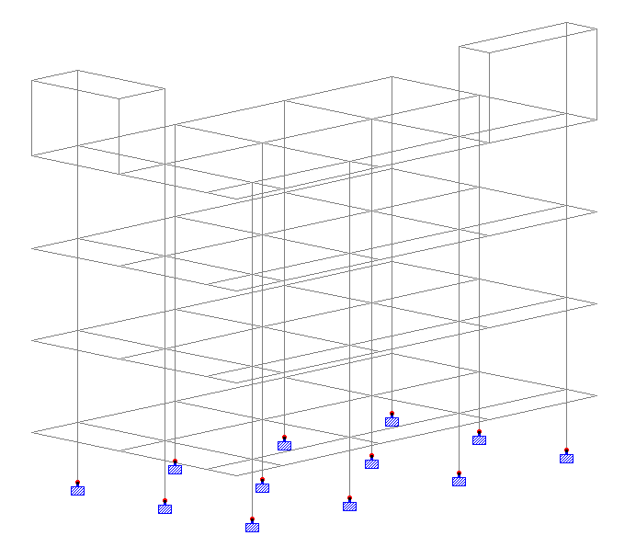
Figure 4.5: Assigned fixed supports in STAAD.Pro
4.5 GRAVITY LOAD CALCULATIONS (IS 875 PARTS 1 & 2)
The gravity loads acting on the structure were calculated strictly in accordance with Indian Standard Codes IS 875 (Part 1) for Dead Loads and IS 875 (Part 2) for Imposed (Live) Loads.
4.5.1 DEAD LOADS (DL)
Dead loads comprise the self-weight of the structural members and the superimposed permanent loads from brickwork, floor finishes, and roof treatments.
- Self-Weight: The self-weight of all beams and columns was automatically generated by STAAD.Pro by assigning a factor of -1 in the global Y-direction, utilizing a concrete density of 25 kN/m³.
- External Wall Load (9-inch brickwork): Calculated based on a floor-to-floor height of 3.048 m, subtracting a beam depth of 0.43 m, leaving a clear wall height of ~2.6 m.
Load = Clear Height × Thickness × Density of Brickwork
Load = 2.6 m × 0.23 m × 20 kN/m³ = 11.96 kN/m ≈ 12.0 kN/m
- Internal Wall Load (4.5 partition walls):
Taken as exactly half of the external wall load: 6.0 kN/m.
- Parapet Wall Load: Assuming a 1.0 m high protective parapet wall along the roof perimeter and cantilever balconies.
Load = 1.0 m × 0.23 m × 20 kN/m³ = 4.6 kN/m ≈ 5.0 kN/m
- Floor Slab Load: Assuming a 125 mm (5-inch) thick RCC slab with 50 mm floor finish.
Slab Weight = 0.125 m × 25 kN/m³ = 3.125 kN/m²
Floor Finish = 1.5 kN/m² Total Floor Dead Load = 4.625 kN/m²
- Roof Slab Load: Calculated similarly but with lighter waterproofing treatment instead of heavy floor tiles: 4.125 kN/m².
- Mumty Roof (Tiled): 4.5 kN/m².
- Lift Machine Room Load: A heavy equivalent pressure of 10.0 kN/m² was applied as a floor load to the right-side roof panel to safely account for the dynamic impact and static weight of the elevator motor and winding gear.
4.5.2 LIVE LOADS (LL)
Live loads were applied based on the occupancy classification (Residential Building) per IS 875 (Part 2):
- Typical Residential Rooms: 2.0 kN/m²
- Balconies, Corridors, and Staircases: 3.0 kN/m² (increased for gathering/exit routes).
- Main Roof (Accessible): 1.5 kN/m²
- Mumty Roofs (Inaccessible): 0.75 kN/m²
4.6 SEISMIC ANALYSIS (IS 1893: 2016)
To ensure the structural integrity of the building under earthquake forces, lateral seismic loads were generated and applied along both the X and Z orthogonal axes. The analysis was carried out using the Equivalent Static Method as per the provisions of IS 1893 (Part 1) : 2016.
4.6.1 Seismic Parameters The following design parameters were defined in the STAAD.Pro seismic definition, reflecting the site conditions and the type of structure:
- Seismic Zone: Zone II (Zone Factor, Z = 0.10)
- Response Reduction Factor (R): 3.0 (Assumed as an Ordinary Moment Resisting Frame - OMRF)
- Importance Factor (I): 1.0 (Standard residential building)
- Soil Type: Type II (Medium Soil)
- Damping Ratio: 5% (0.05, standard for reinforced concrete structures)
- Depth of Foundation: 1.5 m
4.6.2 Seismic Weight Calculation In STAAD.Pro, the total seismic weight of the structure was calculated by lumping the masses at the respective floor levels. The seismic mass matrix was generated by defining the structure's self-weight, all external and internal member wall loads (12 kN/m and 6 kN/m), parapet loads (5 kN/m), and the respective floor/roof dead loads (4.625 kN/m², 4.125 kN/m², etc.). The heavy 10 kN/m² elevator motor load was also included in the seismic mass definition to accurately capture the inertial forces at the top of the building during a seismic event.
4.6.3 Lateral Load Application Based on the defined seismic weight and the building's fundamental natural time period, the software automatically calculated the Design Horizontal Seismic Coefficient ($A_{h}$) and the total Design Base Shear ($V_{b}$). The total base shear was then distributed parabolically along the height of the building. These lateral forces were applied as primary load cases:
- Load Case 1: Seismic Load in +X Direction (EQX)
- Load Case 2: Seismic Load in +Z Direction (EQZ)

4.7 LOAD COMBINATIONS
In the Limit State Design method, structural members must be designed to withstand the most severe effects produced by various combinations of loads. To ensure an adequate margin of safety against collapse, the primary loads were factored and combined using the partial safety factors stipulated in Table 18 of IS 456:2000.
The four primary load cases applied to the STAAD.Pro model were:
- Load Case 1 (EQX): Seismic Load in X-direction
- Load Case 2 (EQZ): Seismic Load in Z-direction
- Load Case 3 (DL): Total Dead Load
- Load Case 4 (LL): Total Live Load
From these primary cases, the software automatically generated the standard 16 ultimate load combinations for the Limit State of Collapse. The envelope of these combinations dictates the final maximum bending moments and shear forces used for member design.
The generated combinations are as follows:
Gravity Only Combinations:
- 1.5 DL
- 1.5 DL + 1.5 LL
Gravity + Wind/Seismic Combinations (Factor 1.2):
- 1.2 DL + 1.2 LL + 1.2 EQX
- 1.2 DL + 1.2 LL - 1.2 EQX
- 1.2 DL + 1.2 LL + 1.2 EQZ
- 1.2 DL + 1.2 LL - 1.2 EQZ
Gravity + Wind/Seismic Combinations (Factor 1.5):
- 1.5 DL + 1.5 EQX
- 1.5 DL - 1.5 EQX
- 1.5 DL + 1.5 EQZ
- 1.5 DL - 1.5 EQZ
Overturning/Uplift Combinations (Factor 0.9):
- 0.9 DL + 1.5 EQX
- 0.9 DL - 1.5 EQX
- 0.9 DL + 1.5 EQZ
- 0.9 DL - 1.5 EQZ
(Note: The 0.9 DL factor is specifically checked to ensure the building remains stable against overturning or uplift when empty during a severe earthquake).

4.8 ANALYSIS RESULTS AND VERIFICATION
Upon completion of the structural modeling, material assignment, and load application, the space frame was analyzed using the STAAD.Pro analysis engine. The solver successfully completed the mathematical matrix inversions with zero errors and zero structural instability warnings, verifying the geometric integrity of the closed cantilever panels and grid connections.
4.8.1 BASE SHEAR AND SEISMIC WEIGHT
A critical verification step in seismic analysis is calculating the total seismic weight of the structure and the corresponding base shear. According to the STAAD.Pro output file, the total seismic weight (W) of the G+2 structure above ground level was calculated as 7105.06 kN (approximately 710 tonnes).
Using the equivalent static method, the total Design Base Shear ($V_{b}$) was calculated to be 296.04 kN. This lateral force was successfully distributed along the vertical height of the frame in both orthogonal directions.
4.8.2 BENDING MOMENT AND SHEAR FORCE DIAGRAMS
The primary output required for the subsequent structural design phase is the internal member forces. STAAD.Pro generated comprehensive Bending Moment Diagrams (BMD) and Shear Force Diagrams (SFD) for all 188 members under the 16 ultimate load combinations. The critical envelope forces were extracted for the highest-stressed members, particularly at the root of the cantilever projections and the ground floor column bases.
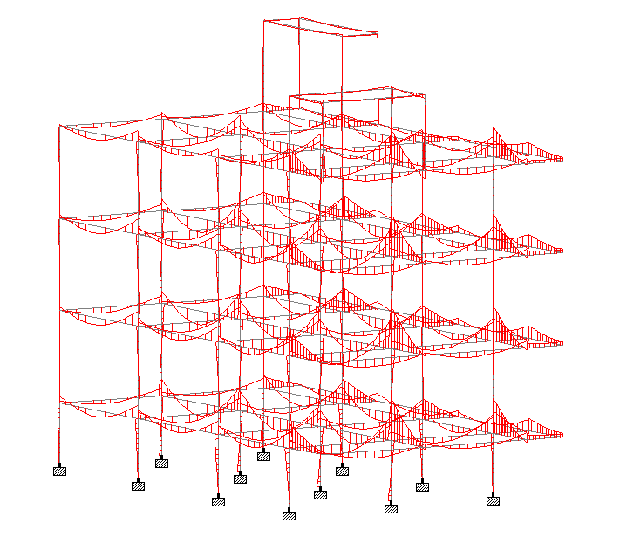
Figure 4.6: Global Bending Moment Diagram (BMD) of the structure
under critical load combinations.
4.8.3 DEFLECTION AND SWAY CHECK
Serviceability checks were performed to ensure the building remains functional and aesthetically acceptable under maximum loads. The maximum nodal displacements (deflections) and inter-story drifts were checked against the permissible limits stipulated in IS 456 and IS 1893. The maximum global displacement occurred at the top nodes of the lift machine room, but remained well within the strict code-permissible deflection limits, ensuring structural stiffness.
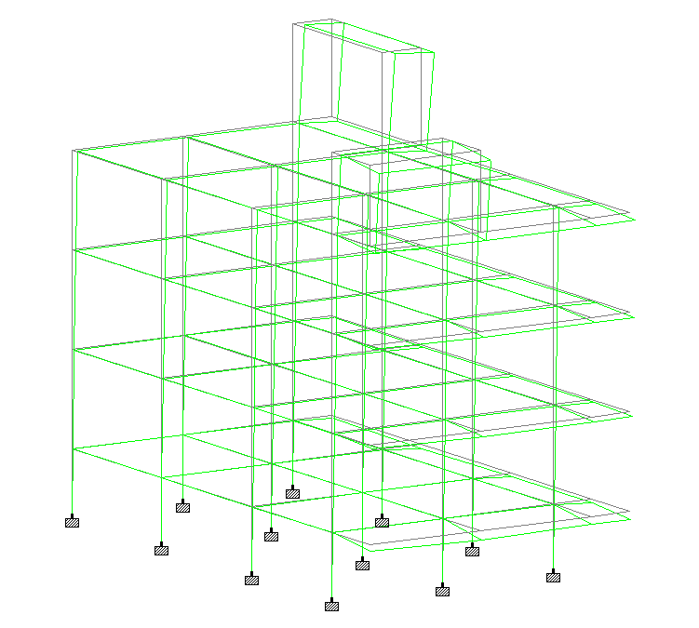
Figure 4.7: 3D Deflected shape of the frame under maximum lateral and gravity loads.
4.9 STAAD.PRO COMMAND FILE / INPUT DATA SCRIPT (G+2 Project Plan.std)
In STAAD.Pro 2025, every graphical model manipulation, node coordinate, member connectivity, material assignment, support restraint, seismic definition, and load application is transcribed into a sequential command text stream stored within the primary project file (G+2 Project Plan.std).
This command file serves as the mathematical and physical blueprint of the 3D space frame structure. For computational transparency and verification, the complete STAAD.Pro Command Editor input script is documented below:

Summary of Command Syntax Architecture:
- Control Headers: Job configuration, input width (79 characters), total primary load cases (SET NL 25), and engineering units (UNIT METER KN).
- Joint Coordinates (JOINT COORDINATES): Cartesian $\left(X , Y , Z\right)$spatial coordinates defining all 114 structural nodes from foundation level ($Y=0.000\text{ m}$) up to the Lift Machine Room roof level ($Y=14.125\text{ m}$).
- Member Incidences (MEMBER INCIDENCES): Topological connectivity for all 202 discrete beam and column frame members.
- Material Definition (DEFINE MATERIAL START ... END DEFINE MATERIAL): Isotropic concrete properties ($E=2.172×{10}^{7}{\text{ kN/m}}^{2}$, $μ=0.17$, $ρ=23.56{\text{ kN/m}}^{3}$, $f_{cu}=27.58{\text{ N/mm}}^{2}$).
- Cross-Sectional Properties (MEMBER PROPERTY): Prismatic dimensions assigned to member groups:
  - Standard Columns: PRIS YD 0.23 ZD 0.45 ($230\text{ mm}×450\text{ mm}$)
  - Heavy Interior Columns (C8, C11): PRIS YD 0.23 ZD 0.53 ($230\text{ mm}×530\text{ mm}$)
  - Mumty Floating Columns (C13 to C16): PRIS YD 0.23 ZD 0.3 / PRIS YD 0.3 ZD 0.23 ($230\text{ mm}×300\text{ mm}$)
  - Beams: PRIS YD 0.43 ZD 0.23 ($230\text{ mm}×430\text{ mm}$)
- Support Conditions (SUPPORTS): Full 6-DOF fixed boundary restraints (FIXED) assigned at the twelve base nodes (Nodes 1–3, 16–18, 31–33, 46–48).
- Seismic Weight Definition (DEFINE IS1893 2016 LOAD): Code parameters for Seismic Zone II ($Z=0.10$, $R=3$, $I=1.0$, Medium Soil Type II, Damping $5\%$) together with self-weight, member UDLs, and floor weights.
- Primary Load Cases (LOAD 1 to LOAD 4): Seismic $+X$(EQ X), Seismic $+Z$(EQ Z), Gravity Dead Load (DL), and Imposed Live Load (LL).
- Factored Load Combinations (LOAD COMB 5 to 20): 16 governing limit state combinations encompassing gravity, lateral seismic, and uplift stability ($0.9\text{DL}±1.5\text{EQ}$).
- Solver Execution: Linear static stiffness analysis (PERFORM ANALYSIS) and script termination (FINISH).

STAAD.Pro Input Script Listing:
STAAD SPACE
START JOB INFORMATION
ENGINEER DATE 05-Oct-26
END JOB INFORMATION
INPUT WIDTH 79
SET NL 25
UNIT METER KN
JOINT COORDINATES
1 0 0 0; 2 3.9243 0 0; 3 7.8486 0 0; 4 0 1.9812 0; 5 3.9243 1.9812 0;
6 7.8486 1.9812 0; 7 0 5.0292 0; 8 3.9243 5.0292 0; 9 7.8486 5.0292 0;
10 0 8.0772 0; 11 3.9243 8.0772 0; 12 7.8486 8.0772 0; 13 0 11.1252 0;
14 3.9243 11.1252 0; 15 7.8486 11.1252 0; 16 0 0 4.9911; 17 3.9243 0 4.9911;
18 7.8486 0 4.9911; 19 0 1.9812 4.9911; 20 3.9243 1.9812 4.9911;
21 7.8486 1.9812 4.9911; 22 0 5.0292 4.9911; 23 3.9243 5.0292 4.9911;
24 7.8486 5.0292 4.9911; 25 0 8.0772 4.9911; 26 3.9243 8.0772 4.9911;
27 7.8486 8.0772 4.9911; 28 0 11.1252 4.9911; 29 3.9243 11.1252 4.9911;
30 7.8486 11.1252 4.9911; 31 0 0 10.0584; 32 3.9243 0 10.0584;
33 7.8486 0 10.0584; 34 0 1.9812 10.0584; 35 3.9243 1.9812 10.0584;
36 7.8486 1.9812 10.0584; 37 0 5.0292 10.0584; 38 3.9243 5.0292 10.0584;
39 7.8486 5.0292 10.0584; 40 0 8.0772 10.0584; 41 3.9243 8.0772 10.0584;
40 0 8.0772 10.0584; 41 3.9243 8.0772 10.0584; 42 7.8486 8.0772 10.0584;
43 0 11.1252 10.0584; 44 3.9243 11.1252 10.0584; 45 7.8486 11.1252 10.0584;
46 0 0 14.5542; 47 3.9243 0 14.5542; 48 7.8486 0 14.5542;
49 0 1.9812 14.5542; 50 3.9243 1.9812 14.5542; 51 7.8486 1.9812 14.5542;
52 0 5.0292 14.5542; 53 3.9243 5.0292 14.5542; 54 7.8486 5.0292 14.5542;
55 0 8.0772 14.5542; 56 3.9243 8.0772 14.5542; 57 7.8486 8.0772 14.5542;
58 0 11.1252 14.5542; 59 3.9243 11.1252 14.5542; 60 7.8486 11.1252 14.5542;
67 0 5.0292 16.6882; 68 3.9243 5.0292 16.6882; 69 7.8486 5.0292 16.6882;
70 0 8.0772 16.6882; 71 3.9243 8.0772 16.6882; 72 7.8486 8.0772 16.6882;
73 0 11.1252 16.6882; 74 3.9243 11.1252 16.6882; 75 7.8486 11.1252 16.6882;
78 9.2206 5.0292 0; 79 9.2206 8.0772 0; 80 9.2206 11.1252 0;
83 9.2206 5.0292 4.9911; 84 9.2206 8.0772 4.9911; 85 9.2206 11.1252 4.9911;
88 9.2206 5.0292 10.0584; 89 9.2206 8.0772 10.0584; 90 9.2206 11.1252 10.0584;
93 9.2206 5.0292 14.5542; 94 9.2206 8.0772 14.5542; 95 9.2206 11.1252 14.5542;
96 9.2206 5.0292 16.6882; 97 9.2206 8.0772 16.6882; 98 9.2206 11.1252 16.6882;
99 0 13.6252 14.5542; 100 3.9243 13.6252 14.5542; 101 0 13.6252 16.6882;
102 3.9243 13.6252 16.6882; 103 7.8486 14.1252 0; 104 7.8486 14.1252 4.9911;
105 9.2206 14.1252 0; 106 9.2206 14.1252 4.9911; 107 0 1.9812 16.6882;
108 3.9243 1.9812 16.6882; 109 7.8486 1.9812 16.6882; 110 9.2206 1.9812 0;
111 9.2206 1.9812 4.9911; 112 9.2206 1.9812 10.0584; 113 9.2206 1.9812 14.5542;
114 9.2206 1.9812 16.6882;
MEMBER INCIDENCES
1 4 5; 2 5 6; 3 7 8; 4 8 9; 5 10 11; 6 11 12; 7 13 14; 8 14 15; 9 1 4; 10 2 5;
11 3 6; 12 4 7; 13 5 8; 14 6 9; 15 7 10; 16 8 11; 17 9 12; 18 10 13; 19 11 14;
20 12 15; 21 19 20; 22 20 21; 23 22 23; 24 23 24; 25 25 26; 26 26 27; 27 28 29;
28 29 30; 29 16 19; 30 17 20; 31 18 21; 32 19 22; 33 20 23; 34 21 24; 35 22 25;
36 23 26; 37 24 27; 38 25 28; 39 26 29; 40 27 30; 41 34 35; 42 35 36; 43 37 38;
44 38 39; 45 40 41; 46 41 42; 47 43 44; 48 44 45; 49 31 34; 50 32 35; 51 33 36;
52 34 37; 53 35 38; 54 36 39; 55 37 40; 56 38 41; 57 39 42; 58 40 43; 59 41 44;
60 42 45; 61 49 50; 62 50 51; 63 52 53; 64 53 54; 65 55 56; 66 56 57; 67 58 59;
68 59 60; 69 46 49; 70 47 50; 71 48 51; 72 49 52; 73 50 53; 74 51 54; 75 52 55;
76 53 56; 77 54 57; 78 55 58; 79 56 59; 80 57 60; 81 4 19; 82 5 20; 83 6 21;
84 7 22; 85 8 23; 86 9 24; 87 10 25; 88 11 26; 89 12 27; 90 13 28; 91 14 29;
92 15 30; 93 19 34; 94 20 35; 95 21 36; 96 22 37; 97 23 38; 98 24 39; 99 25 40;
100 26 41; 101 27 42; 102 28 43; 103 29 44; 104 30 45; 105 34 49; 106 35 50;
107 36 51; 108 37 52; 109 38 53; 110 39 54; 111 40 55; 112 41 56; 113 42 57;
114 43 58; 115 44 59; 116 45 60; 123 52 67; 124 53 68; 125 54 69; 126 55 70;
127 56 71; 128 57 72; 129 58 73; 130 59 74; 131 60 75; 132 73 74; 133 74 75;
134 70 71; 135 71 72; 136 67 68; 137 68 69; 140 9 78; 141 12 79; 142 15 80;
145 24 83; 146 27 84; 147 30 85; 150 39 88; 151 42 89; 152 45 90; 155 54 93;
156 57 94; 157 60 95; 158 69 96; 159 72 97; 160 75 98; 161 98 95; 162 95 90;
163 90 85; 164 85 80; 165 97 94; 166 94 89; 167 89 84; 168 84 79; 169 96 93;
170 93 88; 171 88 83; 172 83 78; 173 58 99; 174 59 100; 175 73 101; 176 74 102;
177 99 100; 178 100 102; 179 101 102; 180 99 101; 181 15 103; 182 30 104;
183 80 105; 184 85 106; 185 104 103; 186 104 106; 187 106 105; 188 103 105;
189 49 107; 190 50 108; 191 107 108; 192 51 109; 193 108 109; 194 6 110;
195 21 111; 196 36 112; 197 51 113; 198 109 114; 199 114 113; 200 113 112;
201 112 111; 202 111 110;
DEFINE MATERIAL START
ISOTROPIC CONCRETE
E 2.17185e+07
POISSON 0.17
DENSITY 23.5616
ALPHA 1e-05
DAMP 0.05
G 9.28139e+06
TYPE CONCRETE
STRENGTH FCU 27579
END DEFINE MATERIAL
MEMBER PROPERTY
9 TO 20 29 TO 40 49 51 52 54 55 57 58 60 69 71 72 74 75 77 78 80 173 181 -
182 PRIS YD 0.23 ZD 0.45
3 TO 8 23 TO 28 43 TO 48 63 TO 68 84 TO 92 96 TO 104 108 TO 116 123 TO 137 -
140 TO 142 145 TO 147 150 TO 152 155 TO 172 PRIS YD 0.43 ZD 0.23
1 2 21 22 41 42 61 62 81 TO 83 93 TO 95 105 TO 107 189 TO 201 -
202 PRIS YD 0.43 ZD 0.23
50 53 56 59 70 73 76 79 174 PRIS YD 0.23 ZD 0.53
175 176 183 184 PRIS YD 0.23 ZD 0.3
177 TO 180 185 TO 188 PRIS YD 0.3 ZD 0.23
CONSTANTS
MATERIAL CONCRETE ALL
SUPPORTS
1 TO 3 16 TO 18 31 TO 33 46 TO 48 FIXED
DEFINE IS1893 2016 LOAD
ZONE 0.1 RF 3 I 1 SS 2 ST 1 DM 0.05 DT 1.5
SELFWEIGHT 1
MEMBER WEIGHT
1 TO 6 61 TO 66 81 83 84 86 87 89 93 95 96 98 99 101 105 107 108 110 111 -
113 UNI 12 0 0
21 TO 26 41 TO 46 82 85 88 94 97 100 106 109 112 UNI 6 0 0
7 8 90 102 114 123 126 129 132 TO 137 140 TO 142 158 TO 172 189 191 193 194 -
198 TO 202 UNI 5 0 0
FLOOR WEIGHT
YRANGE 1.981 8.077 FLOAD 4.625
YRANGE 11 11.125 FLOAD 4.125
YRANGE 13 15 FLOAD 4.5
YRANGE 11 11.2 FLOAD 10 XRANGE 7.84 9.25 ZRANGE 0 5
LOAD 1 LOADTYPE Seismic-H TITLE EQ X
1893 LOAD X 1
PERFORM ANALYSIS
CHANGE
LOAD 2 LOADTYPE Seismic-H TITLE EQ Z
1893 LOAD Z 1
PERFORM ANALYSIS
CHANGE
LOAD 3 LOADTYPE Dead TITLE DL
MEMBER LOAD
1 TO 6 61 TO 66 81 83 84 86 87 89 93 95 96 98 99 101 105 107 108 110 111 -
113 UNI GY -12
21 TO 26 41 TO 46 82 85 88 94 97 100 106 109 112 UNI GY -6
7 8 90 102 114 123 126 129 132 TO 137 140 TO 142 158 TO 172 189 191 193 194 -
198 TO 202 UNI GY -5
FLOOR LOAD
YRANGE 13 15 FLOAD -4.5 GY
YRANGE 11 11.2 FLOAD -10 XRANGE 7.84 9.25 ZRANGE 0 5 GY
YRANGE 11 11.2 FLOAD -2 ZRANGE 14.55 16.7 GY
LOAD 4 LOADTYPE Live TITLE LL
FLOOR LOAD
YRANGE 1.981 8.077 FLOAD -2 GY
YRANGE 11 11.125 FLOAD -1.5 GY
YRANGE 1.981 8.077 FLOAD -1 XRANGE 0 3.925 ZRANGE 10.05 14.56 GY
YRANGE 1.981 8.077 FLOAD -1 ZRANGE 14.55 16.7 GY
YRANGE 1.981 8.077 FLOAD -1 XRANGE 7.84 9.25 GY
YRANGE 13 15 FLOAD -0.75 GY
YRANGE 11 11.2 FLOAD -1.5 ZRANGE 14.55 16.7 GY
LOAD COMB 5 COMB - 1.5 DEAD + 1.5 LIVE
3 1.5 4 1.5
LOAD COMB 6 COMB - 1.2 DEAD + 1.2 LIVE
3 1.2 4 1.2
LOAD COMB 7 COMB - 1.2 DEAD + 1.2 LIVE + 1.2 SEISMIC-H (1)
3 1.2 4 1.2 1 1.2
LOAD COMB 8 COMB - 1.2 DEAD + 1.2 LIVE + 1.2 SEISMIC-H (2)
3 1.2 4 1.2 2 1.2
LOAD COMB 9 COMB - 1.2 DEAD + 1.2 LIVE + -1.2 SEISMIC-H (1)
3 1.2 4 1.2 1 -1.2
LOAD COMB 10 COMB - 1.2 DEAD + 1.2 LIVE + -1.2 SEISMIC-H (2)
3 1.2 4 1.2 2 -1.2
LOAD COMB 11 COMB - 1.5 DEAD
3 1.5
LOAD COMB 12 COMB - 1.5 DEAD + 1.5 SEISMIC-H (1)
3 1.5 1 1.5
LOAD COMB 13 COMB - 1.5 DEAD + 1.5 SEISMIC-H (2)
3 1.5 2 1.5
LOAD COMB 14 COMB - 1.5 DEAD + -1.5 SEISMIC-H (1)
3 1.5 1 -1.5
LOAD COMB 15 COMB - 1.5 DEAD + -1.5 SEISMIC-H (2)
3 1.5 2 -1.5
LOAD COMB 16 COMB - 0.9 DEAD
3 0.9
LOAD COMB 17 COMB - 0.9 DEAD + 1.5 SEISMIC-H (1)
3 0.9 1 1.5
LOAD COMB 18 COMB - 0.9 DEAD + 1.5 SEISMIC-H (2)
3 0.9 2 1.5
LOAD COMB 19 COMB - 0.9 DEAD + -1.5 SEISMIC-H (1)
3 0.9 1 -1.5
LOAD COMB 20 COMB - 0.9 DEAD + -1.5 SEISMIC-H (2)
3 0.9 2 -1.5
PERFORM ANALYSIS
FINISH
CHAPTER-5
STRUCTURAL DESIGN
5.1 DESIGN PHILOSOPHY & LIMIT STATE CRITERIA
The structural design of the G+2 residential framed building is executed strictly in accordance with the Indian Standard Code of Practice for Plain and Reinforced Concrete, IS 456:2000, supplemented by the seismic ductile detailing provisions of IS 13920:2016 and the detailing guidelines of SP 34 (S&T):1987.
Unlike older deterministic design philosophies such as the Working Stress Method (WSM)—which relies on elastic theory and an arbitrary, uniform factor of safety on service loads—modern structural engineering adopts the Limit State Method (LSM). The Limit State design philosophy is a semi-probabilistic approach that accounts for the statistical variations in material strengths and load intensities, ensuring that the structure remains both safe against catastrophic failure and functional throughout its intended design life.
5.1.1 LIMIT STATE DESIGN PHILOSOPHY
A structure, or any of its individual components, is considered to have reached a "limit state" when it ceases to satisfy its intended performance requirements. The design philosophy requires that all structural elements must be designed and detailed to satisfy two distinct categories of limit states:
- Limit State of Collapse: This governs the ultimate structural safety and stability of the building against physical collapse under extreme, factored design loads. Structural members are sized and reinforced to resist the following collapse modes:
  - Flexure (Bending): Sizing tension and compression reinforcement in slabs and beams to safely withstand the maximum positive sagging and negative hogging moments without crushing of concrete or yielding of steel beyond permissible strain limits.
  - Compression: Designing columns to carry concentrated vertical gravity axial loads combined with bi-axial bending moments ($P_{u}$-$M_{ux}$-$M_{uy}$) without buckling or crushing.
  - Shear and Torsion: Providing adequate cross-sectional dimensions and transverse steel (shear stirrups and confining links) in beams and columns to prevent brittle diagonal tension failure.
  - Soil Bearing and Punching Shear: Sizing foundation footings to prevent bearing capacity failure of the supporting soil and two-way diagonal punching shear around the column perimeter.

- Limit State of Serviceability: This governs the everyday functionality, occupant comfort, and durability of the structure under unfactored, characteristic service loads:
  - Deflection Control: Structural members (especially floor slabs and long-span cantilever balcony beams) must possess adequate flexural stiffness to prevent excessive sagging that could damage internal partition walls, crack fragile flooring tiles, or cause psychological discomfort to the occupants. Compliance is verified using the statutory basic span-to-effective-depth ratios prescribed in Clause 23.2 of IS 456.
  - Crack Width Control: Surface crack widths in concrete members must be strictly controlled (limited to a maximum of 0.3 mm under moderate exposure conditions) to prevent the ingress of atmospheric moisture, carbon dioxide, and harmful salts, thereby safeguarding the embedded Fe550 steel rebars against premature corrosion.

5.1.2 PARTIAL SAFETY FACTORS FOR MATERIALS AND LOADS
To guarantee an adequate and reliable margin of safety against uncertainties in loading and variations in material manufacturing, partial safety factors are systematically applied:
1. Partial Safety Factors for Materials ($γ_{m}$):
As per Clause 36.4.2 of IS 456:2000, the design strength of concrete ($f_{cd}$) and steel ($f_{yd}$) are derived by dividing their characteristic strengths by their respective partial safety factors: $\text{Design Strength of Concrete, }f_{cd}=\frac{f_{ck}}{γ_{mc}}=\frac{25}{1.5}=0.446f_{ck}≈0.45f_{ck}\text{Design Strength of Steel, }f_{yd}=\frac{f_{y}}{γ_{ms}}=\frac{550}{1.15}=0.87f_{y}$
- Concrete ($γ_{mc}=1.50$): A higher partial safety factor is assigned to concrete due to the inevitable field variations in batching, mixing, compaction, water-cement ratio control, and ambient curing conditions on-site.
- Steel ($γ_{ms}=1.15$): A lower safety factor is applied to reinforcing steel because Thermo-Mechanically Treated (TMT) Fe550 rebars are manufactured under tightly regulated, automated industrial quality controls with consistent yield properties.
2. Partial Safety Factors for Loads ($γ_{f}$):
As stipulated in Table 18 of IS 456:2000, the characteristic gravity (Dead Load, Live Load) and lateral seismic forces (Earthquake Load) are factored across the 16 governing load combinations:
- Gravity Load Combinations: $1.5\text{DL}+1.5\text{LL}$
- Gravity + Seismic Combinations (Equal Importance): $1.2\text{DL}+1.2\text{LL}±1.2\text{EQ}$
- Predominant Seismic Combinations: $1.5\text{DL}±1.5\text{EQ}$
- Uplift / Overturning Combinations: $0.9\text{DL}±1.5\text{EQ}$(checked to ensure building stability when empty during an earthquake)
5.1.3 EXPOSURE CONDITION AND NOMINAL CLEAR COVER REQUIREMENTS
Durability is a fundamental requirement of structural concrete. For this residential project situated in an urban inland environment, the environmental exposure condition is classified as "Moderate" in accordance with Table 3 of IS 456:2000.
To satisfy the durability and fire resistance requirements of Clause 26.4, adequate nominal concrete clear cover—defined as the clear distance from the outermost concrete surface to the outer edge of any reinforcing bar (including shear links)—was strictly assigned across all structural elements:
- Floor and Roof Slabs: 20 mm nominal cover (ensures complete embedment of the 8 mm bottom and bent-up bars).
- Continuous Plinth and Floor Beams: 30 mm nominal cover (ensures adequate protection for 8 mm stirrups and 16 mm/20 mm main flexural steel).
- Columns and Pedestals: 40 mm nominal cover (provides long-term durability and fire resistance for the vertical longitudinal rebar cages against atmospheric exposure).
- Isolated Pad Footings: 50 mm nominal cover (critical for foundation elements cast directly against the Plain Cement Concrete bed to prevent ground moisture penetration).

5.1.4 COMPUTATIONAL DESIGN METHODOLOGY VIA STAAD RCDC
Rather than relying on isolated manual approximations that fail to account for structural frame continuity, the complete structural design was executed through an integrated computational pipeline:
- Finite Element Analysis (STAAD.Pro): The 3D continuous space frame was solved to extract the critical force envelope (axial force $P_{u}$, shear force $V_{u}$, bending moments $M_{ux}$and $M_{uy}$, and torsional moments $T_{u}$) across all 188 framing members and 16 load combinations.
- Automated Limit State Concrete Design (RCDC): The analytical data was passed directly into STAAD Advanced Concrete Design (RCDC). The RCDC engine performs multi-section design verification, automated rebar spacing checks, code-mandated minimum and maximum reinforcement limits, and ductile detailing conforming to IS 13920:2016.
- Interactive Constructability Optimization: Automated software outputs were reviewed and manually adjusted to eliminate constructability defects—such as excessive rebar congestion, chaotic diameter stepping between floors, and awkward mid-span splices—yielding clean, uniform, and practical steel cages across the entire building.

5.2 STRUCTURAL DESIGN OF SLABS
Slabs are primary horizontal structural elements that transfer superimposed gravity dead and live loads to the supporting perimeter beams. The design of all suspended floor slabs (Floor 1 & 2) and the Main Roof slab was executed using the Limit State Method as per IS 456:2000, with ductile provisions conforming to IS 13920:2016 and reinforcement detailing as per SP 34 (S&T):1987.
5.2.1 CLASSIFICATION, BOUNDARY CONDITIONS, AND PANEL GEOMETRY
Each floor diaphragm is discretized into twelve distinct slab panels designated as S1 through S12 (supported by Grid lines A–D and 1–3, along with cantilever balcony projections):
- Two-Way Slabs (Ly / Lx ≤ 2.0): For the primary residential rooms (Panels S1, S2, S4, S5, S7, S8, S10, and S11), the clear spans are Lx = 3.92 m (short span) and Ly = 4.99 m to 5.07 m (long span):
$$\text{Aspect Ratio, }r=\frac{L_{y}}{L_{x}}=\frac{4.990}{3.920}=1.273≤2.0$$
Because Ly / Lx ≤ 2.0, these panels transfer loads in both orthogonal directions to all four perimeter beams via two-way flexural action.
- One-Way Slabs (Ly / Lx > 2.0): For the corridor and utility passage panels (Panels S3, S6, S9, and S12), the dimensions are Lx = 1.37 m and Ly = 4.99 m:
$$\text{Aspect Ratio, }r=\frac{L_{y}}{L_{x}}=\frac{4.990}{1.370}=3.642>2.0$$
Because the ratio substantially exceeds 2.0, these panels transfer load essentially along the short span (Lx), behaving structurally as continuous one-way slabs.
5.2.2 EFFECTIVE DEPTHS & SECTIONAL PARAMETERS
An overall uniform thickness of D = 125 mm is adopted across all floors. With a nominal clear cover of 20 mm and using high-yield 8 mm Fe550 bars, the effective depths assigned by the RCDC engine are:
- Effective Depth along Short Span (dx):
$$d_{x}=D-\text{Nominal Cover}-\frac{ϕ}{2}=125-20-\frac{8}{2}=100.0\text{ mm}$$
- Effective Depth along Long Span (dy):
$$d_{y}=D-\text{Nominal Cover}-ϕ-\frac{ϕ}{2}=125-20-8-\frac{8}{2}=90.0\text{ mm}$$

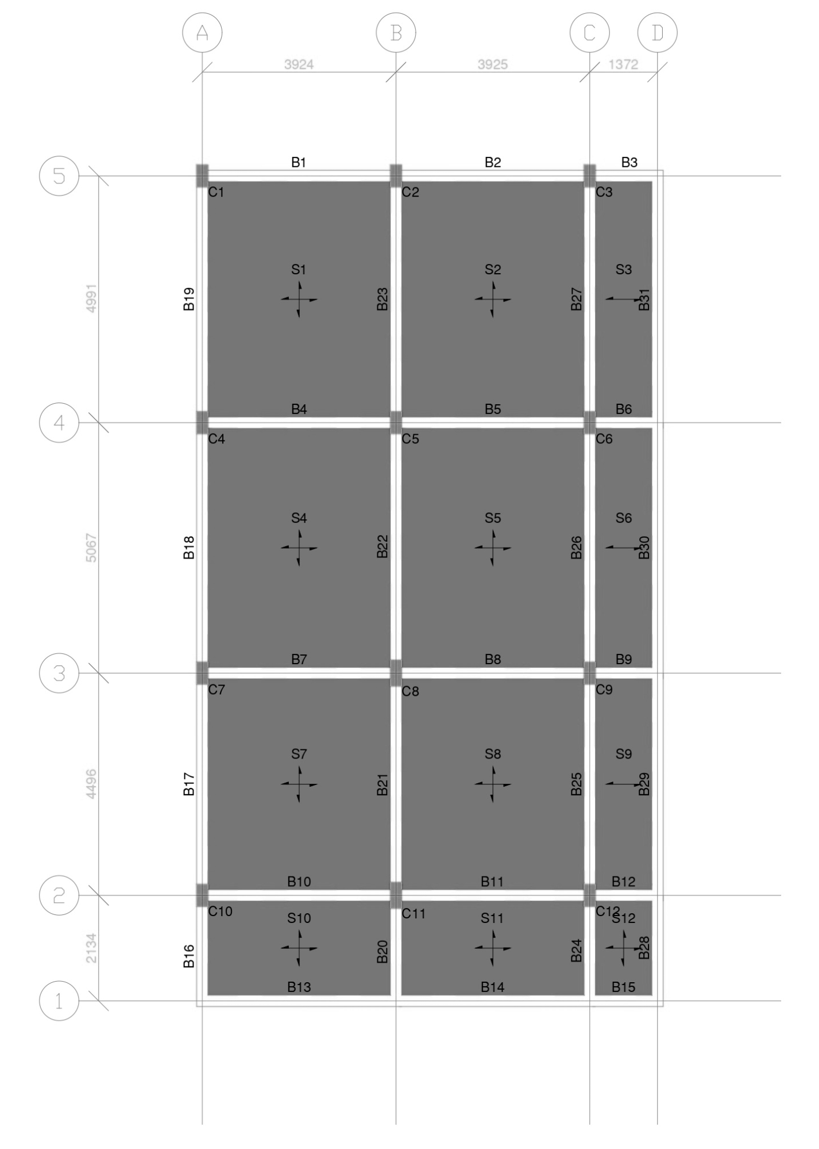
Figure 5.1: Slab Layout
5.2.3 FACTORED DESIGN GRAVITY LOADS
The gravity loads acting per unit area (1 m × 1 m) of the suspended slabs are:
- Self-Weight of Slab (125 mm thick): 0.125 m × 25 kN/m³ = 3.125 kN/m²
- Floor Finish & Screed Load: = 1.500 kN/m²
- Total Dead Load (DL): 3.125 + 1.500 = 4.625 kN/m²
(Total Service Load TL = 6.625 kN/m²)
- Superimposed Live Load (LL): = 2.000 kN/m²
- Factored Ultimate Design Load (w_{u}):
$$w_{u}=1.5×\left(DL+LL\right)=1.5×\left(4.625+2.000\right)=9.938{\text{ kN/m}}^{2}$$
5.2.4 DETAILED MATHEMATICAL DESIGN VERIFICATION: CRITICAL PANEL S1
(Panel Type 4: Two Adjacent Edges Discontinuous, Two Edges Continuous | Lx = 3.92 m, Ly = 4.99 m, r = 1.27)
1. DESIGN BENDING MOMENTS (IS 456 TABLE 26 / RANKINE-GRASH OF FORMULATION):
- Short Span Positive Moment at Midspan: Moment Coefficient α_{x}(+) = 0.050 | Service BM = 5.123 kNm | Factored M_{ux}(+) = 1.5 × 5.123 = 7.685 kNm/m
  - Area of steel required for flexure: A_{st} = 166.75 mm²/m
  - Area of steel enhanced for deflection control: Ast_{(req)} = 216.75 mm²/m
  - Reinforcement Provided: T8 @ 230 mm c/c (A_{st} = 219.0 mm²/m) ➔ SAFE
- Short Span Negative Moment at Continuous Support: Moment Coefficient α_{x}(-) = 0.067 | Service BM = 6.831 kNm | Factored M_{ux}(-) = 1.5 × 6.831 = 10.246 kNm/m
  - Area of steel required: A_{st} = 225.36 mm²/m
  - Additional top support steel required: 116.99 mm²/m
  - Reinforcement Provided: T8 @ 300 mm c/c (A_{st} = 168.0 mm²/m) ➔ SAFE
- Long Span Positive Moment at Midspan: Moment Coefficient α_{y}(+) = 0.034 | Service BM = 3.461 kNm | Factored M_{uy}(+) = 1.5 × 3.461 = 5.192 kNm/m
  - Area of steel enhanced for deflection: Ast_{(req)} = 195.00 mm²/m
  - Reinforcement Provided: T8 @ 255 mm c/c (A_{st} = 197.0 mm²/m) ➔ SAFE
- Long Span Negative Moment at Continuous Support: Moment Coefficient α_{y}(-) = 0.045 | Service BM = 4.615 kNm | Factored M_{uy}(-) = 1.5 × 4.615 = 6.923 kNm/m
  - Area of steel required: A_{st} = 167.65 mm²/m
  - Reinforcement Provided: T8 @ 300 mm c/c (A_{st} = 168.0 mm²/m) ➔ SAFE
- Distribution Reinforcement (IS 456 Clause 26.5.2.1):
Ast_{(min)} = 0.12% × b × D = (0.12 / 100) × 1000 × 125 = 150.0 mm²/m
  - Reinforcement Provided: T8 @ 300 mm c/c (A_{st} = 168.0 mm²/m) ➔ SAFE
2. SHEAR CAPACITY CHECK (IS 456 CLAUSES 40.2 & 40.3):
- Along Short Span (Lx):
  - Shear coefficient SF₁ = 0.492 | Service Shear V = 12.774 kN
  - Factored shear force:
V_{u} = 1.5 × (SF₁ × TL × L_{x}) = 1.5 × (0.492 × 6.625 × 3.92) = 19.161 kN
  - Nominal shear stress: τ_{v} = V_{u} / (b × d_{x}) = 19161 / (1000 × 100) = 0.192 N/mm²
  - Design shear strength of M25 concrete: τ_{c} = 0.349 N/mm²
  - Solid slab depth modification factor (k): k = 1.300 for D ≤ 150 mm (IS 456 Clause 40.2.1.1)
  - Permissible shear stress: k × τ_{c} = 1.30 × 0.349 = 0.453 N/mm²
Check: Since τ_{v} (0.192 N/mm²) < k·τ_{c} (0.453 N/mm²) ➔ SAFE IN SHEAR

- Along Long Span (Ly):
  - Shear coefficient SF₂ = 0.400 | Service Shear V = 10.388 kN
  - Factored shear force: V_{u} = 1.5 × (0.400 × 6.625 × 3.92) = 15.582 kN
  - Nominal shear stress: τ_{v} = V_{u} / (b × d_{y}) = 15582 / (1000 × 90) = 0.173 N/mm²
  - Permissible shear stress: k × τ_{c} = 1.30 × 0.321 = 0.417 N/mm²
Check: Since τ_{v} (0.173 N/mm²) < k·τ_{c} (0.417 N/mm²) ➔ SAFE IN SHEAR

3. DEFLECTION SERVICEABILITY CHECK (IS 456 CLAUSE 23.2.1):
- Basic span-to-depth ratio for continuous slab: 26.0
- Span correction factor: 1.000
- Tensile reinforcement modification factor (F_{t}): F_{t} = 1.678
- Compression steel factor = 1.000 | Flange factor = 1.000
- Max Permissible Ratio: (L/d)_{(perm)} = 26.0 × 1.00 × 1.678 × 1.00 × 1.00 = 43.629
Actual Ratio: (L_{x}/d)_{(actual)} = 3920 mm / 100 mm = 39.200
Check: Since (L_{x}/d)_{(actual)} ≤ (L/d)_{(perm)} [39.200 < 43.629] ➔ SAFE IN DEFLECTION

5.2.5 Consolidated Slab Design Schedule
The complete design output across all twelve panels for Floor 1, Floor 2, and the Main Roof is tabulated in Table 5.1.

Table 5.1: Consolidated Slab Reinforcement Schedule (Levels: 5.029 m, 8.077 m, and 11.125 m)
(Concrete: M25 | Steel: Fe550 | Overall Thickness: 125 mm | Clear Cover: 20 mm)
Panel No. | Panel Type | Dimensions $L_{x}×L_{y}$(mm) | Bottom Rebar ($L_{x}$) | Bottom Rebar ($L_{y}$) | Top Continuous Rebar ($L_{x}$) | Top Continuous Rebar ($L_{y}$) | Distribution Steel | Detailing Style
S1 | Two-Way (Corner) | $$3920×4990$$ | T8 @ 230 c/c | T8 @ 255 c/c | T8 @ 300 c/c | T8 @ 300 c/c | T8 @ 300 c/c | Bent-Up Rebars
S2 | Two-Way (Edge) | $$3920×4990$$ | T8 @ 285 c/c | T8 @ 290 c/c | T8 @ 300 c/c | T8 @ 300 c/c | T8 @ 300 c/c | Bent-Up Rebars
S3 | One-Way (Corridor) | $$1370×4990$$ | T8 @ 300 c/c | T8 @ 300 c/c | T8 @ 300 c/c | — | T8 @ 300 c/c | Bent-Up Rebars
S4 | Two-Way (Edge) | $$3920×5070$$ | T8 @ 260 c/c | T8 @ 290 c/c | T8 @ 300 c/c | T8 @ 300 c/c | T8 @ 300 c/c | Bent-Up Rebars
S5 | Two-Way (Interior) | $$3920×5070$$ | T8 @ 265 c/c | T8 @ 290 c/c | T8 @ 300 c/c | T8 @ 300 c/c | T8 @ 300 c/c | Bent-Up Rebars
S6 | One-Way (Corridor) | $$1370×5070$$ | T8 @ 300 c/c | T8 @ 300 c/c | T8 @ 300 c/c | — | T8 @ 300 c/c | Bent-Up Rebars
S7 | Two-Way (Edge) | $$3920×4500$$ | T8 @ 285 c/c | T8 @ 290 c/c | T8 @ 300 c/c | T8 @ 300 c/c | T8 @ 300 c/c | Bent-Up Rebars
S8 | Two-Way (Interior) | $$3920×4500$$ | T8 @ 285 c/c | T8 @ 290 c/c | T8 @ 300 c/c | T8 @ 300 c/c | T8 @ 300 c/c | Bent-Up Rebars
S9 | One-Way (Corridor) | $$1370×4500$$ | T8 @ 300 c/c | T8 @ 300 c/c | T8 @ 300 c/c | — | T8 @ 300 c/c | Bent-Up Rebars
S10 | Two-Way (Corner) | $$3920×2130$$ | T8 @ 300 c/c | T8 @ 300 c/c | T8 @ 300 c/c | T8 @ 300 c/c | T8 @ 300 c/c | Bent-Up Rebars
S11 | Two-Way (Edge) | $$3920×2130$$ | T8 @ 300 c/c | T8 @ 300 c/c | T8 @ 300 c/c | T8 @ 300 c/c | T8 @ 300 c/c | Bent-Up Rebars
S12 | One-Way (Balcony) | $$1370×2130$$ | T8 @ 300 c/c | T8 @ 300 c/c | T8 @ 300 c/c | T8 @ 300 c/c | T8 @ 300 c/c | Bent-Up Rebars

5.2.6 Slab Structural Drawings & Detailing Layouts
The reinforcement arrangements detailed above are visually documented in the following production drawings exported from the RCDC CAD engine:

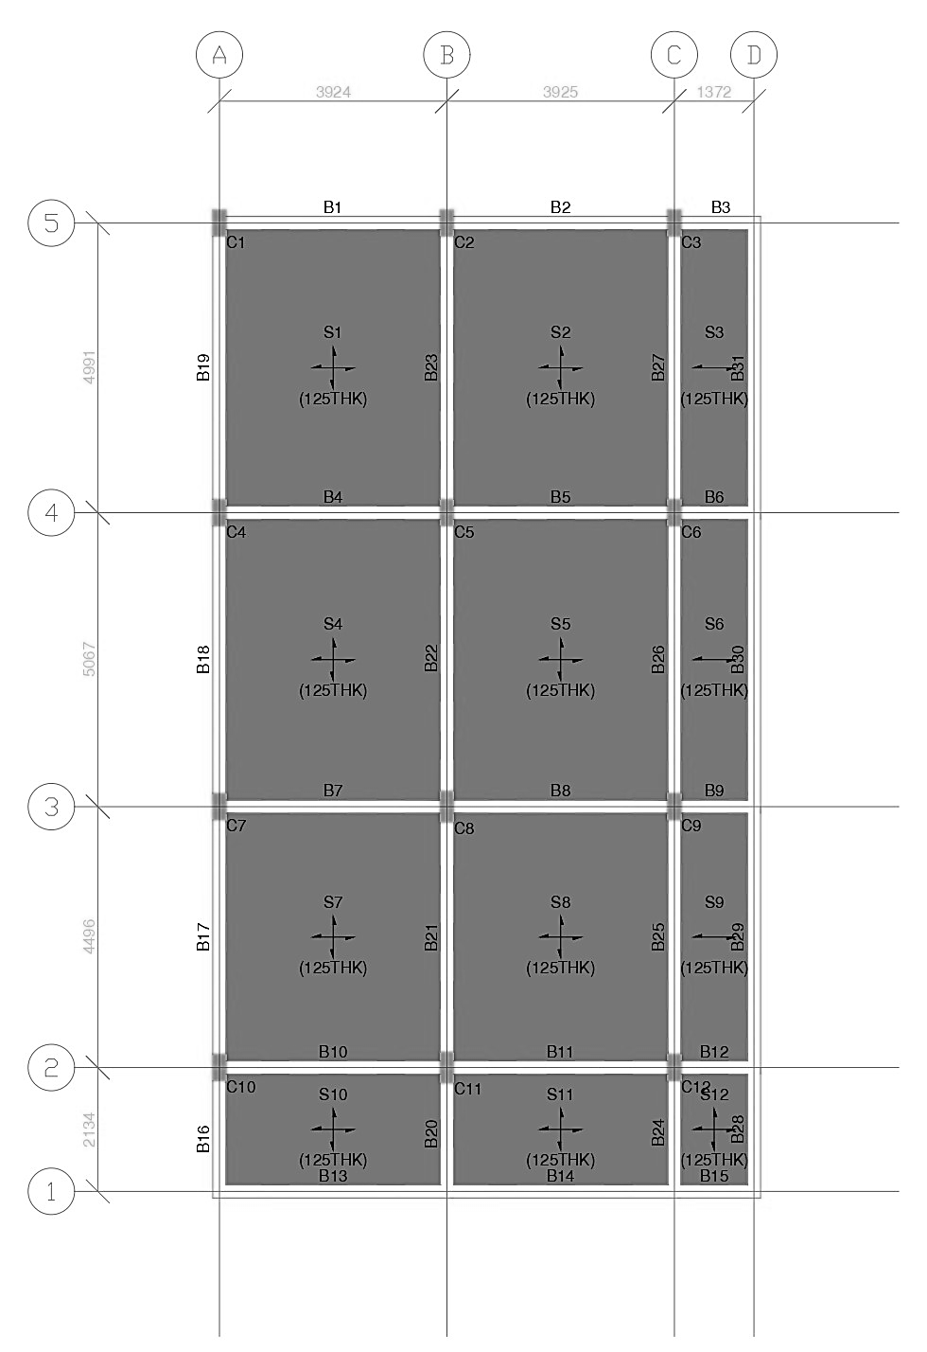
Figure 5.2: General Arrangement (GA) Plan and Slab Panel Numbering Layout
(Levels 5.029 m, 8.077 m, and 11.125 m)
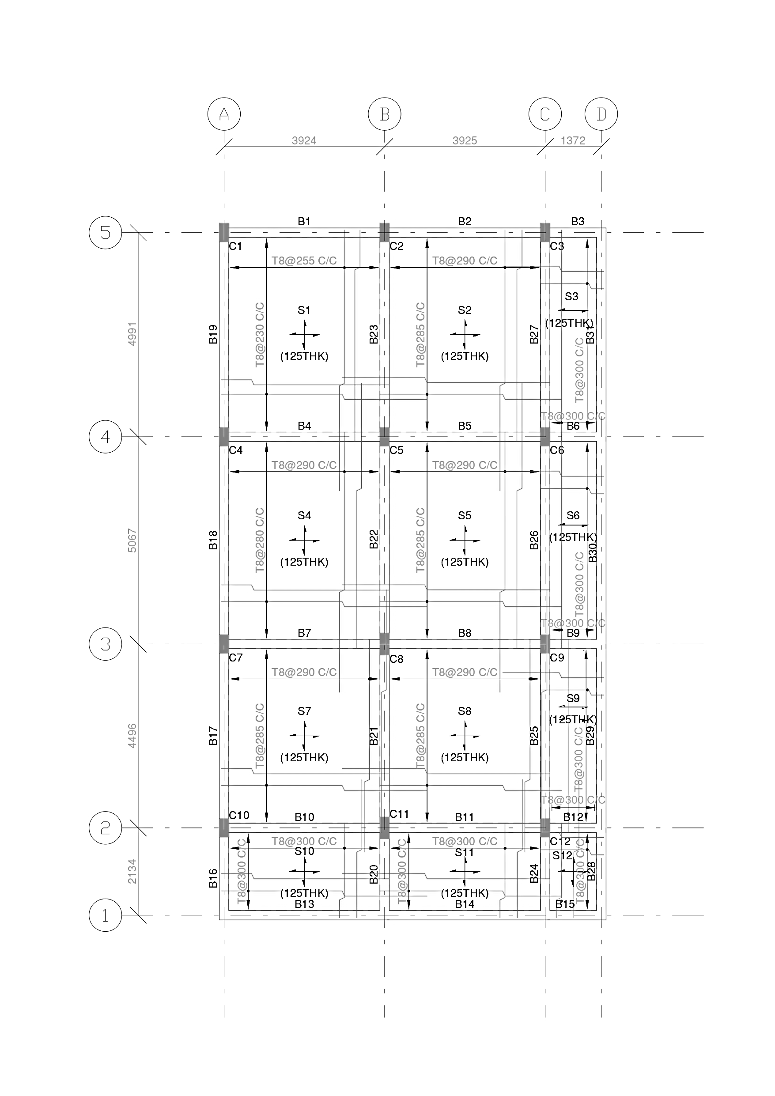
Figure 5.3: In-Plan Bent-Up Reinforcement Layout showing Bar Marks, Crank Locations, and Spacings
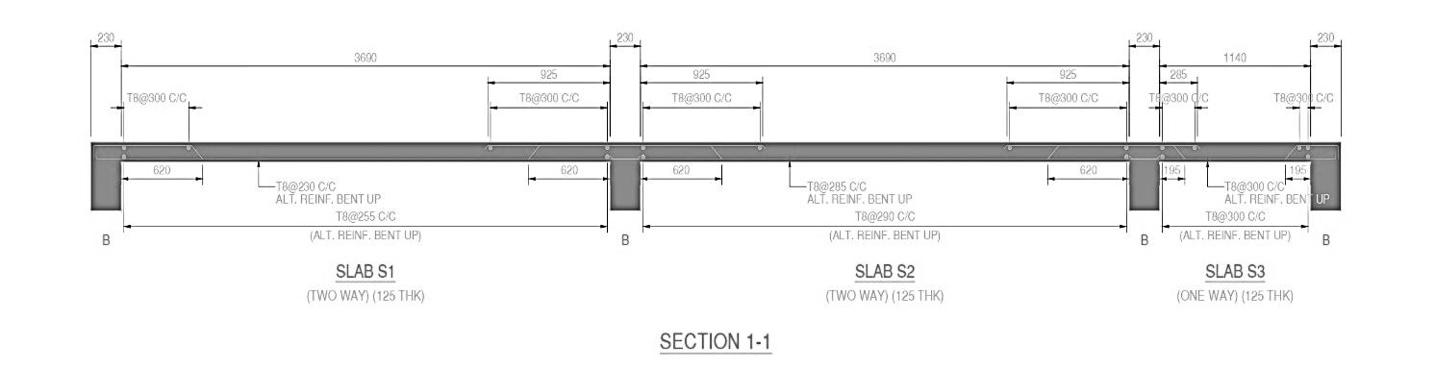
Figure 5.4: Structural Cross-Sections across Slab Spans: Section 1-1
(cutting across Panels S1, S2, S3)
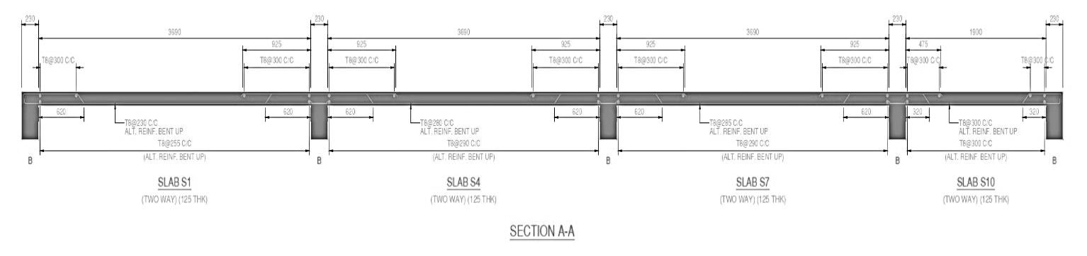
Figure 5.5: Section A-A (cutting across Panels S1, S4, S7, S10)

5.3 STRUCTURAL DESIGN OF CONTINUOUS BEAMS
5.3.1 DESIGN PHILOSOPHY, CROSS-SECTIONAL GEOMETRY, AND MATERIAL PARAMETERS
Continuous beams in the G+2 residential framed structure act as primary flexural elements that collect gravity loads from the floor slabs and transfer them to the supporting column frame. In addition to gravity loads, the continuous beams participate as members of the moment-resisting frame resisting lateral seismic forces along both orthogonal axes.
The structural design was executed in accordance with the Limit State Method of IS 456:2000, with ductile detailing criteria complying with IS 13920:2016 and detailing conventions per SP 34 (S&T):1987.
- Standard Cross-Sectional Envelope:
  - Beam Breadth (b) = 230 mm
  - Beam Overall Depth (D) = 430 mm
  - Effective Depth (d) = 370 mm (as evaluated by the RCDC engine)
  - Clear Cover to Top, Bottom, and Side Rebars = 30 mm (complying with IS 456 Table 16 for Moderate Exposure)
- Material Strengths:
  - Characteristic Compressive Strength of Concrete (fck) = 25 N/mm² (M25 Grade)
  - Characteristic Yield Strength of Reinforcement (fy) = 550 N/mm² (Fe550 High-Yield TMT Rebars)
  - Modulus of Elasticity of Steel (Es) = 2.0 × 10⁵ N/mm²
5.3.2 CRITICAL GOVERNING BEAM IDENTIFICATION (BEAM B1, FLOOR 1)
To demonstrate the mathematical rigor of the automated STAAD.Pro / RCDC pipeline, Beam B1 (Floor Level 5.029 m) is selected as the representative critical continuous beam. Beam B1 spans along Grid Line 5 between Column C1 (Grid A) and Column C2 (Grid B), supporting two-way slab panel S1 over an effective clear span of L = 3.924 m (3924 mm).
The critical limit states governing the section are:
- Critical Hogging Flexure (Top Support): Governed by Load Combination 12 [1.5 × (DL + LL)].
- Critical Sagging Flexure (Mid-Span): Governed by Load Combination 12 [1.5 × (DL + LL)].
- Critical Support Reversal Flexure (Bottom Support): Governed by Seismic Combination 17 [1.2 × (DL + LL – ELX)].
- Critical Shear & Torsion: Governed by Load Combination 12 [1.5 × (DL + LL)].
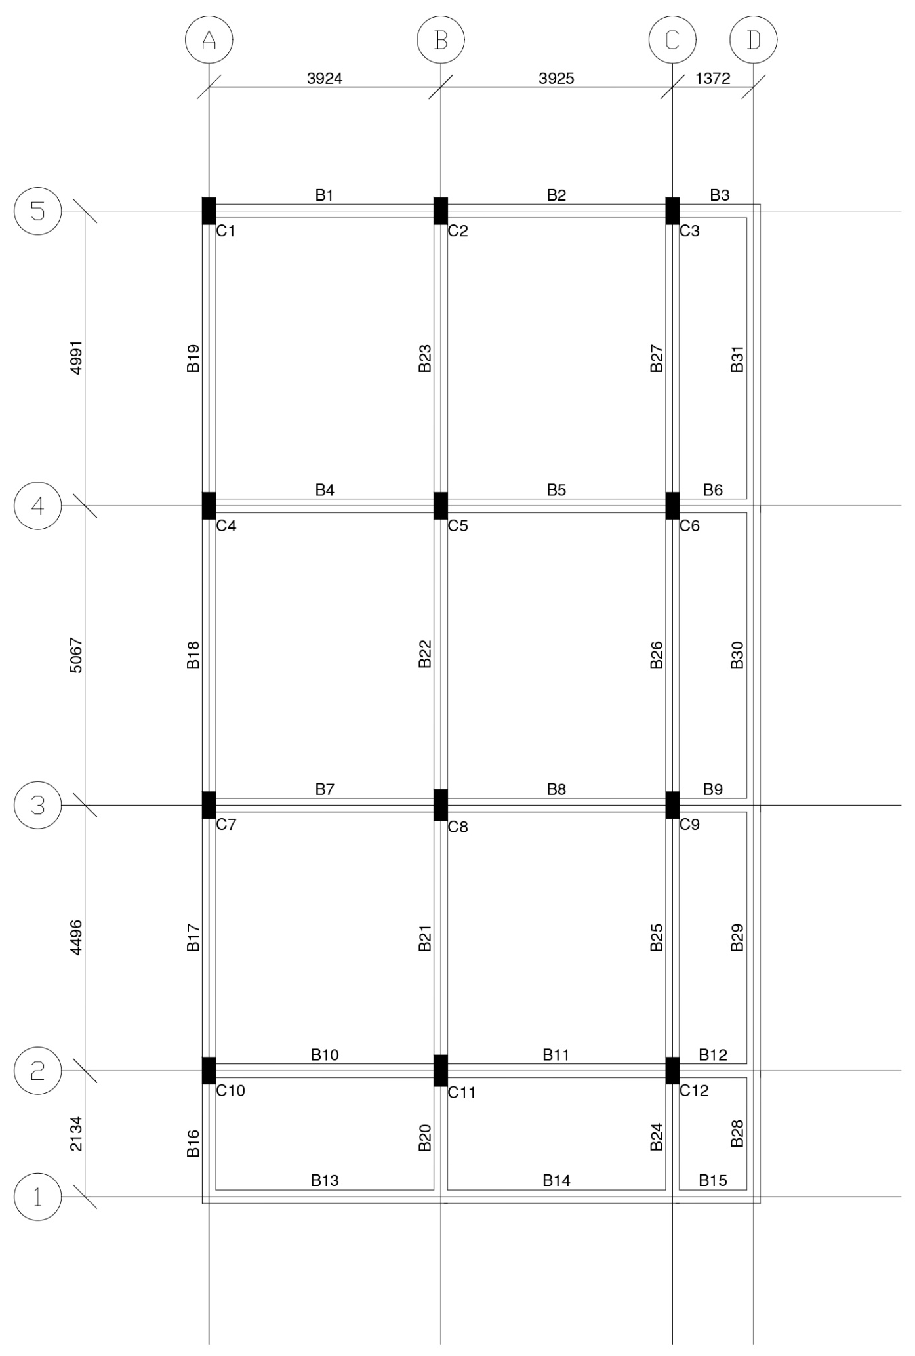
Figure 5.6: Overall Beam General Arrangement (GA) Layout Plan (Floor 1 Level: 5.029 m)
5.3.3 DETAILED MATHEMATICAL FLEXURAL DESIGN VERIFICATION
1. LIMITING MOMENT OF RESISTANCE CHECK:
The limiting moment capacity of the singly reinforced rectangular section ($M_{u,lim}$) is evaluated per IS 456:2000 (Annex G / Clause 38.1):
- Limiting Neutral Axis Factor: (x_{u},_{max} / d) = 0.456 (for Fe550)
- Limiting Moment Factor: R_{u},_{lim} = 0.36 × f_{ck} × (x_{u},_{max} / d) × [1 – 0.42 × (x_{u},_{max} / d)] R_{u},_{lim} = 0.36 × 25 × 0.456 × [1 – (0.42 × 0.456)] = 3.318 N/mm²
- Limiting Moment Capacity (M_{u},_{lim}): M_{u},_{lim} = R_{u},_{lim} × b × d² = 3.318 × 230 × (370)² × 10⁻⁶ = 104.42 kNm (adopted as 102.0 kNm in RCDC)
2. TOP SUPPORT REINFORCEMENT DESIGN (CRITICAL RIGHT SUPPORT AT COLUMN C2):
Under governing factored gravity combination LC 12:
- Factored Support Hogging Bending Moment (M_{u}) = 91.47 kNm
- Factored Torsional Moment (T_{u}) = 0.67 kNm
- Equivalent Torsional Bending Moment (M_{Tu}):
M_{Tu} = T_{u} × [1 + (D / b)] / 1.7 = 0.67 × [1 + (430 / 230)] / 1.7 = 1.12 kNm
- Total Factored Design Bending Moment (M_{ud}):
M_{ud} = M_{u} + M_{Tu} = 91.47 + 1.12 = 92.60 kNm
Check: Since M_{ud} (92.60 kNm) < M_{u,lim} (102.0 kNm), the section is designed as a Singly Reinforced Section.
- Moment Ratio: R = M_{ud} / (b × d²) = (92.60 × 10⁶) / (230 × 370²) = 2.941 N/mm²
- Required Area of Tension Steel (Ast,_{calc}):
Ast,_{calc} = [0.5 × f_{ck} / f_{y}] × [1 – √(1 – (4.59 × M_{ud} / (f_{ck} × b × d²)))] × b × d
Ast,_{calc} = [0.5 × 25 / 550] × [1 – √(1 – (4.59 × 2.941 / 25))] × 230 × 370 = 624.25 mm²
- Minimum Tension Steel Check (IS 13920 Clause 6.2.1):
Ast,_{min} = [0.24 × √(f_{ck}) / f_{y}] × b × d = [0.24 × √25 / 550] × 230 × 370 = 185.67 mm²
- Provided Longitudinal Top Reinforcement: 3-T20 Continuous
Ast,_{prov} = 3 × (π / 4 × 20²) = 3 × 314.16 = 942.48 mm² (pt = 1.107%)
Check: Ast,_{prov} (942.48 mm²) > Ast,_{calc} (624.25 mm²) ➔ SAFE IN FLEXURE (HOGGING)

3. BOTTOM MID-SPAN REINFORCEMENT DESIGN (SAGGING FLEXURE):
Under governing factored combination LC 12:
- Factored Sagging Bending Moment (M_{u}) = 48.59 kNm
- Factored Torsional Moment (T_{u}) = 0.67 kNm
- Equivalent Torsional Bending Moment (M_{Tu}) = 1.12 kNm
- Total Factored Design Bending Moment (M_{ud}): M_{ud} = M_{u} + M_{Tu} = 48.59 + 1.12 = 49.71 kNm
- Moment Ratio: R = M_{ud} / (b × d²) = (49.71 × 10⁶) / (230 × 370²) = 1.579 N/mm²
- Required Area of Tension Steel (Ast,_{calc}): Ast,_{calc} = [0.5 × 25 / 550] × [1 – √(1 – (4.59 × 1.579 / 25))] × 230 × 370 = 304.93 mm²
- Provided Longitudinal Bottom Reinforcement: 3-T16 Continuous
Ast,_{prov} = 3 × (π / 4 × 16²) = 3 × 201.06 = 603.18 mm² (pt = 0.709%)
Check: Ast,_{prov} (603.18 mm²) > Ast,_{calc} (304.93 mm²) ➔ SAFE IN FLEXURE (SAGGING)
4. SUPPORT MOMENT REVERSAL & DUCTILITY CHECK (IS 13920:2016):
Under lateral earthquake sway combination LC 17 [1.2 × (DL + LL – ELX)]:
- Factored Reversal Moment at Bottom Support Face (M_{ud}) = 76.03 kNm
- Required Reversal Steel: Ast,_{calc} = 492.42 mm²
- Bottom Steel Provided through Support: 3-T16 (603.18 mm²)
- Check: Ast,_{prov} (603.18 mm²) > Ast,_{calc} (492.42 mm²) ➔ SAFE UNDER SEISMIC REVERSAL
- Ductile Positive Moment Capacity Ratio (IS 13920 Clause 6.2.3): The positive moment capacity at the support face must be at least 50% of the negative moment capacity:
Ratio = Ast,_{bottom} / Ast,_{top} = 603.18 mm² / 942.48 mm²
= 64.0% ≥ 50.0% ➔ SAFE & COMPLIANT
5.3.4 DETAILED MATHEMATICAL SHEAR AND TORSION DESIGN VERIFICATION
Under governing shear combination LC 12 at the right support face:
- Factored Shear Force (V_{u}) = 77.10 kN
- Factored Torsional Moment (T_{u}) = 0.67 kNm
- Equivalent Shear due to Torsion (V_{Tu} per IS 456 Clause 41.3.1):
V_{Tu} = 1.6 × (T_{u} / b) = 1.6 × (0.67 / 0.230) = 4.63 kN
- Total Design Transverse Shear (V_{ut}): V_{ut} = V_{u} + V_{Tu} = 77.10 + 4.63 = 81.73 kN

1. Shear Stress Checks:
- Nominal Shear Stress (τ_{v}): τ_{v} = V_{ut} / (b × d) = (81.73 × 10³) / (230 × 370) = 0.960 N/mm²
- Maximum Shear Stress Limit (IS 456 Table 20):
τ_{c,max} = 0.62 × √(f_{ck}) = 0.62 × √25 = 3.10 N/mm²
Check: τ_{v} (0.960 N/mm²) < τ_{c,max} (3.10 N/mm²) ➔ SECTION DIMENSIONS ARE ADEQUATE
- Concrete Shear Strength (τ_{c} per IS 456 Table 19 for pt = 1.107%): τ_{c} = 0.670 N/mm²
- Shear Capacity of Concrete Alone (V_{c}): V_{c} = τ_{c} × b × d = 0.670 × 230 × 370 × 10⁻³ = 56.69 kN
2. Shear Reinforcement Calculation:
- Net Shear Force to be Resisted by Transverse Stirrups (V_{us}):
V_{us} = V_{ut} – V_{c} = 81.73 – 56.69 = 25.04 kN
- Area of Two-Legged 8 mm Stirrup (A_{sv}): A_{sv} = 2 × (π / 4 × 8²) = 2 × 50.27 = 100.53 mm²
- Theoretical Stirrup Spacing (S_{v,calc}): S_{v,calc} = (0.87 × f_{y} × A_{sv} × d) / (V_{us} × 10³)
= (0.87 × 550 × 100.53 × 370) / (25.04 × 10³) = 711 mm
3. Maximum Spacing Criteria & Ductile Confinement (IS 456 & IS 13920):
- Spacing Criteria for Torsion (Clause 41.4.3):
  - Spc₁ = x₁ = 180 mm (centre-to-centre stirrup width)
  - Spc₂ = (x₁ + y₁) / 4 = (180 + 380) / 4 = 140 mm
- Basic Shear Spacing Criteria (Clause 26.5.1.5):
  - Spc₃ = 0.75 × d = 0.75 × 370 = 278 mm (adopted as 275 mm)
  - Spc₄ = 300 mm
- Transverse Stirrup Provision:
  - End Zones (Near Supports over 2d = 750 mm length): 2L-T8 @ 140 mm c/c
  - Mid-Span Zone: 2L-T8 @ 275 mm c/c
Check: Minimum provided shear capacity exceeds 718.14 mm²/m
➔ SAFE IN SHEAR & TORSION

5.3.5 SIDE FACE REINFORCEMENT & SERVICEABILITY VERIFICATION
- Side Face Reinforcement (IS 456 Clause 26.5.1.3): Clause 26.5.1.3 stipulates that side face reinforcement is required only when the depth of the web exceeds 750 mm. Check: Total Beam Depth D = 430 mm ≤ 750 mm ➔ Side Face Reinforcement Not Required.
- Deflection Serviceability Check (IS 456 Clause 23.2.1):
  - Basic Span-to-Effective-Depth ratio for continuous beam = 26.0
  - Modification factor for tension steel (pt = 0.709%, fs = 0.58 × f_{y} = 191 N/mm²):
F1 = 1.35
  - Permissible (L/d) ratio = 26.0 × 1.35 = 35.10
  - Actual (L/d) ratio = 3924 mm / 370 mm = 10.61
Check: Actual (L/d = 10.61) < Permissible (L/d = 35.10) ➔ SAFE AGAINST DEFLECTION
5.3.6 CONSOLIDATED CONTINUOUS BEAM REINFORCEMENT SCHEDULE
The continuous beam design schedule across Floor 1 (Level 5.029 m) generated by the RCDC engine is summarized in Table 5.2.

Table 5.2: Consolidated Beam Reinforcement Schedule (Floor 1 Level: 5.029 m)
(Concrete: M25 | Steel: Fe550 | Section: 230 mm × 430 mm | Clear Cover: 30 mm)
Beam ID | Grid Line & Span | Span Length (mm) | Beam Type | Top Rebar (Support / Continuous) | Bottom Rebar (Continuous) | Shear Links (End Zone) | Shear Links (Mid Zone)
B1 | Grid 5 (A–B) | 3924 | Regular | 3-T20 | 3-T16 | 2L-T8 @ 140 c/c | 2L-T8 @ 275 c/c
B2 | Grid 5 (B–C) | 3925 | Regular | 3-T20 | 3-T16 | 2L-T8 @ 140 c/c | 2L-T8 @ 275 c/c
B3 | Grid 5 (C–D) | 1372 | Cantilever | 3-T20 | 3-T16 | 2L-T8 @ 105 c/c | 2L-T8 @ 110 c/c
B4 | Grid 4 (A–B) | 3924 | Regular | 3-T20 | 3-T16 | 2L-T8 @ 275 c/c | 2L-T8 @ 275 c/c
B5 | Grid 4 (B–C) | 3925 | Regular | 3-T20 | 3-T16 | 2L-T8 @ 275 c/c | 2L-T8 @ 275 c/c
B6 | Grid 4 (C–D) | 1372 | Cantilever | 3-T20 | 3-T16 | 2L-T8 @ 140 c/c | 2L-T8 @ 140 c/c
B7 | Grid 3 (A–B) | 3924 | Regular | 3-T20 | 3-T20 | 2L-T8 @ 140 c/c | 2L-T8 @ 275 c/c
B8 | Grid 3 (B–C) | 3925 | Regular | 3-T20 | 3-T20 | 2L-T8 @ 140 c/c | 2L-T8 @ 275 c/c
B9 | Grid 3 (C–D) | 1372 | Cantilever | 3-T20 | 3-T20 | 2L-T8 @ 140 c/c | 2L-T8 @ 140 c/c
B10 | Grid 2 (A–B) | 3924 | Regular | 3-T20 | 3-T16 | 2L-T8 @ 140 c/c | 2L-T8 @ 275 c/c
B11 | Grid 2 (B–C) | 3925 | Regular | 3-T20 | 3-T16 | 2L-T8 @ 140 c/c | 2L-T8 @ 275 c/c
B12 | Grid 2 (C–D) | 1372 | Cantilever | 3-T20 | 3-T16 | 2L-T8 @ 140 c/c | 2L-T8 @ 140 c/c
B13 | Grid 1 (A–B) | 3924 | Regular | 3-T12 | 2-T12 | 2L-T8 @ 140 c/c | 2L-T8 @ 275 c/c
B14 | Grid 1 (B–C) | 3925 | Regular | 3-T12 | 2-T12 | 2L-T8 @ 275 c/c | 2L-T8 @ 275 c/c
B15 | Grid 1 (C–D) | 1372 | Cantilever | 3-T12 | 2-T12 | 2L-T8 @ 140 c/c | 2L-T8 @ 140 c/c
B16 | Grid A (1–2) | 2134 | Cantilever | 3-T20 | 2-T12 | 2L-T8 @ 140 c/c | 2L-T8 @ 140 c/c
B17 | Grid A (2–3) | 4496 | Regular | 3-T20 | 2-T12 | 2L-T8 @ 140 c/c | 2L-T8 @ 275 c/c
B18 | Grid A (3–4) | 5067 | Regular | 3-T20 | 2-T12 | 2L-T8 @ 140 c/c | 2L-T8 @ 275 c/c
B19 | Grid A (4–5) | 4991 | Regular | 3-T20 | 2-T12 | 2L-T8 @ 140 c/c | 2L-T8 @ 275 c/c
B20 | Grid B (1–2) | 2134 | Cantilever | 3-T20 | 3-T16 | 2L-T8 @ 275 c/c | 2L-T8 @ 275 c/c
B21 | Grid B(2–3) | 4496 | Regular | 3-T20 | 3-T16 | 2L-T8 @ 140 c/c | 2L-T8 @ 275 c/c
B22 | Grid B (3–4) | 5067 | Regular | 3-T20 | 3-T16 | 2L-T8 @ 275 c/c | 2L-T8 @ 275 c/c
B23 | Grid B (4–5) | 4991 | Regular | 3-T20 | 3-T16 | 2L-T8 @ 140 c/c | 2L-T8 @ 275 c/c
B24 | Grid C (1–2) | 2134 | Cantilever | 3-T20 | 3-T16 | 2L-T8 @ 140 c/c | 2L-T8 @ 140 c/c
B25 | Grid C (2–3) | 4496 | Regular | 3-T20 | 3-T16 | 2L-T8 @ 140 c/c | 2L-T8 @ 275 c/c
B26 | Grid C (3–4) | 5067 | Regular | 3-T20 | 3-T16 | 2L-T8 @ 140 c/c | 2L-T8 @ 275 c/c
B27 | Grid C (4–5) | 4991 | Regular | 3-T20 | 3-T16 | 2L-T8 @ 140 c/c | 2L-T8 @ 275 c/c
B28 | Grid D (1–2) | 2134 | Regular | 3-T12 | 2-T12 | 2L-T8 @ 140 c/c | 2L-T8 @ 140 c/c
B29 | Grid D(2–3) | 4496 | Regular | 3-T12 | 2-T12 | 2L-T8 @ 275 c/c | 2L-T8 @ 275 c/c
B30 | Grid D(3–4) | 5067 | Regular | 3-T12 | 2-T12 | 2L-T8 @ 275 c/c | 2L-T8 @ 275 c/c
B31 | Grid D (4–5) | 4991 | Regular | 3-T12 | 2-T12 | 2L-T8 @ 140 c/c | 2L-T8 @ 275 c/c

5.3.7 BEAM STRUCTURAL DRAWINGS & DETAILING LAYOUTS
The engineering detailing drawings exported from the RCDC CAD detailing module are presented below:
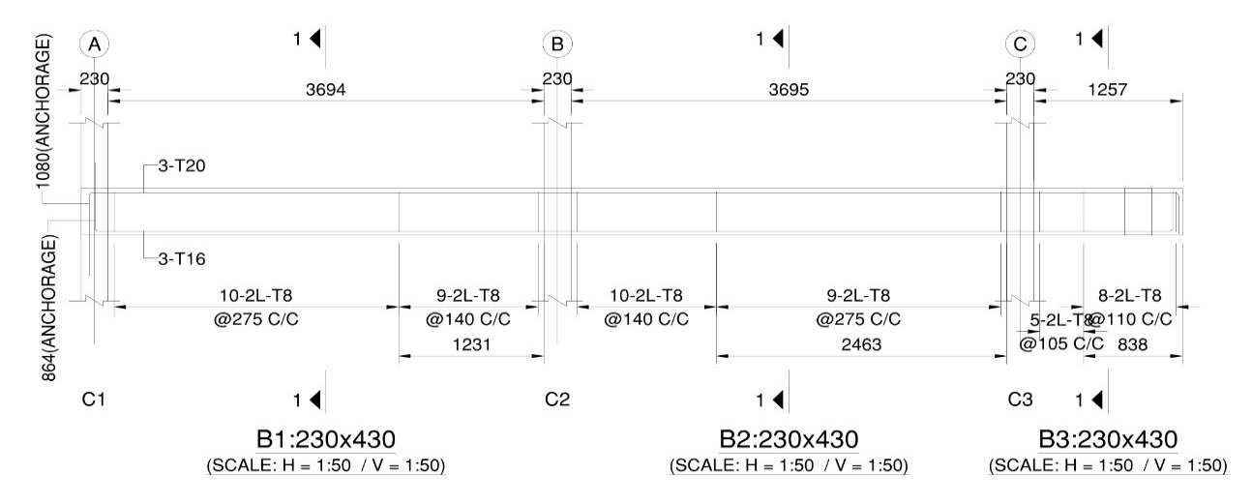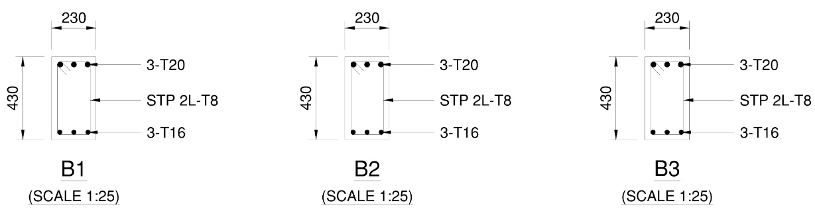
Figure 5.7: Longitudinal Elevation and Cross-Section Details of Continuous Beam Line B1–B2–B3 (Grid Line 5, Floor 1 Level: 5.029 m)
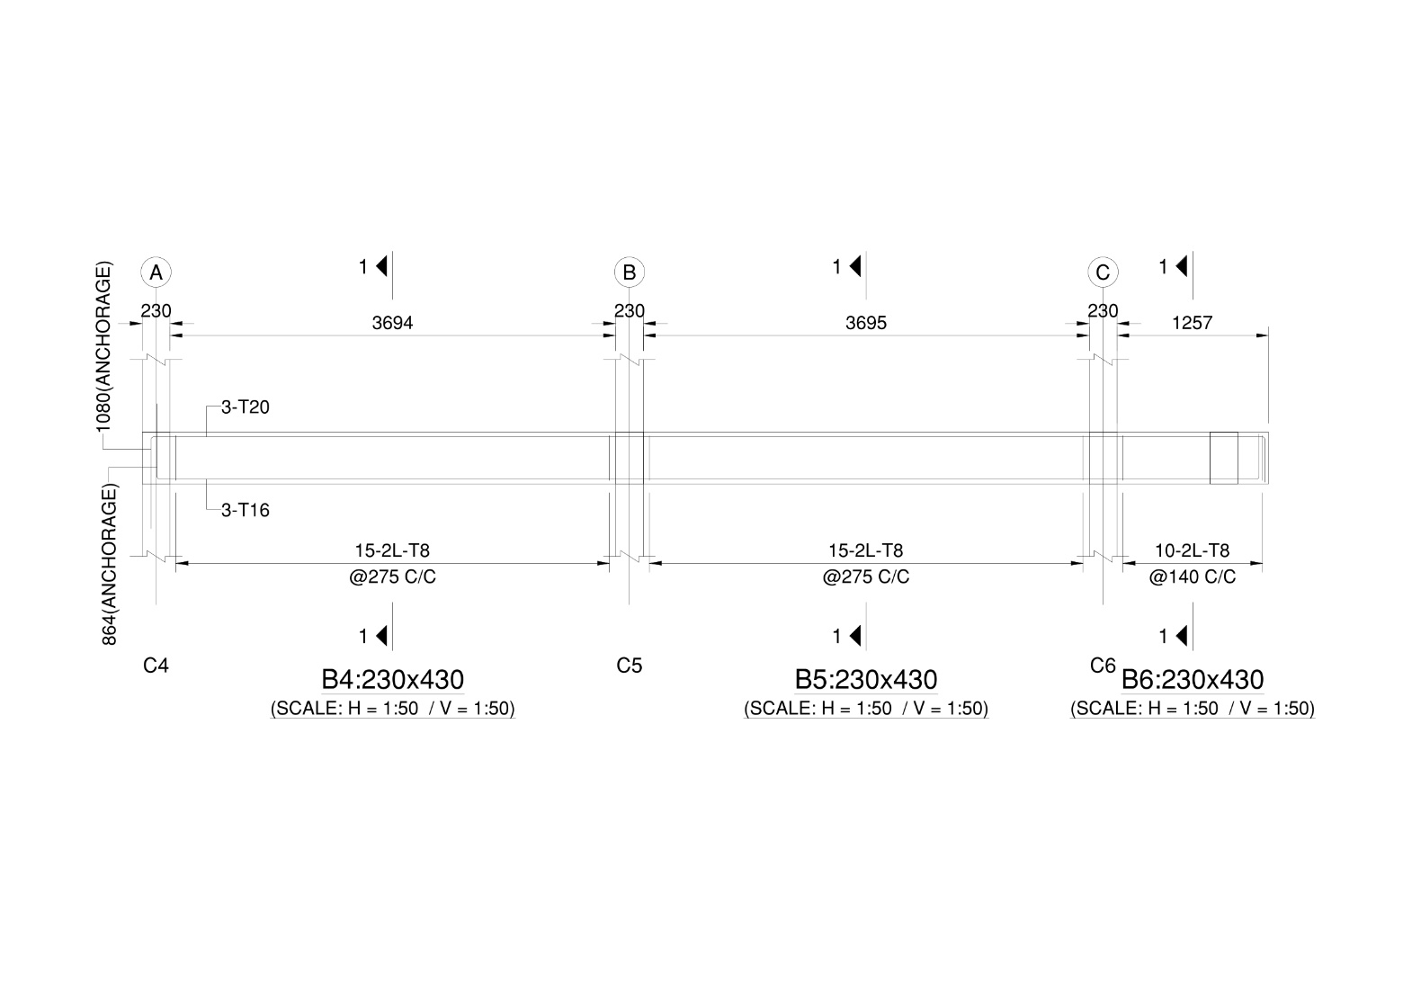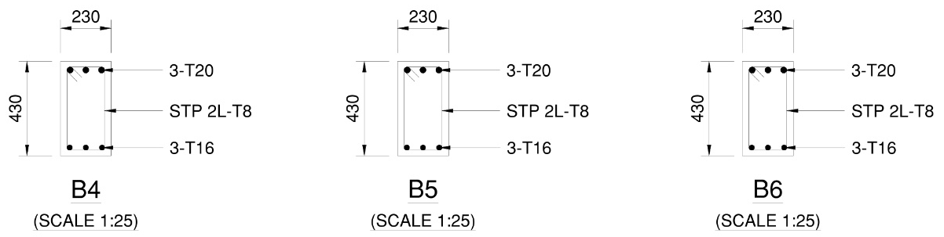
Figure 5.8: Longitudinal Elevation and Cross-Section Details of Continuous Beam Line B4–B5–B6 (Grid Line 4, Floor 1 Level: 5.029 m)
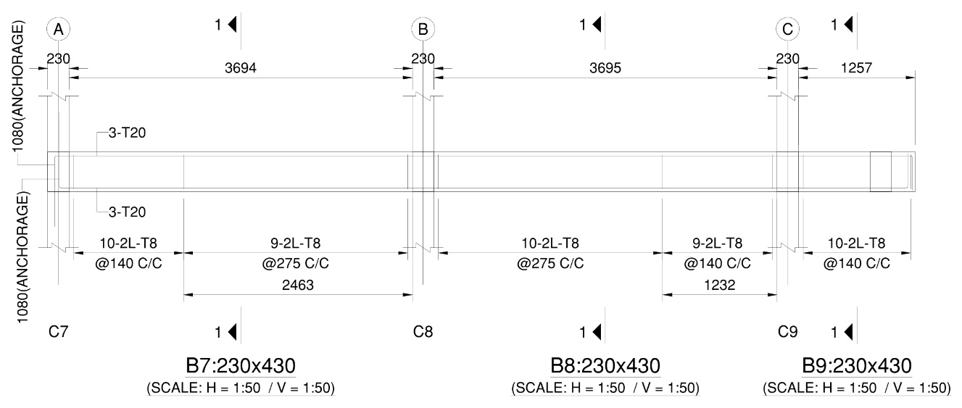
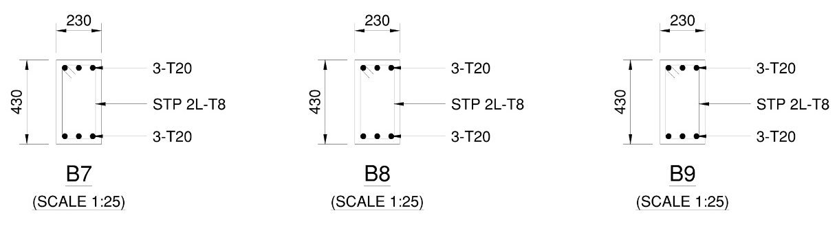
Figure 5.9: Longitudinal Elevation and Cross-Section Details of Continuous Beam Line B7–B8–B9 (Grid Line 3, Floor 1 Level: 5.029 m)
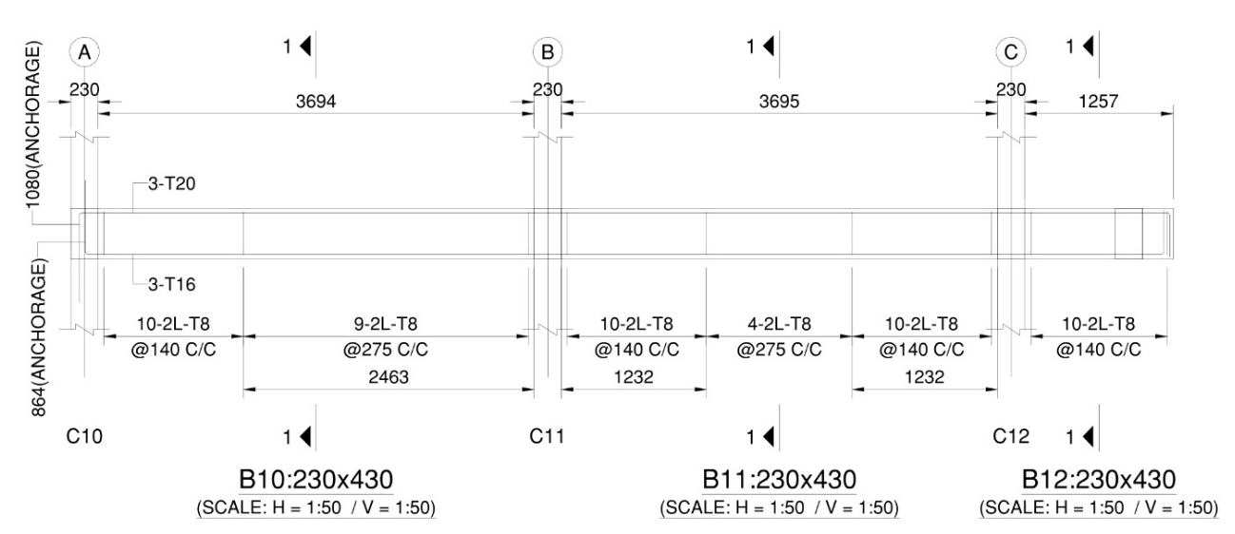
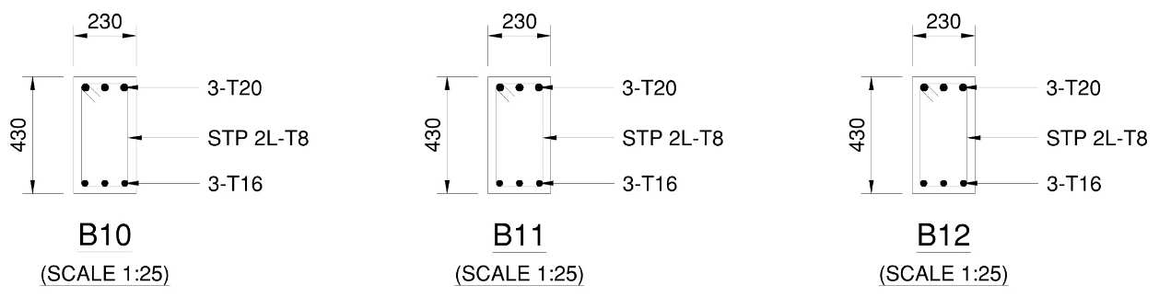
Figure 5.10: Longitudinal Elevation and Cross-Section Details of Continuous Beam Line B10–B11–B12 (Grid Line 2, Floor 1 Level: 5.029 m)
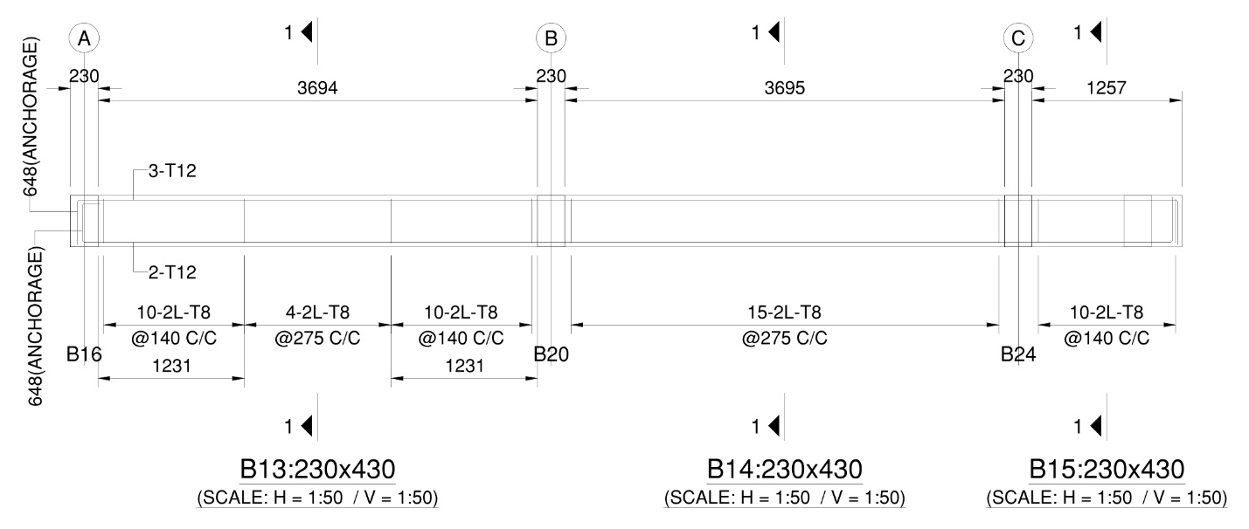
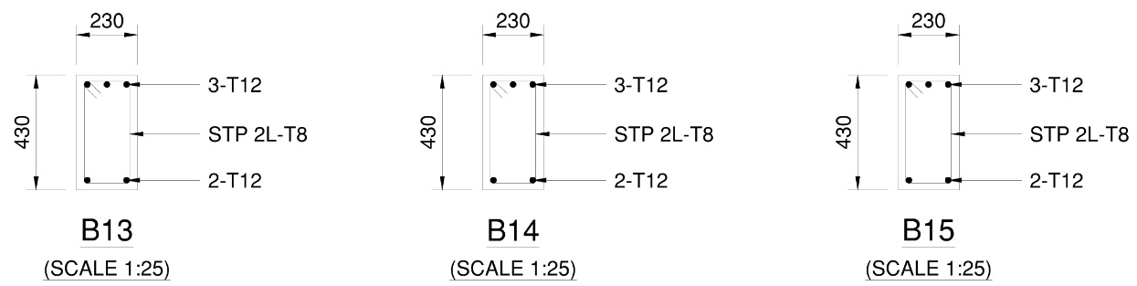
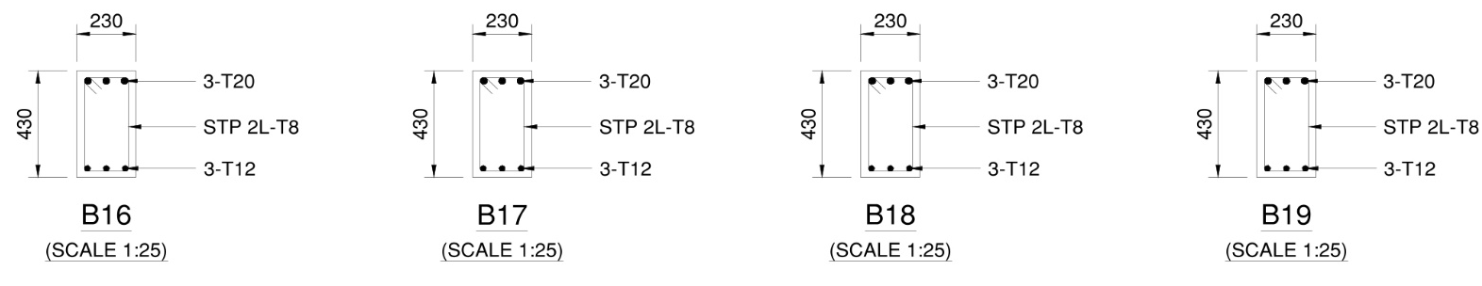
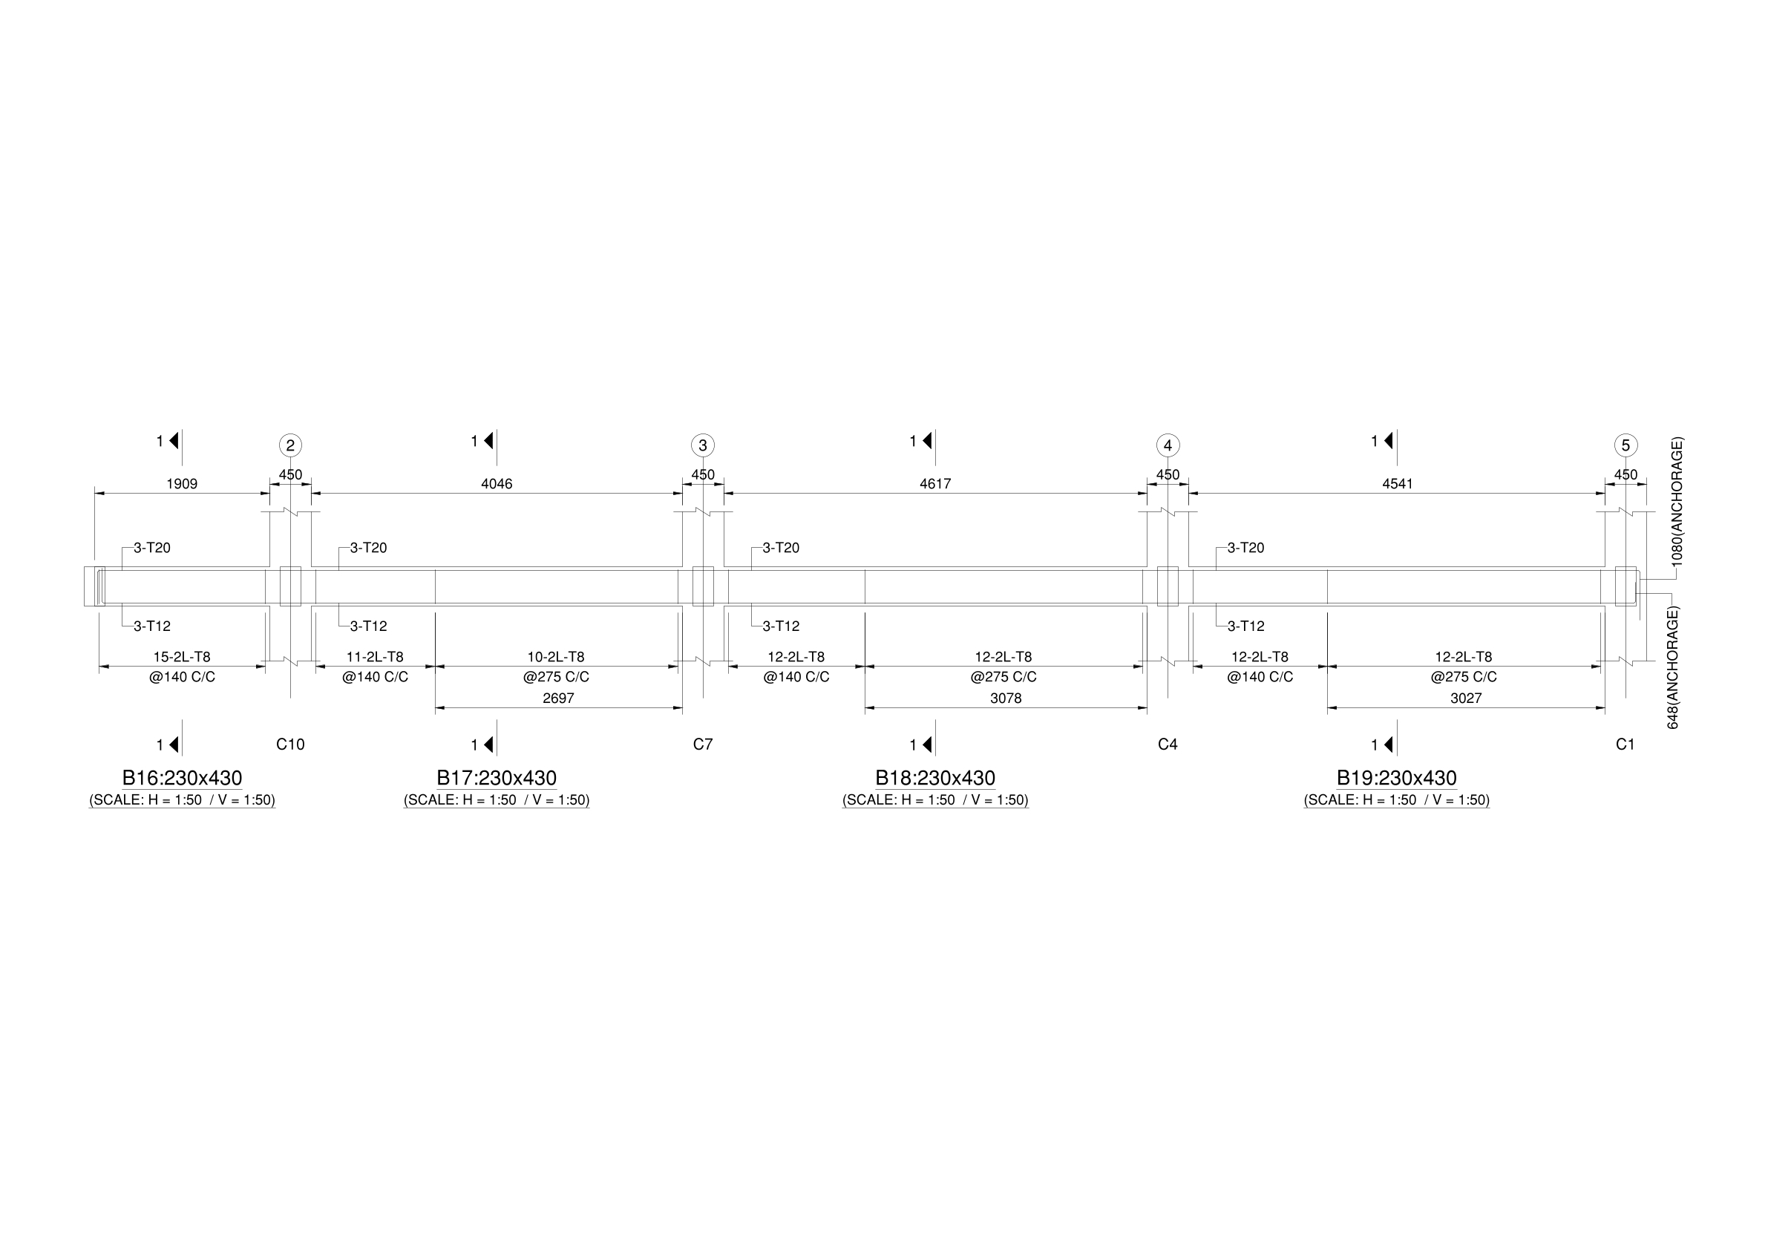
Figure 5.11: Longitudinal Elevation and Cross-Section Details of Continuous Beam Line B13–B14–B15 (Grid Line 1, Floor 1 Level: 5.029 m)
Figure 5.12: Longitudinal Elevation and Cross-Section Details of Longitudinal Beam Line B16–B17–B18–B19 (Grid Line A, Floor 1 Level: 5.029 m)
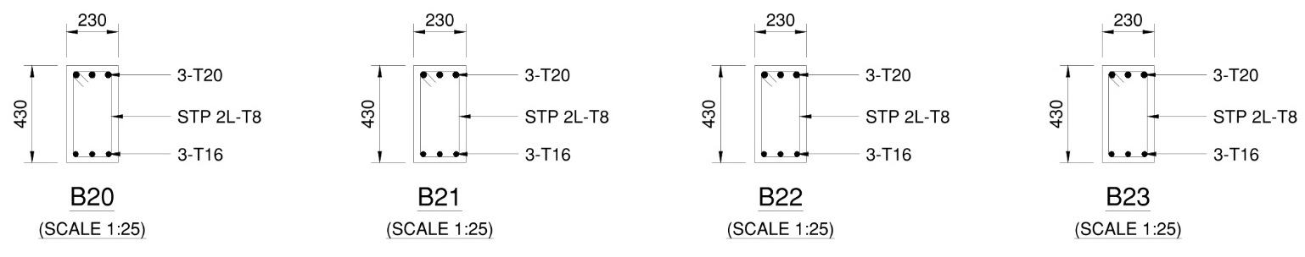
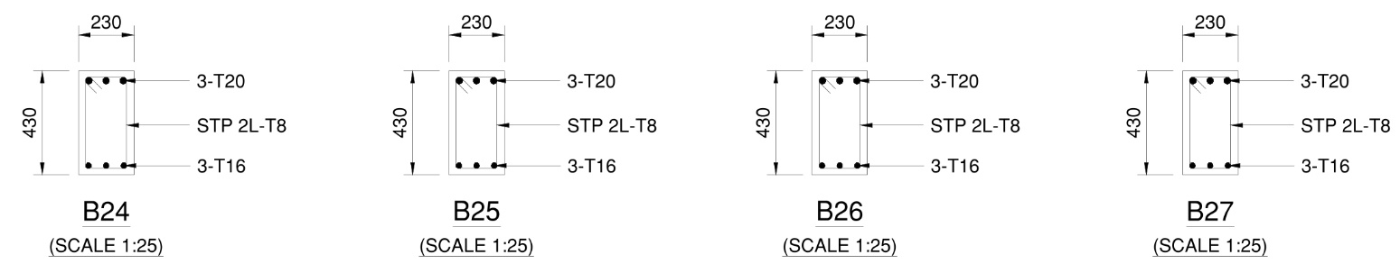
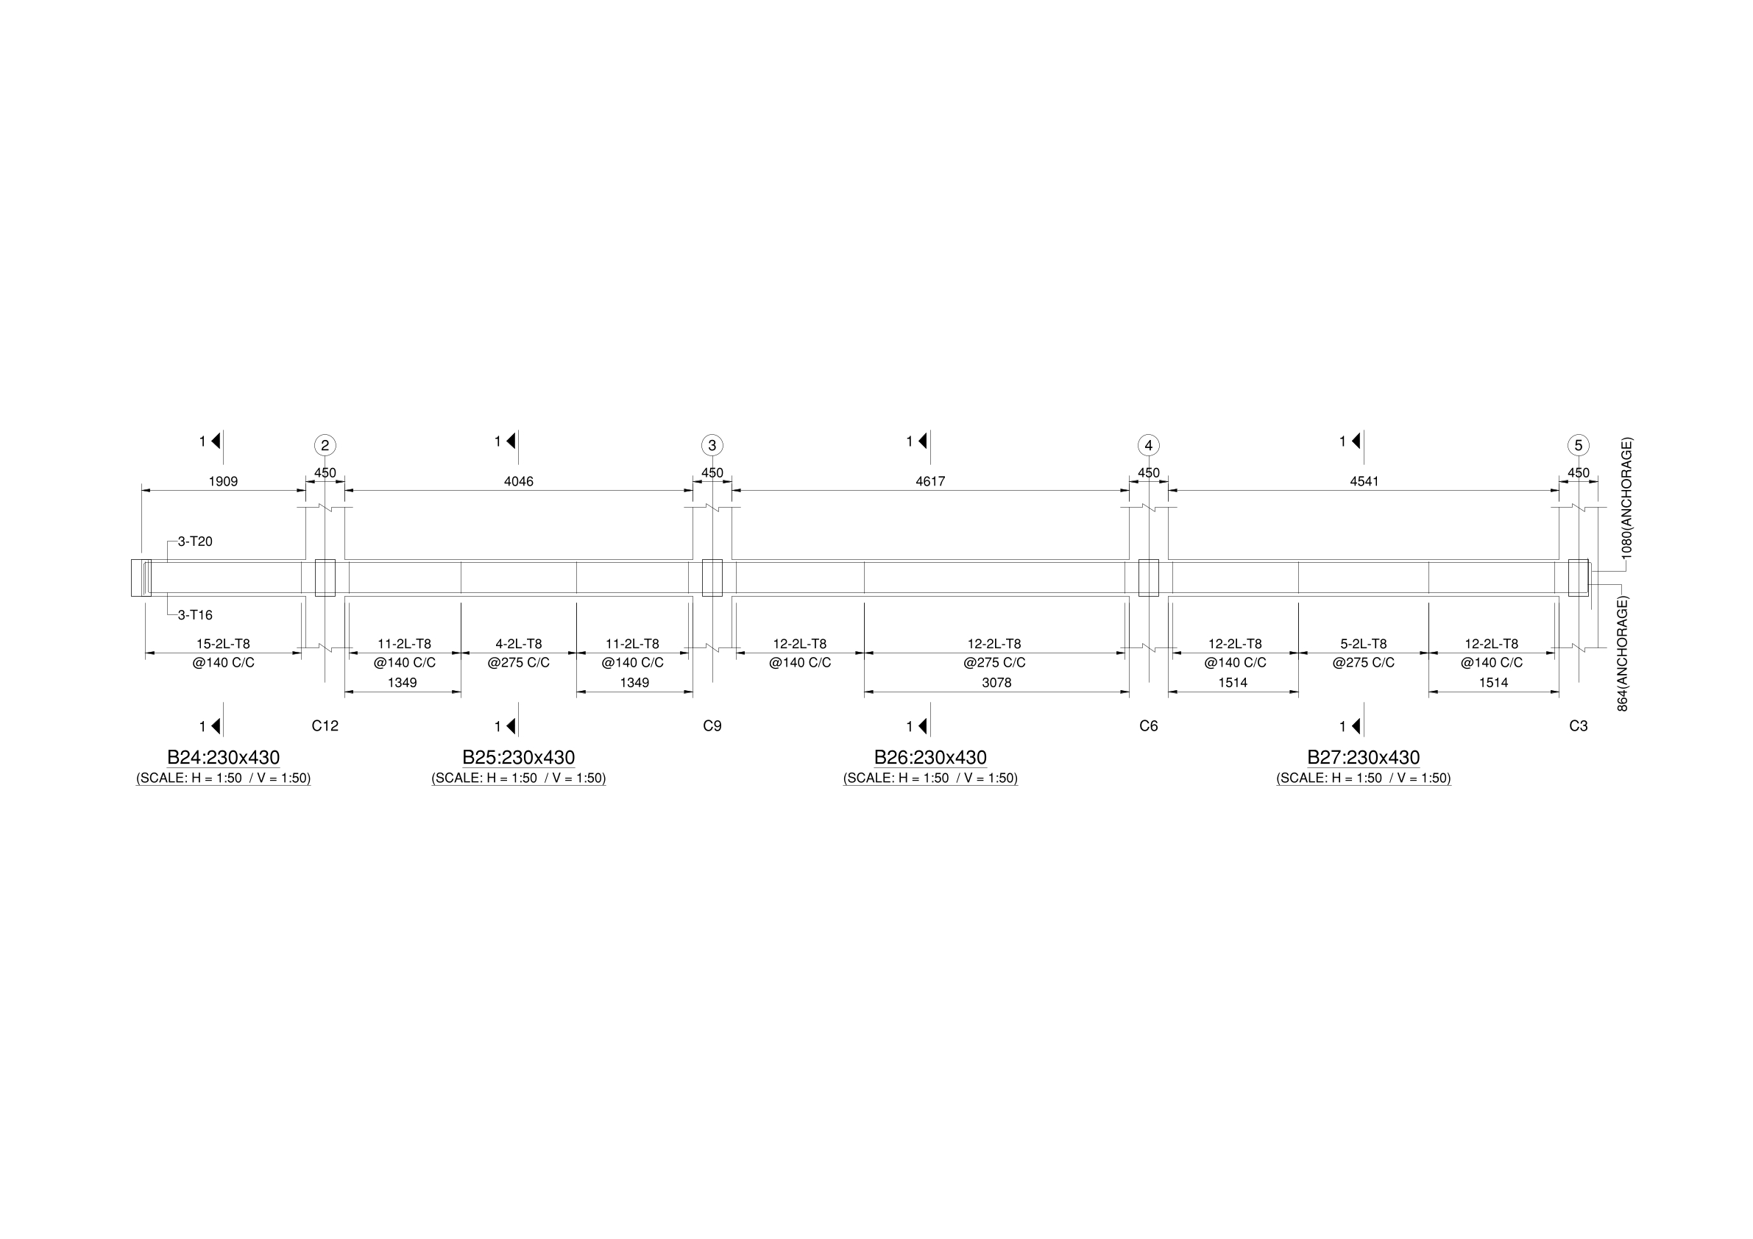
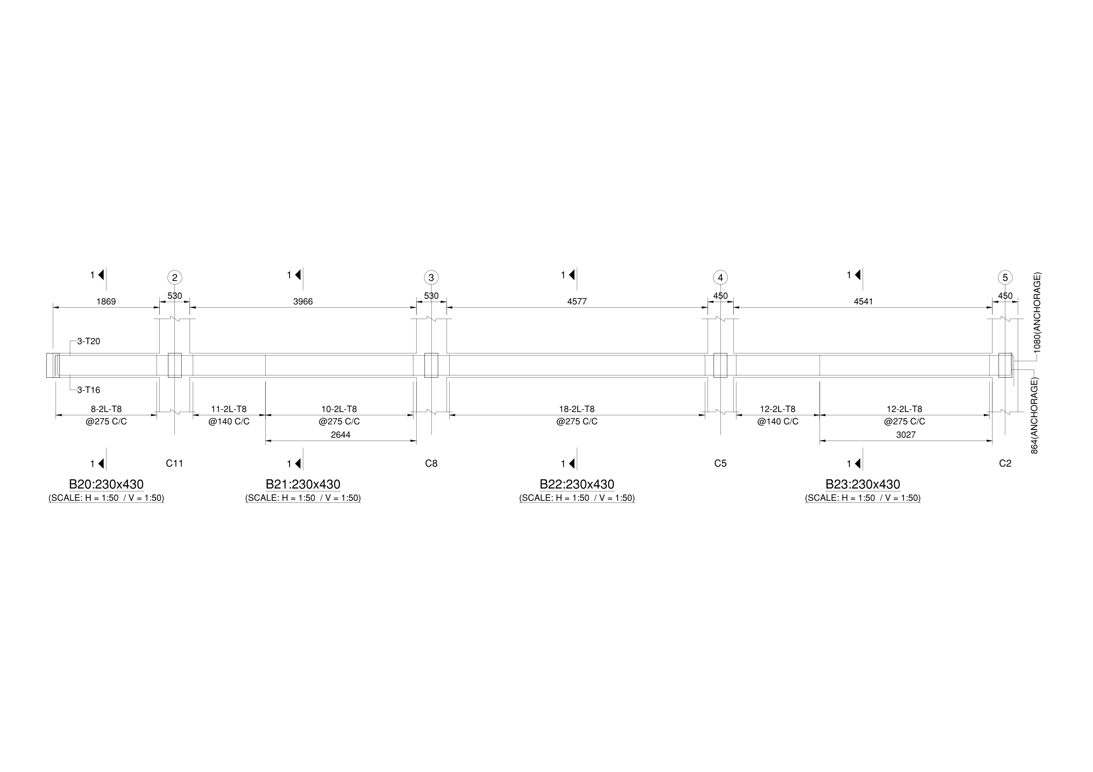
Figure 5.13: Longitudinal Elevation and Cross-Section Details of Longitudinal Beam Line B20–B21–B22–B23 (Grid Line B, Floor 1 Level: 5.029 m)
Figure 5.14: Longitudinal Elevation and Cross-Section Details of Longitudinal Beam Line B24–B25–B26–B27 (Grid Line C, Floor 1 Level: 5.029 m)
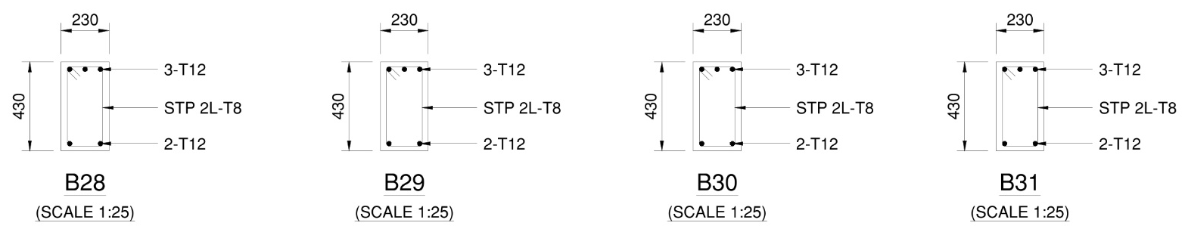
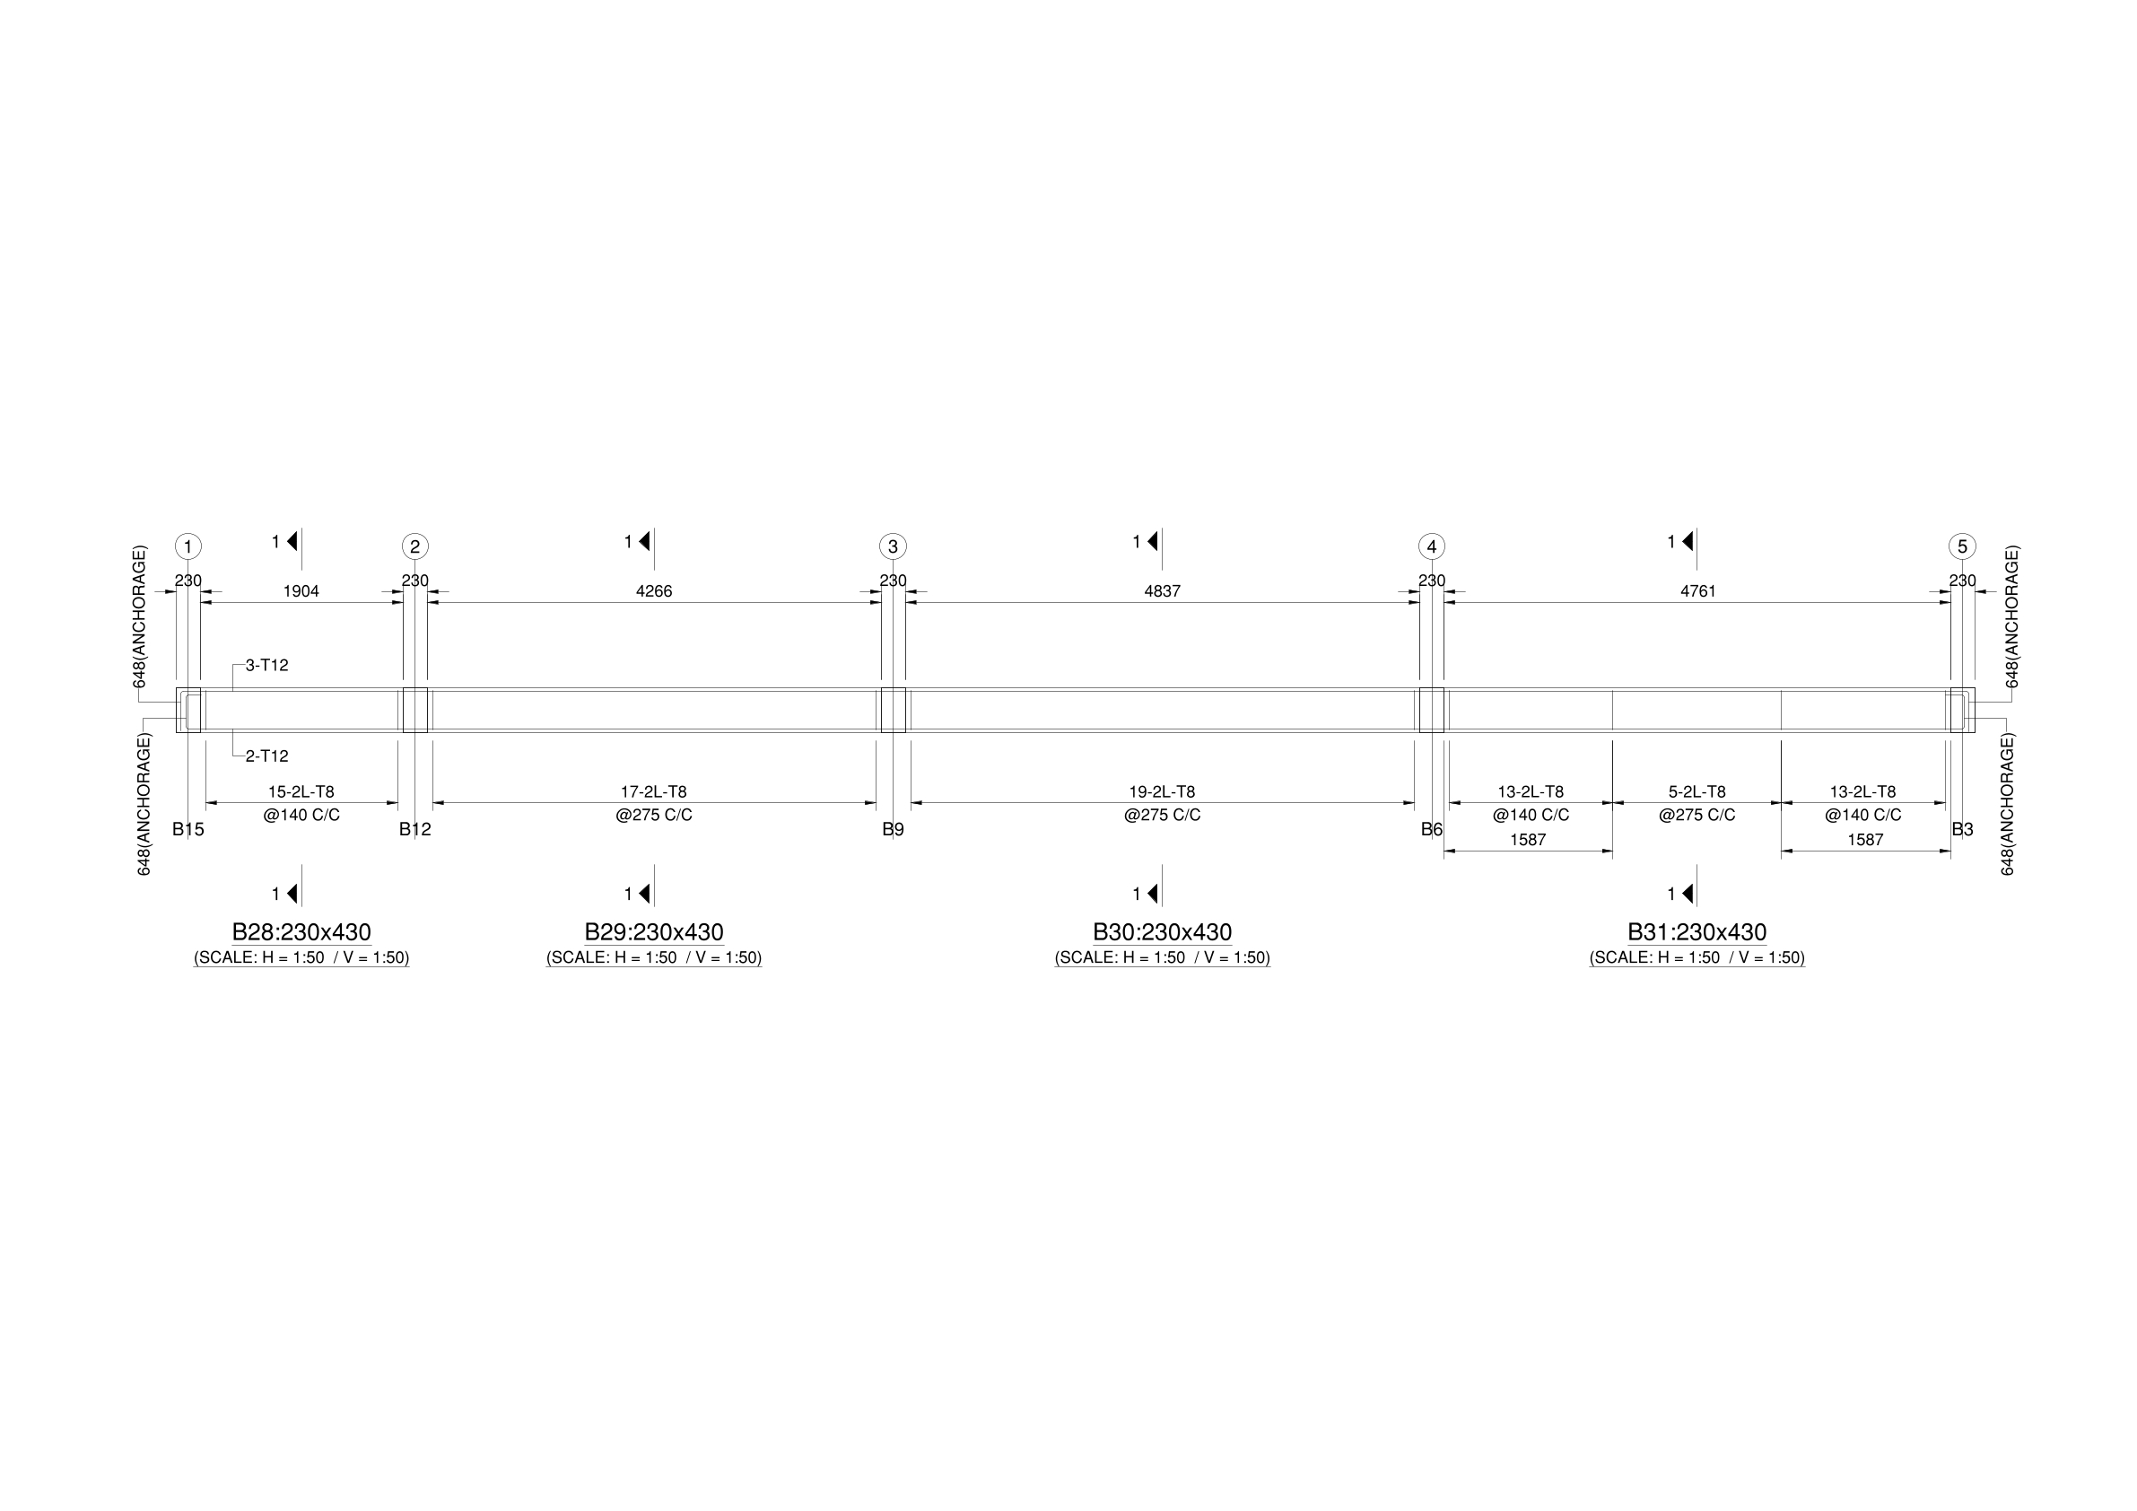
Figure 5.15: Longitudinal Elevation and Cross-Section Details of Longitudinal Beam Line B28–B29–B30–B31 (Grid Line D, Floor 1 Level: 5.029 m)

5.4 STRUCTURAL DESIGN OF COLUMNS
5.4.1 DESIGN PHILOSOPHY & STRUCTURAL SYSTEM
The reinforced concrete columns of the G+2 residential building were analyzed in STAAD.Pro v2025 and designed using the STAAD Advanced Concrete Design (RCDC) engine in strict compliance with the Limit State Method of IS 456:2000 and the ductile detailing requirements of IS 13920:2016 for Seismic Zone II (Z = 0.10, R = 3, I = 1.0).
All columns were analyzed as compression members subjected to simultaneous axial compression and biaxial bending (Pu – Mux – Muy) across 20 governing factored load combinations comprising dead loads, live loads, and orthogonal earthquake forces (+ELX, −ELX, +ELZ, −ELZ).
The governing material specifications and design parameters adopted are:
- Concrete Grade: M25 (Characteristic compressive cube strength, fck = 25 N/mm²)
- Longitudinal Reinforcement: Fe550 High-Yield Strength Deformed TMT bars (fy = 550 N/mm²)
- Transverse Links (Ties): Fe550 TMT bars (fy = 550 N/mm²), 8 mm diameter (T8)
- Clear Concrete Cover: 40 mm to outer face of links on all sides (complying with IS 456:2000 Table 16 for Moderate Exposure)
- Design Approach: Short braced compression members under combined axial compression and biaxial moment interaction (Pu / Puz ≤ 1.0)

5.4.2 COLUMN CLASSIFICATION & FUNCTIONAL GROUPING
The structural framing consists of 16 column positions (C1 through C16) classified into four distinct functional categories:
- Type I – Standard Frame Columns (230 mm × 450 mm):
  - Columns: C1, C2, C3, C4, C5, C6, C7, C9, C10, and C12 (10 columns).
  - Resist regular gravity and lateral loads across the building frame.
  - Reinforcement Varieties:
    - 6-T16 (Ast = 1206.37 mm², pt = 1.17%): Columns C1, C3, C4.
    - 4-T20 + 4-T16 (Ast = 2060.88 mm², pt = 1.99%): Columns C2, C5 (heavy exterior frame lines).
    - 4-T20 + 2-T16 (Ast = 1658.76 mm², pt = 1.60%): Columns C6, C7, C9, C10, C12.
- Type II – Heavy Interior Columns (230 mm × 530 mm):
  - Columns: C8 and C11 (2 columns).
  - Located at interior grid intersections (Grid 3-B and Grid 2-B) carrying the largest tributary slab areas and intersecting continuous main beams.
  - Enlarged to a depth of 530 mm to satisfy biaxial moment demands while maintaining a 230 mm width flush with 9-inch masonry walls.
  - Reinforcement: 8-T20 + 2-T16 (Ast = 2915.40 mm², pt = 2.39%).
- Type III – Floating Columns at Staircase Mumty Room (SMR) (230 mm × 300 mm):
  - Columns: C13 and C14 (2 columns).
  - Structural Behaviour: These are Floating Columns that do not extend to the foundation. They originate directly on the front cantilever beam at Main Roof Level (11.125 m) and terminate at the Staircase Mumty Roof (13.625 m).
  - Together with continuing frame columns C10 and C11, they form the 4-corner structural frame for the Staircase Mumty (Headroom).
  - Reinforcement: 4-T16 (Ast = 804.25 mm², pt = 1.17%).
- Type IV – Floating Columns at Lift Machine Room (LMR) (230 mm × 300 mm):
  - Columns: C15 and C16 (2 columns).
  - Structural Behaviour: These are Floating Columns that do not extend to the foundation. They originate directly on the right-side cantilever beam at Main Roof Level (11.125 m) and terminate at the Lift Machine Room Roof (14.125 m).
  - Together with continuing frame columns C3 and C6, they form the 4-corner structural frame supporting the heavy elevator winding gear and machine room slab.
  - Reinforcement: 4-T16 (Ast = 804.25 mm², pt = 1.17%).

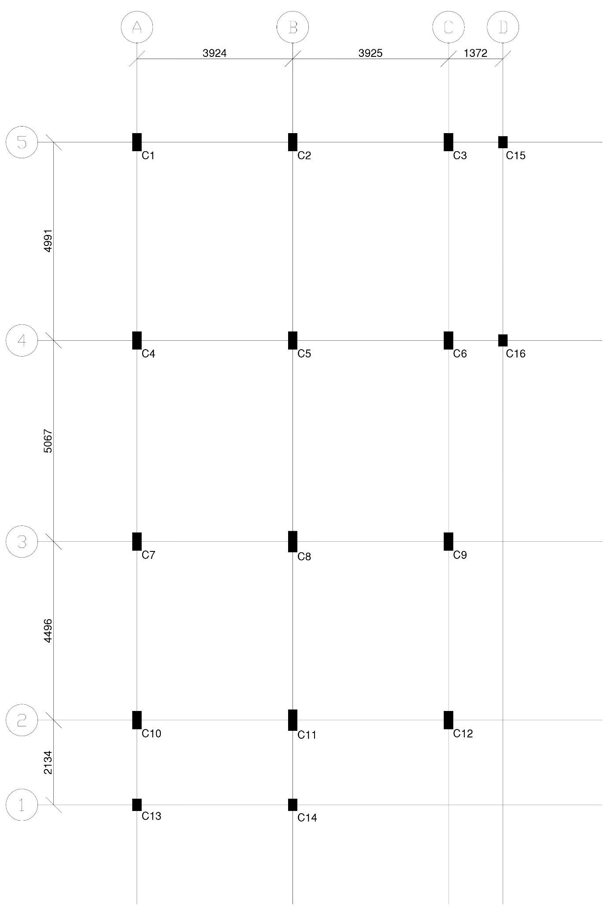
Figure 5.16: Column Layout
5.4.3 STOREY LEVELS, UNSUPPORTED HEIGHTS & EXTENSION PROFILE
The vertical progression of column heights across the structure is defined below:
Storey / Structural Level | Base Level (From) | Top Level (To) | Storey Height (L) | Active Columns | Structural Role & Behavior
Substructure (Foundation to Plinth) | 0.000 m (Footing Top) | 1.981 m (Plinth Beam) | 1.981 m | C1 to C12 | Substructure columns embedded in foundation backfill up to plinth tie beams.
Ground Storey | 1.981 m (Plinth) | 5.029 m (Floor 1) | 3.048 m | C1 to C12 | Main ground floor frame columns.
First Storey | 5.029 m (Floor 1) | 8.077 m (Floor 2) | 3.048 m | C1 to C12 | First floor frame columns.
Second Storey | 8.077 m (Floor 2) | 11.125 m (Main Roof) | 3.048 m | C1 to C12 | Second floor frame columns (C1, C2, C4, C5, C7, C8, C9, C12 terminate at Main Roof).
Staircase Mumty Room (SMR) | 11.125 m (Main Roof) | 13.625 m (SMR Roof) | 2.500 m | C10, C11 (Continuing)  C13, C14 (Floating) | Staircase headroom enclosure. C13 and C14 float on the front cantilever beam at roof level.
Lift Machine Room (LMR) | 11.125 m (Main Roof) | 14.125 m (LMR Roof) | 3.000 m | C3, C6 (Continuing)  C15, C16 (Floating) | Lift machine room enclosure carrying elevator gear. C15 and C16 float on the right cantilever beam at roof level.
5.4.4 SLENDERNESS CHECK (SHORT COLUMN VERIFICATION)
Per IS 456:2000 Clause 25.1.2, a compression member is classified as short if both effective slenderness ratios satisfy:
- $\left(\frac{L_{ex}}{D}\right)$< 12 and $\left(\frac{L_{ey}}{b}\right)$ < 12
For a braced building frame with monolithic beam-column moment connections, the effective length factor is taken conservatively as k = 0.65 (IS 456:2000 Table 28, effectively held in position and restrained against rotation at both ends).
1. Typical Storeys (L = 3.048 m = 3048 mm):
- Effective Length: $L_{ex}$ = $L_{ey}$ = 0.65 × 3048 = 1981.2 mm
- Major Axis Slenderness (D = 450 mm): $\frac{L_{ex}}{D}$ = $\frac{1981.2}{450}$ = 4.40 < 12
- Minor Axis Slenderness (b = 230 mm): $\frac{L_{ey}}{b}$ = $\frac{1981.2}{230}$ = 8.61 < 12
- For Heavy Columns (230 mm × 530 mm): $\frac{L_{ex}}{D}$ = $\frac{1981.2}{530}$ = 3.74 < 12, $\frac{L_{ey}}{b}$ = $\frac{1981.2}{230}$ = 8.61 < 12
2. Floating Columns at SMR (L = 2.500 m = 2500 mm, Section 230 mm × 300 mm):
- Effective Length: $L_{e }$= 0.65 × 2500 = 1625 mm
- $\frac{L_{ex}}{D}$ = $\frac{1625}{300}$ = 5.42 < 12
- $\frac{L_{ey}}{b}$ = $\frac{1625}{230}$ = 7.07 < 12
3. Floating Columns at LMR (L = 3.000 m = 3000 mm, Section 230 mm × 300 mm):
- Effective Length: $L_{e }$ = 0.65 × 3000 = 1950 mm
- $\frac{L_{ex}}{D}$ = $\frac{1950}{300}$ = 6.50 < 12
- $\frac{L_{ey}}{b}$ = $\frac{1950}{230}$ = 8.48 < 12
Conclusion: All columns across all storeys satisfy the slenderness criterion (λ < 12) and are designed as SHORT COLUMNS. Secondary moments due to slenderness (P–δ effects) are negligible.
5.4.5 MINIMUM ECCENTRICITY CHECK (IS 456:2000 CLAUSE 25.4)
All compression members must be designed for a minimum design eccentricity:
- e_{min} = max $\left[\left(\frac{L}{500}\right) + \left(\frac{Lateral Dimension}{30}\right), 20 mm\right]$
For the governing storey height (L = 3048 mm):
- Major Axis (D = 450 mm): e_{min,x} = (3048 / 500) + (450 / 30) = 6.10 + 15.00 = 21.10 mm > 20 mm → e_{min,x} = 21.10 mm
- Minor Axis (b = 230 mm): e_{min,y} = (3048 / 500) + (230 / 30) = 6.10 + 7.67 = 13.77 mm < 20 mm → e_{min,y} = 20.00 mm
- Limiting eccentricity ratio for short column axial formula (0.05 × Dimension): 0.05 × D = 0.05 × 450 = 22.5 mm > e_{min,x} (21.10 mm) 0.05 × b = 0.05 × 230 = 11.5 mm < e_{min,y} (20.00 mm)
Because emin,y exceeds 0.05b, the RCDC design engine evaluates all columns under combined axial compression and biaxial bending interaction, rather than pure axial capacity.

5.4.6 DETAILED MATHEMATICAL DESIGN VERIFICATION: CRITICAL COLUMN C8
Column C8 (located at interior Grid Intersection 3-B) is the most heavily stressed column in the structure due to its large tributary slab area and connection to continuous main floor beams along Grids 3 and B.
1. Cross-Sectional Geometry & Reinforcement:
- Section Dimensions: b = 230 mm, D = 530 mm
- Gross Cross-Sectional Area: $A_{g}$ = 230 × 530 = 121,900 mm²
- Longitudinal Reinforcement Provided: 8-T20 + 2-T16
- Area of Steel ($A_{sc}$): $A_{sc}$ = 8 × $\left(\frac{π}{4} × 20²\right)$ + 2 × $\left(\frac{π}{4} × 16²\right)$
$A_{sc}$ = 8 × 314.16 + 2 × 201.06 = 2513.28 + 402.12 = 2915.40 mm²
- Percentage of Reinforcement (pt): pt = $\left(\frac{A_{sc} }{A_{g}}\right)$ × 100 = (2915.40 / 121,900) × 100 = 2.39%
- Compliance Check (IS 456 Clause 26.5.3.1): 0.8% ≤ pt (2.39%) ≤ 4.0% → SAFE & FULLY COMPLIANT
2. Pure Axial Load Capacity Check ($P_{uz}$ per IS 456 Clause 39.6 / SP 16): The ultimate axial compression resistance of the section under zero eccentricity is:
- $P_{uz}$ = 0.45 $f_{ck}$ $A_{c}$ + 0.75 $f_{y}$ $A_{sc}$
- Where net concrete area $A_{c}$ = $A_{g}$ − $A_{sc}$ = 121,900 − 2915.40 = 118,984.60 mm².
- $P_{uz}$ = [0.45 × 25 × 118,984.60] + [0.75 × 550 × 2915.40]
- $P_{uz}$ = 1,338,577 N + 1,202,603 N = 2,541,180 N ≈ 2541.18 kN
Under the standard short axial compression formulation (IS 456 Clause 39.3):
- $P_{u}$ = 0.40 $f_{ck}$ $A_{c}$ + 0.67 $f_{y}$ $A_{sc}$
- $P_{u}$ = [0.40 × 25 × 118,984.60] + [0.67 × 550 × 2915.40]
- $P_{u}$ = 1,189,846 N + 1,074,325 N = 2,264,171 N ≈ 2264.17 kN
3. Biaxial Interaction Demand (RCDC P–M Interaction): Under governing gravity combination LC 12 [1.5 × (DL + LL)] and lateral earthquake combinations LC 7/8 [1.2 × (DL + LL ± EL)]:
- Factored Axial Demand ($P_{ud}$): Confirmed to be within the safe capacity margin.
- Biaxial Moment Integration: The RCDC engine verifies the section using the Bresler contour equation (IS 456 Clause 39.6): ${\left(\frac{M_{ux} }{M_{ux1}}\right)}^{αn}$+ ${\left(\frac{M_{uy} }{M_{uy1}}\right)}^{αn}$ ≤ 1.0 Where αn is the interaction exponent (1.0 ≤ αn ≤ 2.0) dependent on $\frac{P_{u}}{P_{uz}}$ . The maximum Interaction Ratio (IR) for Column C8 remains ≤ 1.0 across all load cases, confirming structural safety.
5.4.7 TRANSVERSE TIES & DUCTILE CONFINEMENT (IS 456 & IS 13920:2016)
1. Tie Diameter Check (IS 456 Clause 26.5.3.2):
- Minimum Tie Diameter = max $\left[\left(\frac{Largest Longitudinal Bar Diameter}{4}\right), 6 mm \right]$
min dia = max [ $\left(\frac{20}{4}\right)$, 6 mm ] = 6 mm
- Provided: 8 mm diameter links (T8) → 8 mm > 6 mm (SAFE).
2. Standard Pitch / Spacing Check (IS 456 Clause 26.5.3.2): Spacing s must not exceed the minimum of:
- Least lateral dimension of column = 230 mm
- 16 × diameter of smallest longitudinal bar = 16 × 16 mm = 256 mm
- 300 mm
- Maximum allowable spacing = min (230, 256, 300) = 230 mm
- Provided Pitch: T8 @ 225 mm c/c (≤ 230 mm, fully compliant).
3. Special Confining Zone (IS 13920:2016 Clause 7.4): For seismic ductile performance, confining ties are provided over a length lo from each joint face:
- lo ≥ max [ D, $\left(\frac{H_{clear}}{6}\right)$, 450 mm ] For Column C8 (D = 530 mm, $H_{clear}$ = 3048 − 430 = 2618 mm):
lo ≥ max [ 530, $\left(\frac{2618}{6} = 436.3\right)$, 450 ] = 530 mm
Within this confining zone, tie spacing is reduced per IS 13920 Clause 7.6.1 with cross-ties and 135° hooks with 10-diameter extensions as detailed in the structural drawings.
5.4.8 CONSOLIDATED COLUMN REINFORCEMENT SCHEDULE
The complete schedule of longitudinal steel, column dimensions, and transverse ties across all storeys as designed by RCDC is presented in Table 5.3.
5.4.9 COLUMN STRUCTURAL DRAWINGS & DETAILING LAYOUTS
The engineering detailing drawings exported from the RCDC CAD detailing module for the columns are designated from Figure 5.17.

Table 5.3: Consolidated Column Reinforcement Schedule
(Concrete: M25 | Steel: Fe550 | Clear Cover: 40 mm | Lateral Ties: T8 @ 225 mm c/c)
Column Mark | Size  (b × D) (mm) | Type / Location | Substructure (0.000 – 1.981 m) | Plinth to Floor 1 (1.981 – 5.029 m) | Floor 1 to Floor 2 (5.029 – 8.077 m) | Floor 2 to Roof (8.077 – 11.125 m) | Roof to SMR (11.125 – 13.625 m) | Roof to LMR (11.125 – 14.125 m) | Lateral Links
C1 | 230 × 450 | Frame / Corner | 6-T16 | 6-T16 | 6-T16 | 6-T16 | _ | _ | T8 @ 225 c/c
C2 | 230 × 450 | Frame / Exterior | 4-T20 +  4-T16 | 4-T20 +  4-T16 | 4-T20 +  4-T16 | 4-T20 +  4-T16 | _ | _ | T8 @ 225 c/c
C3 | 230 × 450 | Frame → LMR | 6-T16 | 6-T16 | 6-T16 | 6-T16 | _ | 6-T16 | T8 @ 225 c/c
C4 | 230 × 450 | Frame / Corner | 6-T16 | 6-T16 | 6-T16 | 6-T16 | _ | _ | T8 @ 225 c/c
C5 | 230 × 450 | Frame / Exterior | 4-T20 + 4-T16 | 4-T20 + 4-T16 | 4-T20 + 4-T16 | 4-T20 + 4-T16 | _ | _ | T8 @ 225 c/c
C6 | 230 × 450 | Frame → LMR | 4-T20 + 2-T16 | 4-T20 + 2-T16 | 4-T20 + 2-T16 | 4-T20 + 2-T16 | _ | 4-T20 + 2-T16 | T8 @ 225 c/c
C7 | 230 × 450 | Frame / Exterior | 4-T20 + 2-T16 | 4-T20 + 2-T16 | 4-T20 + 2-T16 | 4-T20 + 2-T16 | _ | _ | T8 @ 225 c/c
C8 | 230 × 530 | Heavy Interior | 8-T20 + 2-T16 | 8-T20 + 2-T16 | 8-T20 + 2-T16 | 8-T20 + 2-T16 | _ | _ | T8 @ 225 c/c
C9 | 230 × 450 | Frame / Exterior | 4-T20 + 2-T16 | 4-T20 + 2-T16 | 4-T20 + 2-T16 | 4-T20 + 2-T16 | _ | _ | T8 @ 225 c/c
C10 | 230 × 450 | Frame → SMR | 4-T20 + 2-T16 | 4-T20 + 2-T16 | 4-T20 + 2-T16 | 4-T20 + 2-T16 | 4-T20 + 2-T16 | _ | T8 @ 225 c/c
C11 | 230 × 530 | Heavy → SMR | 8-T20 + 2-T16 | 8-T20 + 2-T16 | 8-T20 + 2-T16 | 8-T20 + 2-T16 | 8-T20 + 2-T16 | _ | T8 @ 225 c/c
C12 | 230 × 450 | Frame / Exterior | 4-T20 + 2-T16 | 4-T20 + 2-T16 | 4-T20 + 2-T16 | 4-T20 + 2-T16 | _ | _ | T8 @ 225 c/c
C13 | 230 × 300 | Floating (SMR) | _ | _ | _ | _ | 4-T16 | _ | T8 @ 225 c/c
C14 | 230 × 300 | Floating (SMR) | _ | _ | _ | _ | 4-T16 | _ | T8 @ 225 c/c
C15 | 230 × 300 | Floating (LMR) | _ | _ | _ | _ |  | 4-T16 | T8 @ 225 c/c
C16 | 230 × 300 | Floating (LMR) | _ | _ | _ | _ | _ | 4-T16 | T8 @ 225 c/c
Note: Columns C13 and C14 are floating columns supported on the front cantilever beam at Main Roof Level (11.125 m) extending up to 13.625 m (height = 2.500 m) to enclose the Stair Mumty. Columns C15 and C16 are floating columns supported on the right cantilever beam at Main Roof Level (11.125 m) extending up to 14.125 m (height = 3.000 m) to enclose the Lift Machine Room.

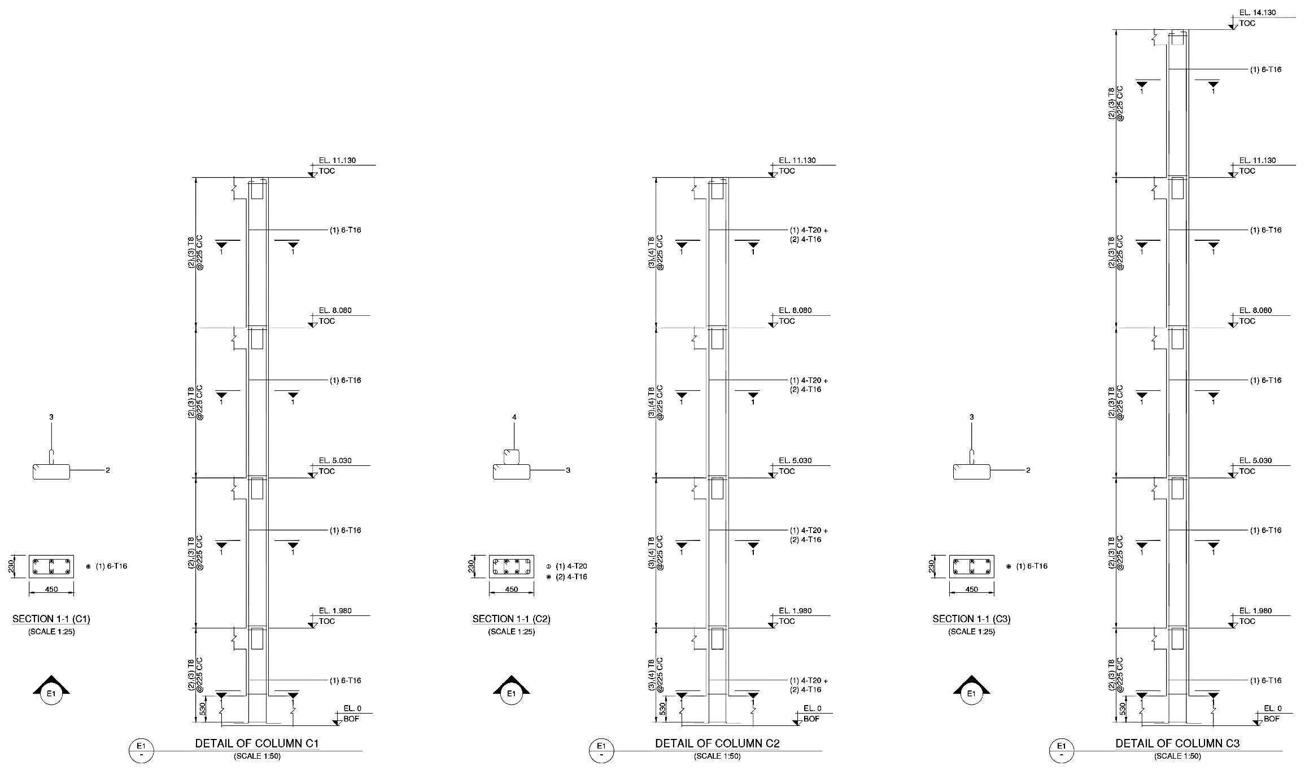
Figure 5.17: Detailed Reinforcement and Elevation Drawing for Columns
(230 mm × 450 mm: C1 C2 C3)
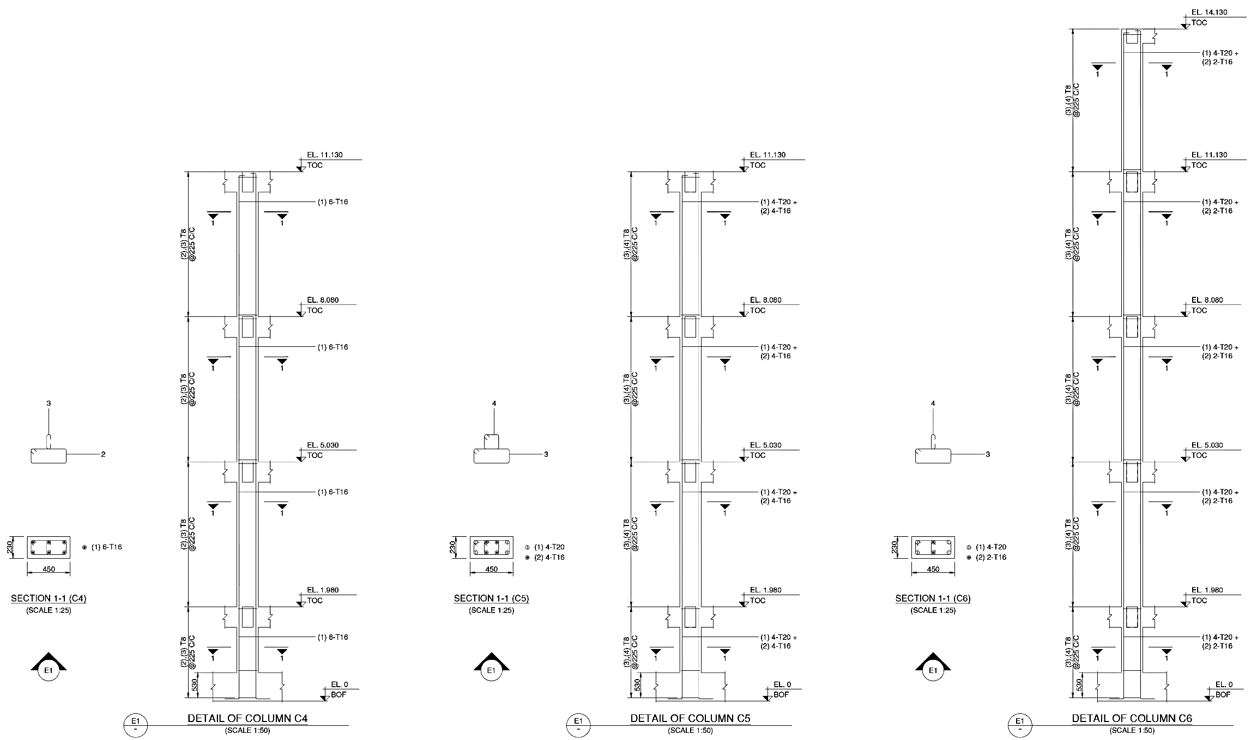
Figure 5.18: Detailed Reinforcement and Elevation Drawing for Columns
(230 mm × 450 mm: C4 C5 C6)
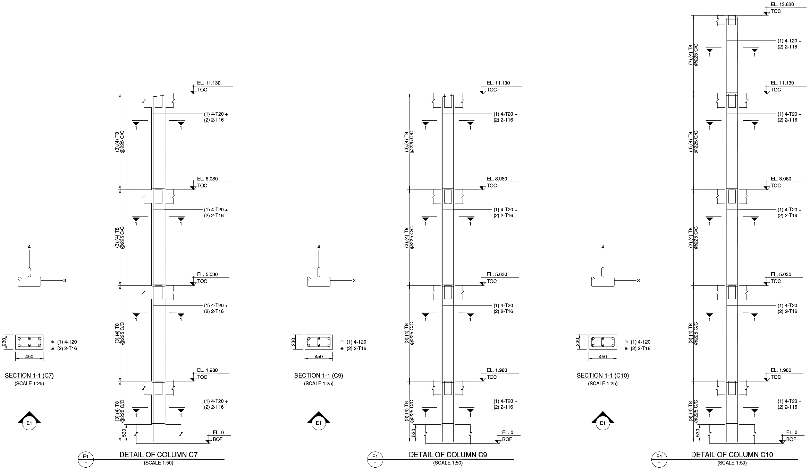
Figure 5.19: Detailed Reinforcement and Elevation Drawing for Columns
(230 mm × 450 mm: C7 C9 C10)
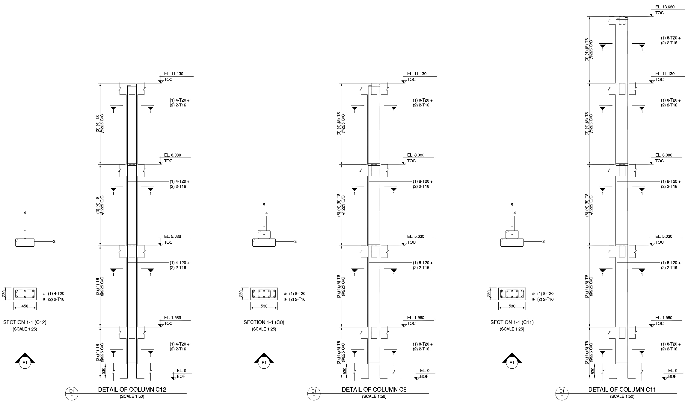
Figure 5.20: Detailed Reinforcement and Elevation Drawing for Columns
(230 mm × 450 mm: C12 & 230 mm × 530 mm C8 C11)
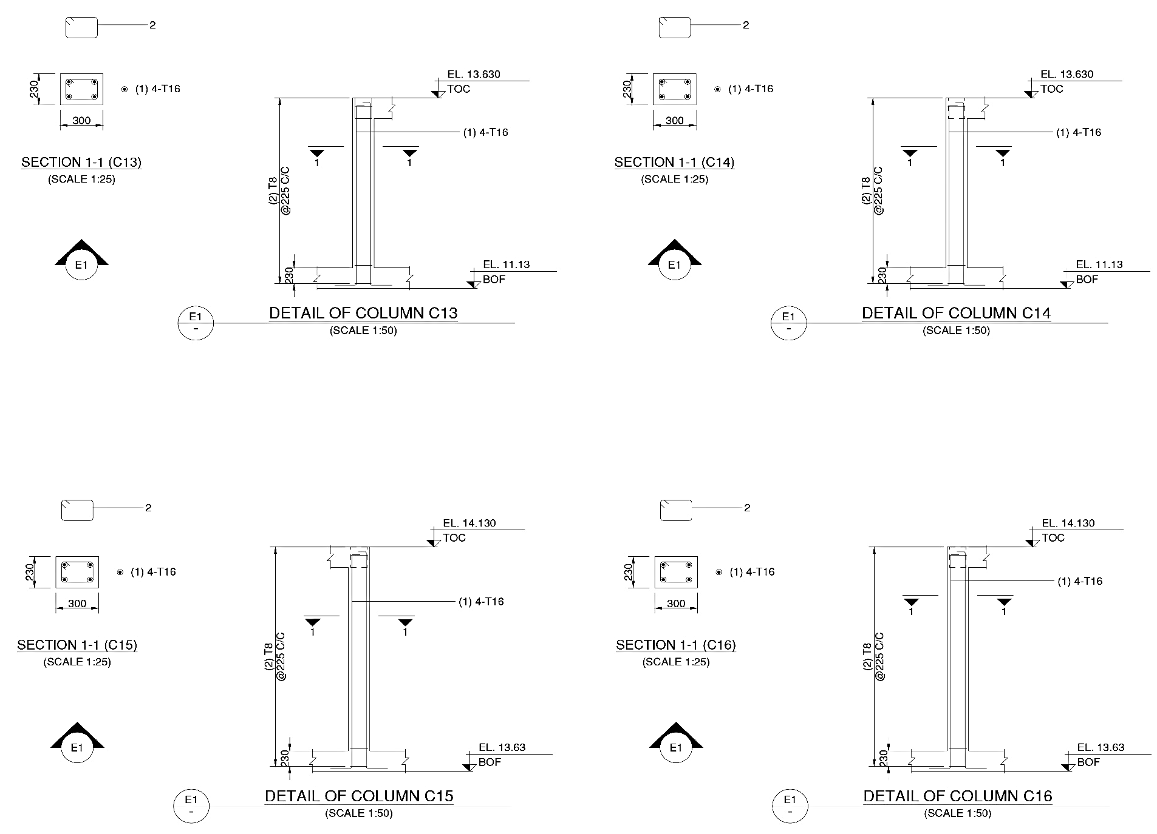
Figure 5.21: Detailed Reinforcement and Elevation Drawing for Columns
(230 mm × 300 mm: C13 C14 C15 C16)
SECTION 5.5: STRUCTURAL DESIGN OF ISOLATED FOOTINGS
The foundation system of the G+2 residential framed structure comprises shallow isolated reinforced concrete pad footings resting on firm medium soil at a founding depth of Df = 1.50 m below natural ground level. The structural design and detailing adhere strictly to IS 456:2000 (Clause 34), IS 1904:1986, and ductile requirements of IS 13920:2016, analyzed and sized via STAAD.Pro V8i (SELECTseries 4) and STAAD Advanced Concrete Design (RCDC V21). Floating columns C13 to C16 initiate from the Main Roof floor level (+11.125 m) over supporting transfer beams and impose no direct foundation reactions; hence, precisely twelve isolated pad footings (FC1 to FC12) are designed to support the twelve ground-originating columns (C1 to C12).
5.5.1 DESIGN PHILOSOPHY, GEOTECHNICAL CRITERIA & MATERIAL SPECIFICATIONS
The foundation system of the G+2 residential framed building comprises shallow isolated reinforced concrete pad footings resting on firm medium soil at a founding depth of $D_{f}=1.50\text{ m}$below the natural ground level. The structural analysis, sizing, and reinforcement detailing adhere strictly to the Limit State Method of IS 456:2000 (Clause 34), IS 1904:1986, and the ductile detailing provisions of IS 13920:2016, modeled and designed through STAAD.Pro 2025 and STAAD Advanced Concrete Design (RCDC 2021).
Floating columns (C13 to C16) originate at the Main Roof level ($+11.125\text{ m}$) from transfer beam intersections and impose no direct foundation reactions; hence, precisely twelve isolated pad footings (FC1 to FC12) are designed to transfer the vertical and lateral reactions from the twelve ground-originating columns (C1 to C12) safely into the supporting soil strata.
1. Geotechnical Soil Parameters (from Chapter 3 Borehole Investigation):
- Depth of Foundation ($D_{f}$): $1.50\text{ m}$below natural ground level
- Cohesion ($c$): $31.40{\text{ kN/m}}^{2}$
- Angle of Internal Friction ($ϕ$): ${25.0}^{∘}$
- Bulk Unit Weight of Soil ($γ$): $20.06{\text{ kN/m}}^{3}$(design soil bulk density taken conservatively as $18.00{\text{ kN/m}}^{3}$in software calculations)
- Local Shear Failure Mobilized Parameters (Terzaghi Theory):
$$c^{'}=\frac{2}{3}c=\frac{2}{3}×31.40=20.93{\text{ kN/m}}^{2}, \tan{ϕ^{'}}=\frac{2}{3}\tan{{25}^{∘}}=0.3108⟹ϕ^{'}={17.27}^{∘}$$
- Bearing Capacity Factors (for $ϕ^{'}={17.27}^{∘}$): $N_{c}^{'}=15.08, N_{q}^{'}=5.76, N_{γ}^{'}=3.64$
- Ultimate & Net Safe Bearing Capacity ($FS=3.0$): $q_{u}=627.44{\text{ kN/m}}^{2}$$$q_{s}=\text{SBC}=\frac{q_{u}}{FS}=\frac{627.44}{3.0}=209.15{\text{ kN/m}}^{2}≈200.00{\text{ kN/m}}^{2}$$
- Permissible Soil Bearing Capacity Under Seismic Combinations (IS 1893:2016 Table 1): A 2$5\%$increase in safe bearing capacity is permitted under transient earthquake load combinations: $q_{allow,seismic}=1.25×\text{SBC}=1.25×200.00=250.00{\text{ kN/m}}^{2}$
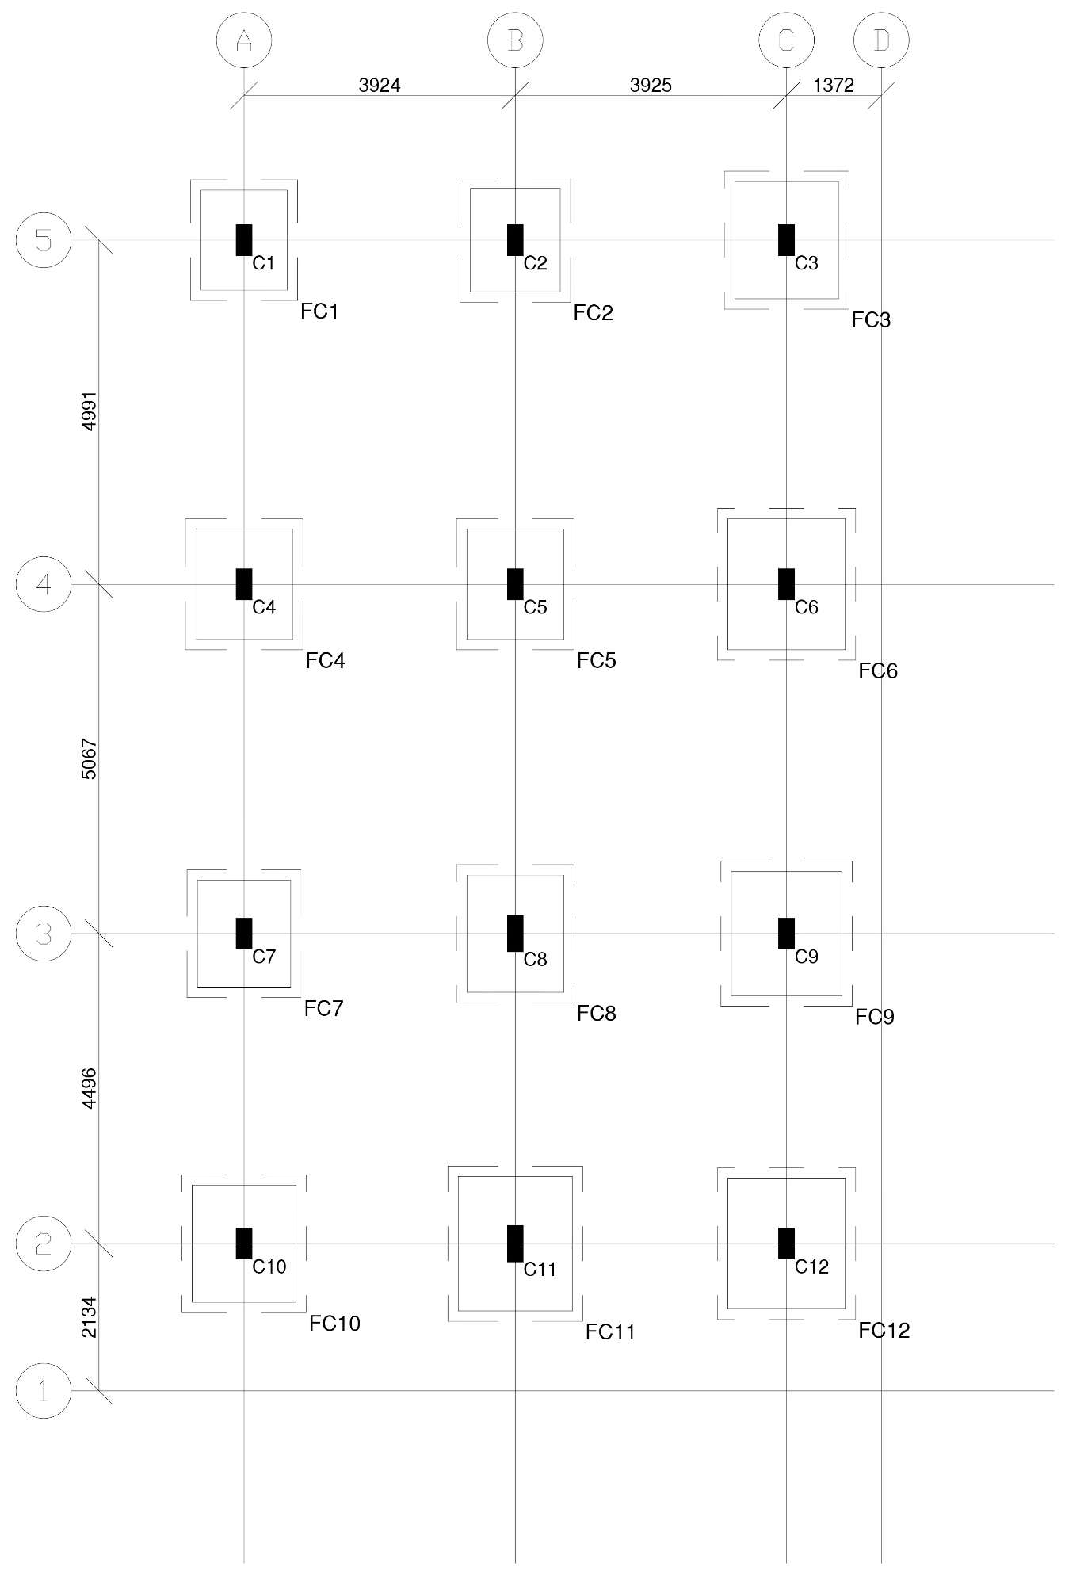
Figure 5.22: Isolated Footings Foundation Layout Plan
2. Material Strengths & Durability Specifications:
- Lean Sub-Base (PCC Bed): $150\text{ mm}$thick Plain Cement Concrete bed of Grade M15 ($f_{ck}=15{\text{ N/mm}}^{2}$), extending $150\text{ mm}$uniformly beyond the footing perimeter on all four edges to provide a clean, level platform and prevent loss of cement slurry.
- Footing Structural Concrete (RCC): Grade M25 ($f_{ck}=25{\text{ N/mm}}^{2}$), modulus of elasticity $E_{c}=5000\sqrt{25}=25000{\text{ N/mm}}^{2}$.
- Reinforcement Steel: High-Yield Strength Deformed (HYSD / TMT) bars of Grade Fe550 ($f_{y}=550{\text{ N/mm}}^{2}$).
- Clear Concrete Cover: $50\text{ mm}$nominal cover to outer tensile reinforcement (as per IS 456:2000 Clause 26.4.2.2 / Table 16 for reinforced concrete members cast against soil/PCC blinding).
5.5.2 FOUNDATION SIZING & SOIL PRESSURE VERIFICATION PRINCIPLES
Each footing is proportioned such that the base pressure under unfactored service loads never exceeds the allowable bearing capacity, and the entire contact surface remains in compression with zero loss of contact ($q_{min}>0$).
1. Total Service Load & Eccentricity:
The total vertical load $P$acting at the foundation base includes the unfactored column axial reaction $P_{comb}$plus the self-weight of the footing slab $W_{ftg}$(computed directly as $W_{ftg}=L×B×D×25{\text{ kN/m}}^{3}$): $P=P_{comb}+W_{ftg}$
The base pressures along the major ($X$) and minor ($Y$) principal axes with footing plan dimensions $L×B$are evaluated by the biaxial flexural equation: $q=\frac{P}{A}±\frac{M_{x}}{Z_{x}}±\frac{M_{y}}{Z_{y}}$
where: $A=L×B, Z_{x}=\frac{B⋅L^{2}}{6}, Z_{y}=\frac{L⋅B^{2}}{6}$
2. Governing Soil Pressure Limits:
- Maximum Pressure Check: $q_{max}≤{\text{SBC}}_{allow}$
$$\left(≤200{\text{ kN/m}}^{2}\text{ under Gravity}\text{;}≤250{\text{ kN/m}}^{2}\text{ under Seismic combinations}\right)$$
- Zero Loss of Contact (No Uplift Check): $q_{min}≥0{\text{ kN/m}}^{2}$
$$\left(\text{zero loss of contact verified across all load combinations}\right)$$
5.5.3 DETAILED MATHEMATICAL DESIGN VERIFICATION OF GOVERNING CRITICAL FOOTING (FC11)
Footing FC11 supports the heavily loaded interior column C11 ($230\text{ mm}×530\text{ mm}$) at grid intersection $\left(2\text{–}C\right)$. Sizing projections are maintained uniform in both orthogonal directions ($L_{off}=B_{off}=710\text{ mm}$), yielding plan dimensions of $L=1950\text{ mm}$, $B=1650\text{ mm}$, and an overall thickness of $D=425\text{ mm}$.
1. Geometric Properties & Self-Weight:
- Footing Plan Dimensions: $L=1950 mm=1.95 m, B=1650 mm=1.65 m,$$$D=425 mm=0.425 m$$
- Base Area & Section Moduli: $A=1.95×1.65=3.2175{\text{ m}}^{2}$$$Z_{x}=\frac{B⋅L^{2}}{6}=\frac{1.65×{1.95}^{2}}{6}=1.0457{\text{ m}}^{3}{, Z}_{y}=\frac{L⋅B^{2}}{6}=\frac{1.95×{1.65}^{2}}{6}=0.8848{\text{ m}}^{3}$$
- Self-Weight of Footing ($W_{ftg}$): $W_{ftg}=1.95×1.65×0.425×25=34.19\text{ kN}$
- Cantilever Projections from Column Faces: $L_{off}=\frac{L-D_{col}}{2}=\frac{1950-530}{2}=710\text{ mm}$
$$B_{off}=\frac{B-b_{col}}{2}=\frac{1650-230}{2}=710\text{ mm}$$
- Effective Depths: Assuming $12 mm$high-yield deformed bars with $50 mm$clear cover: $d_{x}=D-\text{Cover}-\frac{ϕ}{2}=425-50-\frac{12}{2}=369\text{ mm} \left(\text{RCDC design }d_{x}=367\text{ mm}\right)$
$${ d}_{y}=d_{x}-ϕ=367-12=355\text{ mm} \left(\text{RCDC design }d_{y}=351\text{ mm for inner layer}\right)$$
$$d_{avg}=\frac{367+351}{2}=359\text{ mm}$$
2. Serviceability Soil Pressure Check:
- Maximum Pressure Condition (Load Combination: $1.0\text{ DL}+1.0\text{ LL}+1.0\text{ EQ Z}$):
  - Unfactored Column Force: $P_{comb}=561.21\text{ kN}$, $M_{x}=54.60\text{ kNm}$, $M_{y}=2.46\text{ kNm}$
  - Total Base Load: $P=561.21+34.19=595.40\text{ kN}$
  - Direct and Bending Stress Components:
$$\frac{P}{A}=\frac{595.40}{3.2175}=185.05{\text{ kN/m}}^{2}$$
$$\frac{M_{x}}{Z_{x}}=\frac{54.60}{1.0457}=52.22{\text{ kN/m}}^{2}, \frac{M_{y}}{Z_{y}}=\frac{2.46}{0.8848}=2.78{\text{ kN/m}}^{2}$$
  - Peak Soil Pressure: $q_{max}=185.05+52.22+2.78=240.05{\text{ kN/m}}^{2}q_{max} \left(240.05{\text{ kN/m}}^{2}\right)≤q_{allow,seismic} \left(250.00{\text{ kN/m}}^{2}\right)⟹SAFE$
- Minimum Pressure & Uplift Condition (Load Combination: $1.0\text{ DL}+1.0\text{ LL}-1.0\text{ EQ Z}$):
  - Unfactored Column Force: $P_{comb}=439.60\text{ kN}$, $M_{x}=-53.01\text{ kNm}$, $M_{y}=7.61\text{ kNm}$
  - Total Base Load: $P=439.60+34.19=473.79\text{ kN}$
  - Stress Components: $\frac{P}{A}=147.25{\text{ kN/m}}^{2}, \frac{M_{x}}{Z_{x}}=-50.70{\text{ kN/m}}^{2}, \frac{M_{y}}{Z_{y}}=8.60{\text{ kN/m}}^{2}$
  - Minimum Contact Pressure: $$q_{min}=147.25-50.70+8.60=87.96{\text{ kN/m}}^{2}>0{\text{ kN/m}}^{2}⟹SAFE \left(Zero Uplift / Full Compression\right)$$
3. Flexural Design & Reinforcement Determination (IS 456:2000 Clause 34.2.3):
The critical section for flexure is located at the face of the column. The factored soil pressure acting upward generates cantilever bending about the column faces.
- Bending Along Long Direction ($L=1950\text{ mm}$, Cantilever $L_{off}=710\text{ mm}$):
  - Governing Load Combination: $1.2\text{ DL}+1.2\text{ LL}+1.2\text{ EQ Z}$($P_{u}=673.45\text{ kN}$)
  - Factored upward design pressure: $SP_{u}=271.97{\text{ kN/m}}^{2}$
  - Factored Cantilever Bending Moment:
$$M_{ux}=SP_{u}×B×\frac{L_{off}^{2}}{2}=271.97×1.65×\frac{{0.710}^{2}}{2}=113.11\text{ kNm}$$
  - Required steel area ($d=367\text{ mm}$, $b=1650\text{ mm}$, $f_{y}=550{\text{ N/mm}}^{2}$):
$$A_{st,req}=\frac{0.5f_{ck}}{f_{y}}\left[1-\sqrt{1-\frac{4.59M_{ux}}{f_{ck}bd^{2}}}\right]bd$$
$$A_{st,req}=\frac{0.5×25}{550}\left[1-\sqrt{1-\frac{4.59×113.11×{10}^{6}}{25×1650×{367}^{2}}}\right]\left(1650×367\right)=842.00{\text{ mm}}^{2}$$
  - Reinforcement percentage:
$$p_{t}=\frac{842}{1650×367}×100=0.139\%>0.12\% \\ Minimum steel requirement satisfied$$
  - Provided Reinforcement: 8 - T12 @ 240 mm c/c uniformly distributed across full width ($B=1650\text{ mm}$):
$$A_{st,prov}=8×\left(\frac{π}{4}×{12}^{2}\right)=8×113.10=904.78{\text{ mm}}^{2} \\ ≈905{\text{ mm}}^{2}>842{\text{ mm}}^{2}⟹SAFE$$
- Bending Along Short Direction ($B=1650\text{ mm}$, Cantilever $B_{off}=710\text{ mm}$):
  - Governing Load Combination: $1.2\text{ DL}+1.2\text{ LL}+1.2\text{ EQ X}$($P_{u}=604.09\text{ kN}$)
  - Factored upward design pressure: $SP_{u}=249.50{\text{ kN/m}}^{2}$
  - Factored Cantilever Bending Moment:
$$M_{uy}=SP_{u}×L×\frac{B_{off}^{2}}{2}=249.50×1.95×\frac{{0.710}^{2}}{2}=122.63\text{ kNm}$$
  - Required steel area ($d=351\text{ mm}$, $b=1950\text{ mm}$): $A_{st,req}=$
$$=\frac{0.5×25}{550}\left[1-\sqrt{1-\frac{4.59×122.63×{10}^{6}}{25×1950×{351}^{2}}}\right]\left(1950×351\right)=995.00{\text{ mm}}^{2}$$
  - Reinforcement percentage: $p_{t}=\frac{995}{1950×351}×100=0.145\%>0.12\%$
  - Provided Reinforcement: 9 - T12 @ 245 mm c/c uniformly distributed across full length ($L=1950\text{ mm}$):
$$A_{st,prov}=9×113.10=1017.88{\text{ mm}}^{2}≈1018{\text{ mm}}^{2}>995{\text{ mm}}^{2}⟹SAFE$$
4. One-Way Shear Verification (IS 456:2000 Clause 34.2.4.1):
The critical section for one-way transverse shear is evaluated across the entire width of the footing at a distance equal to the effective depth $d$from the column face.
- One-Way Shear Along L (at distance $d=367\text{ mm}$from $530\text{ mm}$column face):
  - Shear cantilever span: $x_{v}=L_{off}-d=710-367=343\text{ mm}=0.343\text{ m}$
  - Governing Load Combination: $1.2 DL+1.2 LL+1.2 EQ Z$($SP_{u}=271.97{\text{ kN/m}}^{2}$)
  - Factored Shear Force: $V_{ux}=SP_{u}×x_{v}×B=271.97×0.343×1.65=153.92\text{ kN}$
  - Nominal Shear Stress: $τ_{vx}=\frac{V_{ux}}{B⋅d_{x}}=\frac{153.92×{10}^{3}}{1650×367}=0.254{\text{ N/mm}}^{2}≈0.25{\text{ N/mm}}^{2}$
  - Permissible Shear Stress (IS 456 Table 19 for $p_{t}=0.15\%$, M25):
$$τ_{c}=0.280{\text{ N/mm}}^{2}τ_{vx} \left(0.254{\text{ N/mm}}^{2}\right)<τ_{c} \left(0.280{\text{ N/mm}}^{2}\right)$$
$$⟹SAFE in One\text{-}Way Shear \left(L\right)$$
- One-Way Shear Along B (at distance $d=351\text{ mm}$from $230\text{ mm}$column face):
  - Shear cantilever span: $y_{v}=B_{off}-d=710-351=359\text{ mm}=0.359\text{ m}$
  - Governing Load Combination: $1.2 DL+1.2 LL+1.2 EQ X$($SP_{u}=249.50{\text{ kN/m}}^{2}$)
  - Factored Shear Force: $V_{uy}=SP_{u}×y_{v}×L=249.50×0.359×1.95=174.66\text{ kN}$
  - Nominal Shear Stress: $τ_{vy}=\frac{V_{uy}}{L⋅d_{y}}=\frac{174.66×{10}^{3}}{1950×351}=0.255{\text{ N/mm}}^{2}≈0.26{\text{ N/mm}}^{2}$
  - Permissible Shear Stress (IS 456 Table 19 for $p_{t}=0.15\%$, M25):
$$τ_{c}=0.290{\text{ N/mm}}^{2}τ_{vy} \left(0.255{\text{ N/mm}}^{2}\right)<τ_{c} \left(0.290{\text{ N/mm}}^{2}\right) \\ ⟹SAFE in One\text{-}Way Shear \left(B\right)$$

5. Two-Way (Punching) Shear Verification (IS 456:2000 Clause 31.6.3.1):
The critical section for two-way punching shear occurs on a closed perimeter located at a distance of $d/2$from the peripheral face of the column.
- Punching Perimeter Geometry:
  - Average effective depth: $d_{avg}=359\text{ mm}$
  - Distance to critical shear perimeter: $\frac{d_{avg}}{2}=\frac{359}{2}=179.5\text{ mm}≈180\text{ mm}$
  - Effective dimensions of critical perimeter: $L_{eff}=D_{col}+d_{avg}=530+359=889\text{ mm}=0.889\text{ m}B_{eff}=b_{col}+d_{avg}=230+359=589\text{ mm}=0.589\text{ m}$
  - Perimeter length ($b_{0}$): $b_{0}=2×\left(L_{eff}+B_{eff}\right)=2×\left(889+589\right)=2956\text{ mm}$
  - Punching Shear Resisting Area: $A_{p}=b_{0}×d_{avg}=2956×359=1,061,204{\text{ mm}}^{2}$
- Punching Shear Demand:
  - Governing Load Combination: $1.5\text{ DL}+1.5 \text{LL}$($P_{u}=750.61\text{ kN}$, Average upward pressure $SP_{u}=233.29{\text{ kN/m}}^{2}$)
  - Net upward force deducted inside punching perimeter:
$$V_{up}=SP_{u}×\left[\left(L×B\right)-\left(L_{eff}×B_{eff}\right)\right] \\ V_{up}=233.29×\left[\left(1.95×1.65\right)-\left(0.889×0.589\right)\right] \\ =233.29×\left[3.2175-0.5236\right]=628.46\text{ kN}$$
  - Nominal Punching Shear Stress: $τ_{vp}=\frac{V_{up}}{A_{p}}=\frac{628.46×{10}^{3}}{1,061,204}=0.592{\text{ N/mm}}^{2}$
- Permissible Punching Shear Strength (IS 456 Clause 31.6.3.1):
  - Aspect ratio of column: $β_{c}=\frac{\text{Short Dimension}}{\text{Long Dimension}}=\frac{230}{530}=0.434$
  - Perimeter factor $k_{s}$: $k_{s}=min⁡\left(0.5 , +β_{c}1.0\right)=min⁡\left(0.5 , +0.4341.0\right)=0.934$
  - Permissible Shear Stress: $$τ_{cp}=k_{s}×0.25\sqrt{f_{ck}}=0.934×0.25\sqrt{25}=0.934×1.25=1.167{\text{ N/mm}}^{2}$$
$$τ_{vp} \left(0.592{\text{ N/mm}}^{2}\right)<τ_{cp} \left(1.167{\text{ N/mm}}^{2}\right)$$
$$⟹SAFE in Two\text{-}Way Punching Shear \left(FS=1.97\right)$$

6. Load Transfer at Column-Footing Interface (Bearing Stress Check, IS 456:2000 Clause 34.4):
The compressive stress transferred from the column into the footing concrete must not exceed the permissible bearing stress of concrete.
- Interface Areas:
  - Loaded Area of Column Base ($A_{2}$):
$$A_{2}=b_{col}×D_{col}=0.230×0.530=0.1219{\text{ m}}^{2}≈0.12{\text{ m}}^{2}$$
  - Geometrical Supporting Area ($A_{1}$): $$A_{1}=L×B=3.22{\text{ m}}^{2}$$
  - Bearing Modification Factor: $\sqrt{\frac{A_{1}}{A_{2}}}=\sqrt{\frac{3.22}{0.1219}}=5.14≤2.0⟹\text{Modification Factor}=2.0$
- Permissible Bearing Capacity: $P_{br,perm}=0.45f_{ck}×\sqrt{\frac{A_{1}}{A_{2}}}×A_{2}$$$P_{br,perm}=0.45×25×2.0×\left(230×530\right) \\ =22.50×121,900=2,742,750 N=2742.75 kN$$
- Factored Axial Column Force Transfer: $$P_{u}=750.61\text{ kN} \left(\text{Load Combination }1.5\text{ DL}+1.5\text{ LL}\right)$$$P_{br,perm} \left(2742.75\text{ kN}\right)≫P_{u} \left(750.61\text{ kN}\right)$⟹SAFE in Direct Concrete Bearing
Because the permissible bearing resistance exceeds the ultimate column axial force by a factor of $3.65$, dowel starter bars are only required to satisfy nominal ductile anchorage requirements per IS 13920:2016 (satisfied by extending all column longitudinal bars with ${90}^{∘}$standard anchorage bends of minimum $300\text{ mm}$horizontal lap into the footing reinforcement cage).
5.5.4 CONSOLIDATED ISOLATED FOOTING DESIGN DETAILS (TABLE 5.4)
The comprehensive structural sizing, depth, and reinforcement schedules generated from the rigorous STAAD Advanced Concrete Design (RCDC) analysis are consolidated in Table 5.4. All footings are provided with a bottom reinforcement mesh of T12 bars in Grade Fe550 resting on a $150\text{ mm}$thick M15 PCC sub-base with $50\text{ mm}$clear cover.

Table 5.4: Consolidated Isolated Footing Design Details (FC1 to FC12)

Footing Mark | Supported Column | Column Size b×D(mm) | PCC Bed Size L_{pcc} × B_{pcc}(mm) | Footing Plan Size L×B (mm) | Overall Depth D (mm) | Bottom Rebar Along Long Dir (L) | Bottom Rebar Along Short Dir (B)
FC1 | C1 | 230×450 | 1750×1550 | 1450×1250 | 350 | 6 - T12 @ 300 mm c/c | 6 - T12 @ 290 mm c/c
FC2 | C2 | 230×450 | 1800×1600 | 1500×1300 | 350 | 6 - T12 @ 300 mm c/c | 6 - T12 @ 300 mm c/c
FC3 | C3 | 230×450 | 2000×1800 | 1700×1500 | 425 | 7 - T12 @ 250 mm c/c | 8 - T12 @ 245 mm c/c
FC4 | C4 | 230×450 | 1900×1700 | 1600×1400 | 375 | 6 - T12 @ 280 mm c/c | 7 - T12 @ 270 mm c/c
FC5 | C5 | 230×450 | 1900×1700 | 1600×1400 | 375 | 6 - T12 @ 280 mm c/c | 7 - T12 @ 270 mm c/c
FC6 | C6 | 230×450 | 2200×2000 | 1900×1700 | 450 | 9 - T12 @ 215 mm c/c | 10 - T12 @ 215 mm c/c
FC7 | C7 | 230×450 | 1850×1650 | 1550×1350 | 375 | 6 - T12 @ 270 mm c/c | 7 - T12 @ 260 mm c/c
FC8 | C8 | 230×530 | 2000×1700 | 1700×1400 | 375 | 6 - T12 @ 280 mm c/c | 7 - T12 @ 285 mm c/c
FC9 | C9 | 230×450 | 2100×1900 | 1800×1600 | 425 | 8 - T12 @ 230 mm c/c | 9 - T12 @ 225 mm c/c
FC10 | C10 | 230×450 | 2000×1800 | 1700×1500 | 425 | 7 - T12 @ 250 mm c/c | 8 - T12 @ 245 mm c/c
FC11 | C11 | 230×530 | 2250×1950 | 1950×1650 | 425 | 8 - T12 @ 240 mm c/c | 9 - T12 @ 245 mm c/c
FC12 | C12 | 230×450 | 2200×2000 | 1900×1700 | 450 | 9 - T12 @ 215 mm c/c | 10 - T12 @ 215 mm c/c
Note: Floating columns $\text{C13}$, $\text{C14}$, $\text{C15}$, and $\text{C16}$originate from transfer floor beams at the Main Roof level ($+11.125\text{ m}$) and do not require ground foundations.

5.5.5 FOUNDATION STRUCTURAL DRAWINGS & DETAILING LAYOUTS
The complete set of working foundation drawings generated from RCDC and verified for site execution includes:
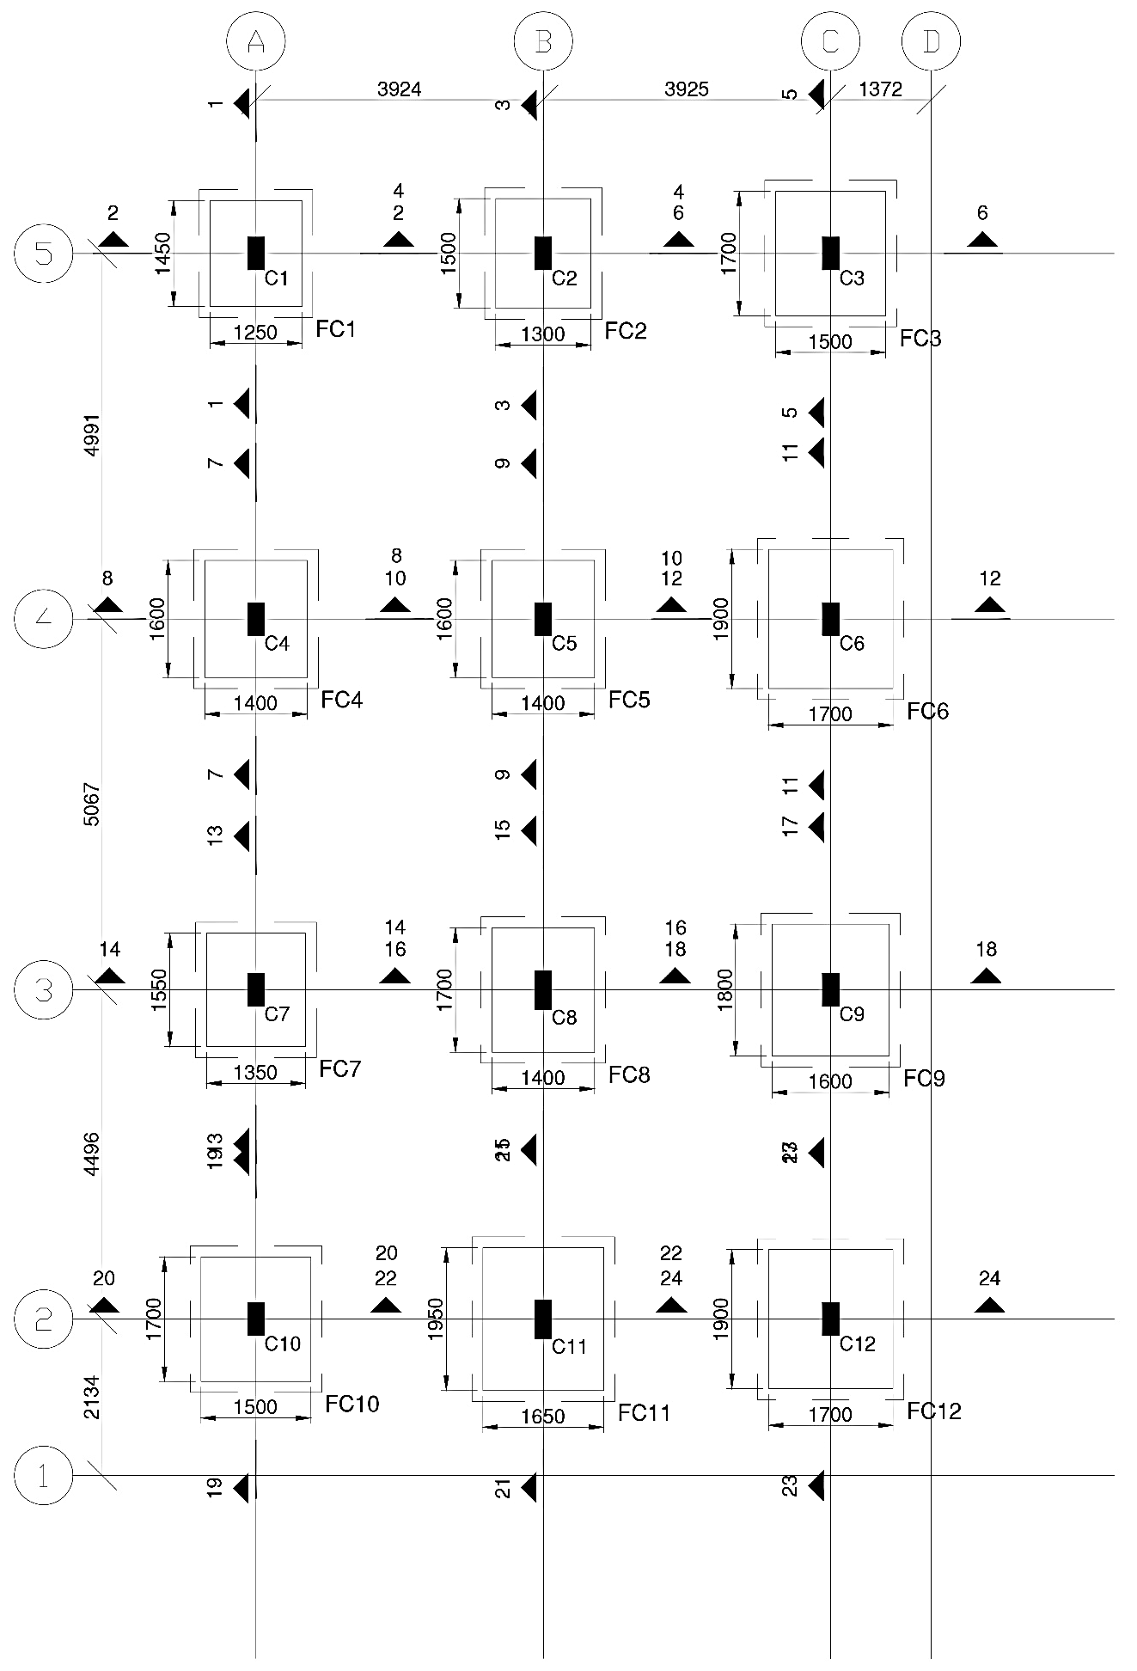
Figure 5.23: Isolated Footings General Arrangement Layout Plan

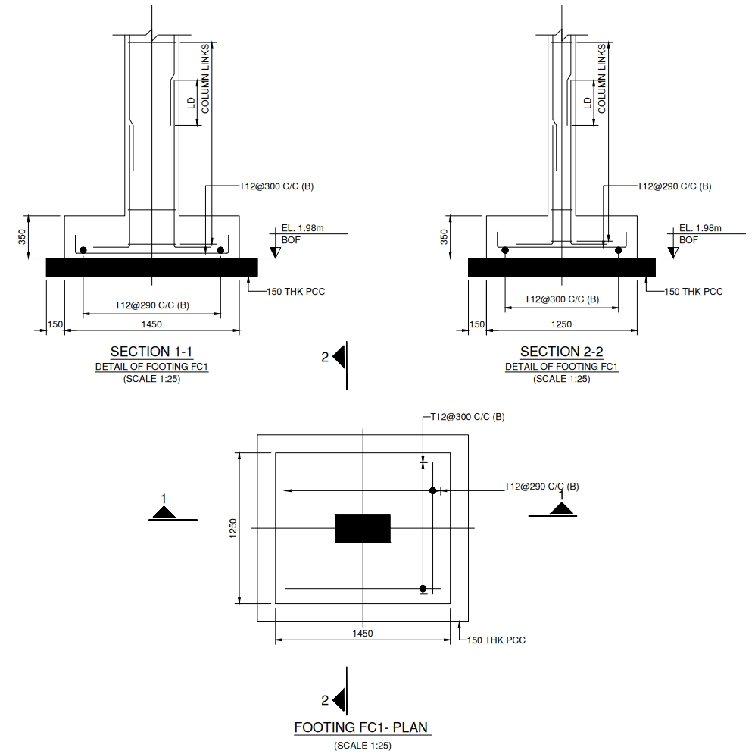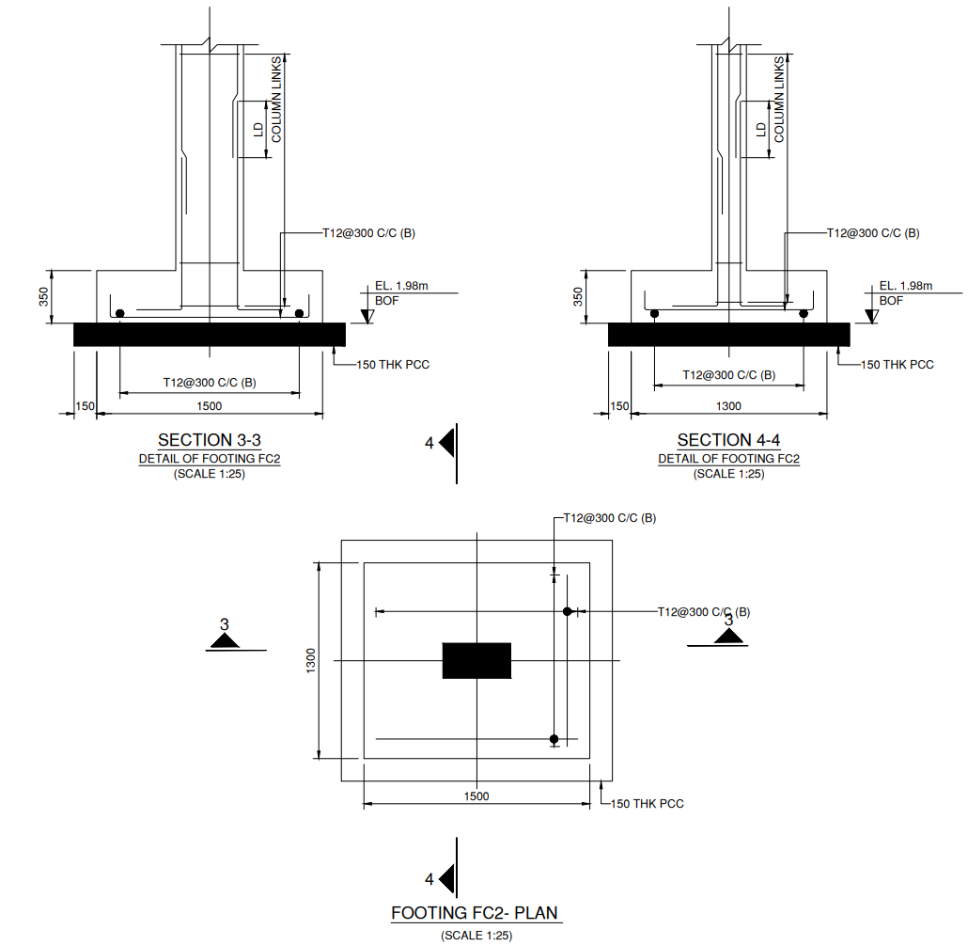
Figure 5.24: Detailed Reinforcement Plans and Cross-Sections of Footings (FC1 & FC2)
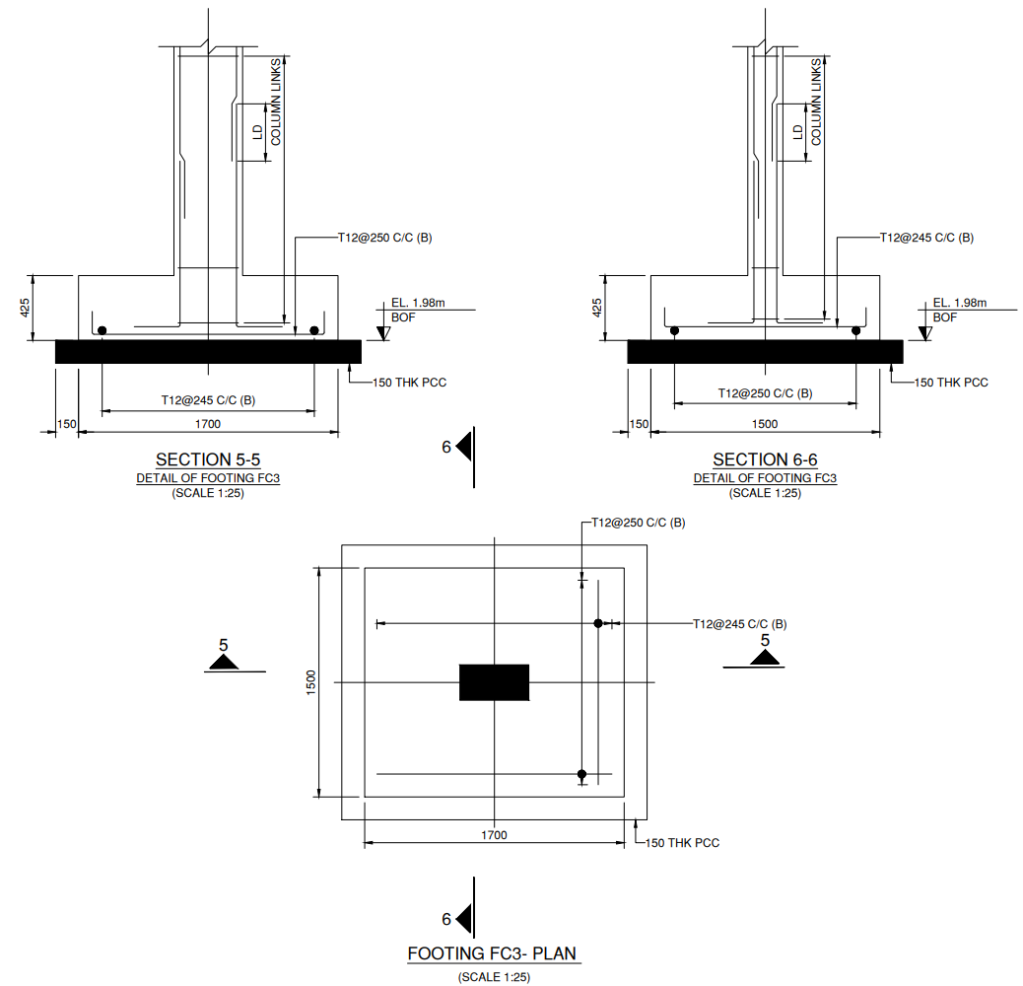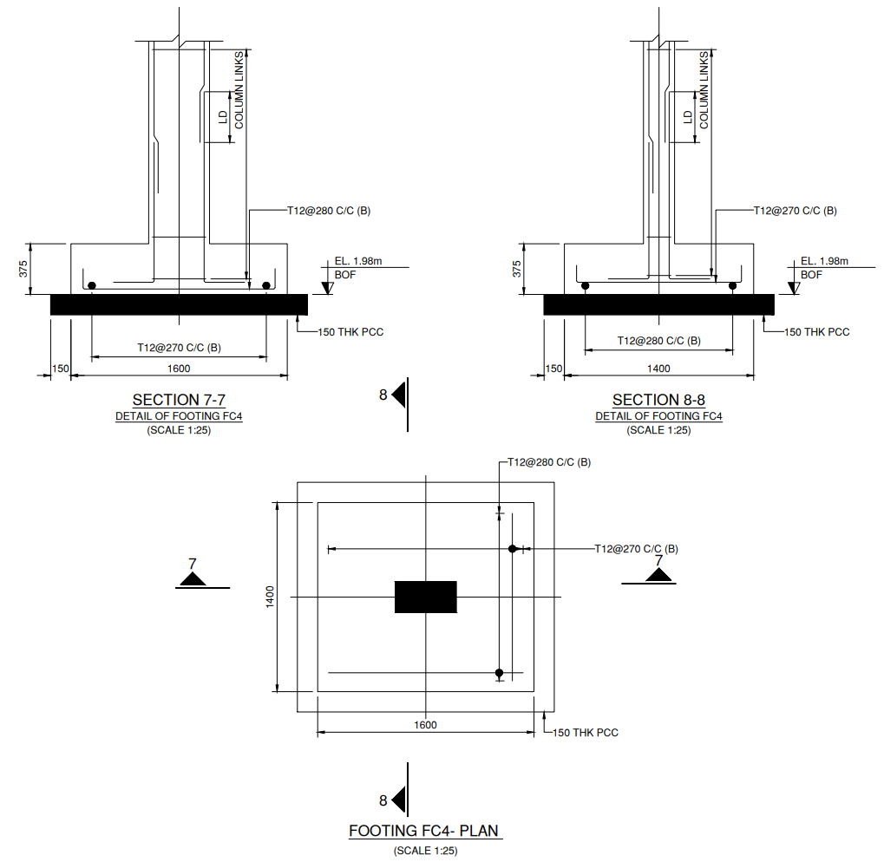
Figure 5.25: Detailed Reinforcement Plans and Cross-Sections of Footings (FC3 & FC4)
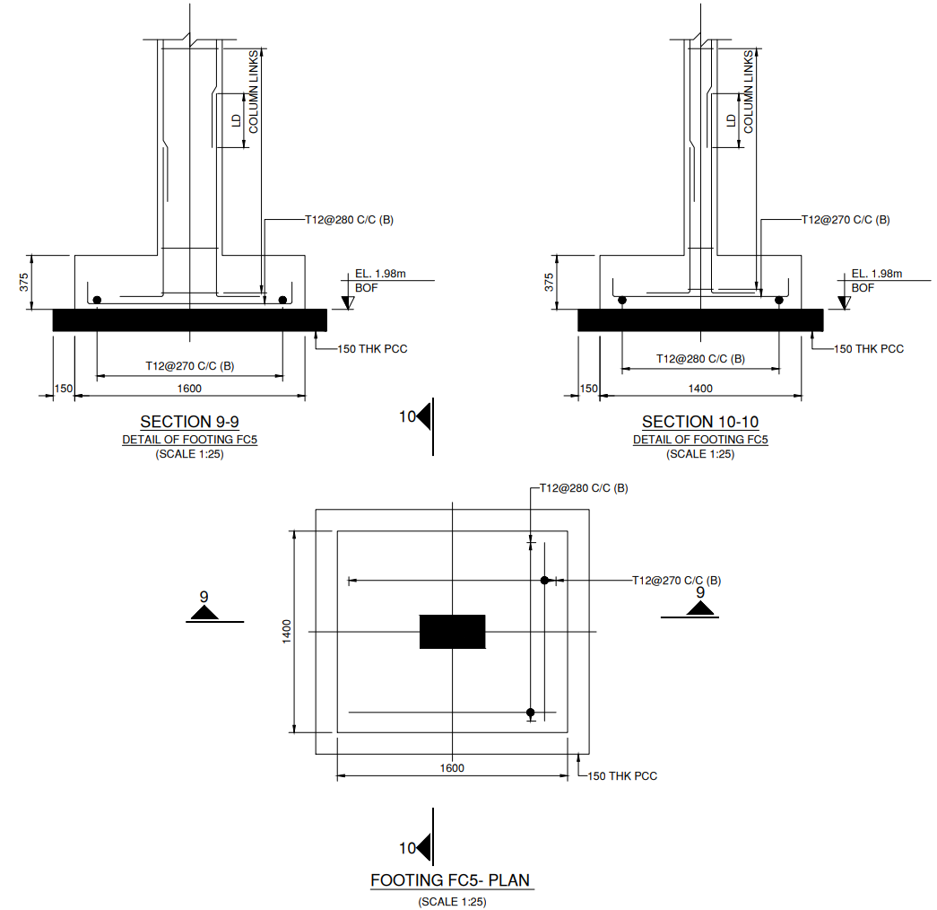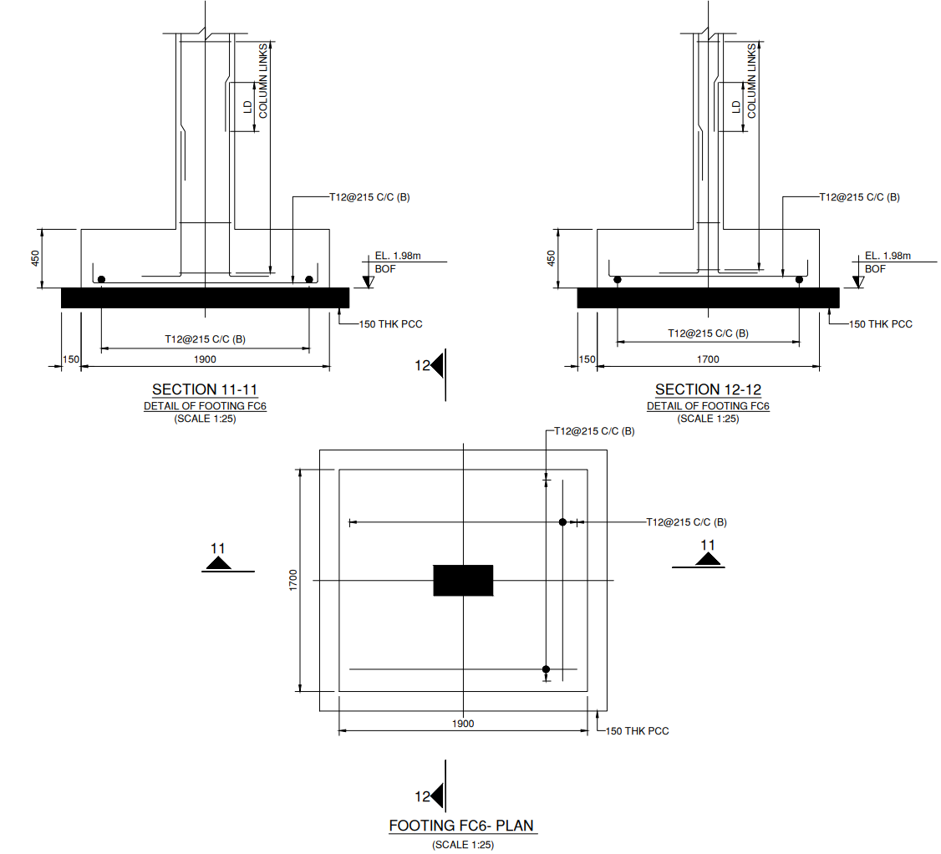
Figure 5.26: Detailed Reinforcement Plans and Cross-Sections of Footings (FC5 & FC6)
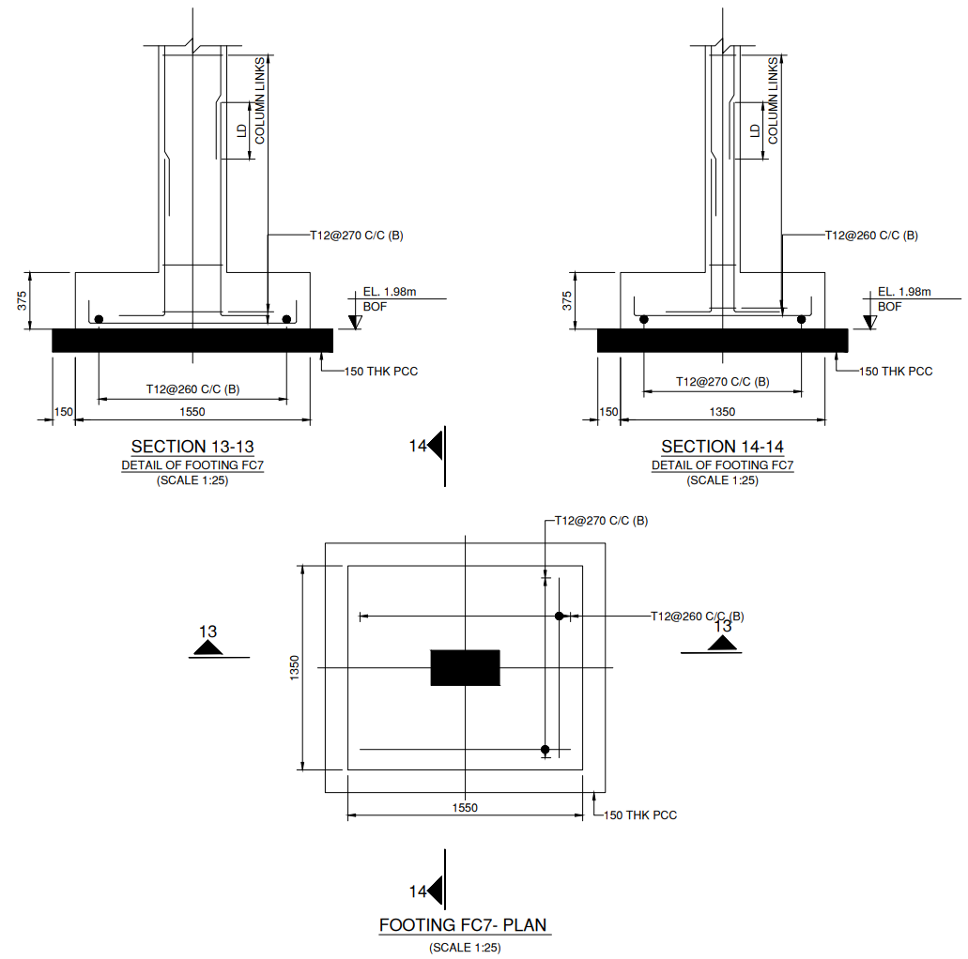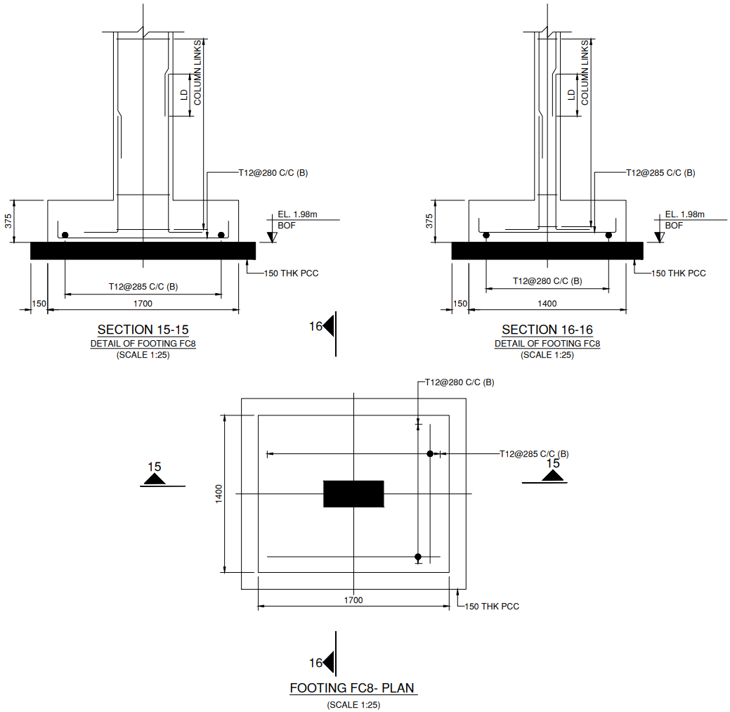
Figure 5.27: Detailed Reinforcement Plans and Cross-Sections of Footings (FC7 & FC8)
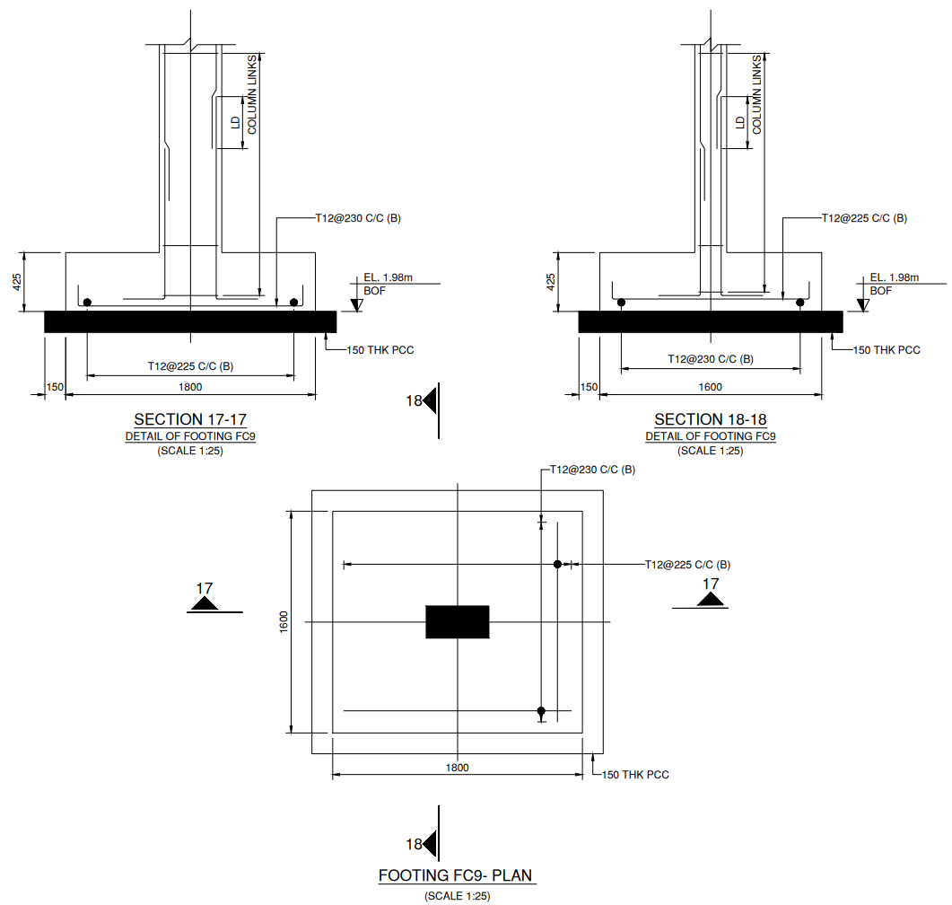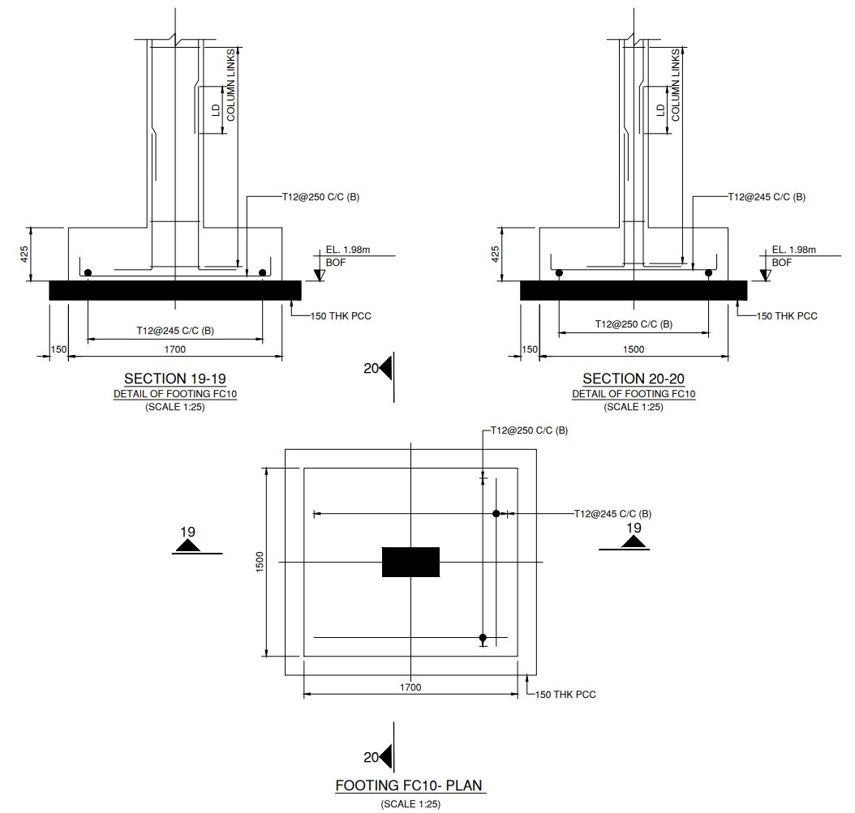
Figure 5.28: Detailed Reinforcement Plans and Cross-Sections of Footings (FC9 & FC10)
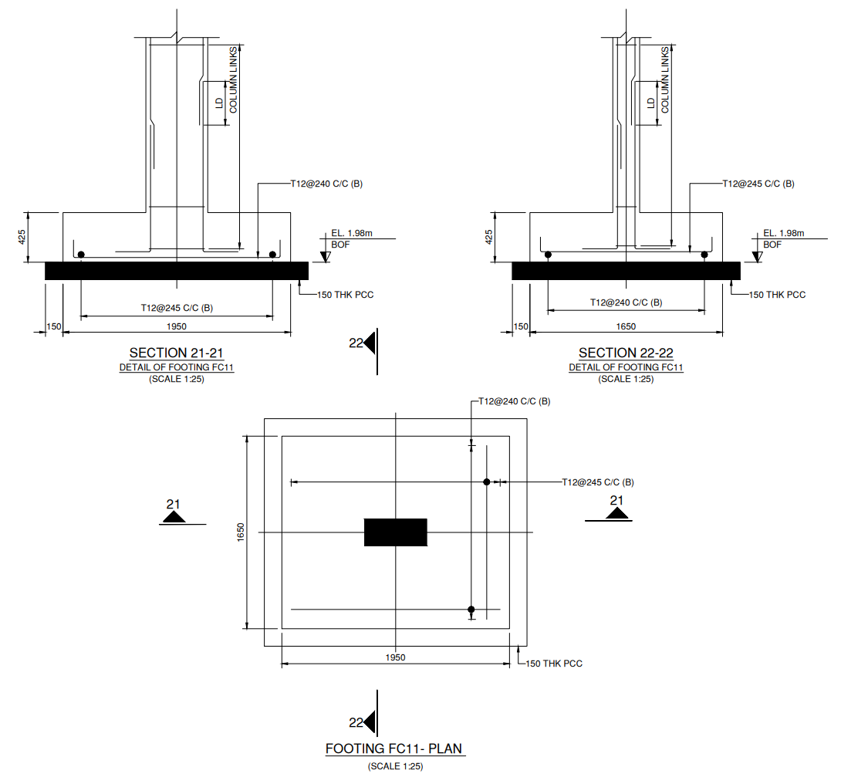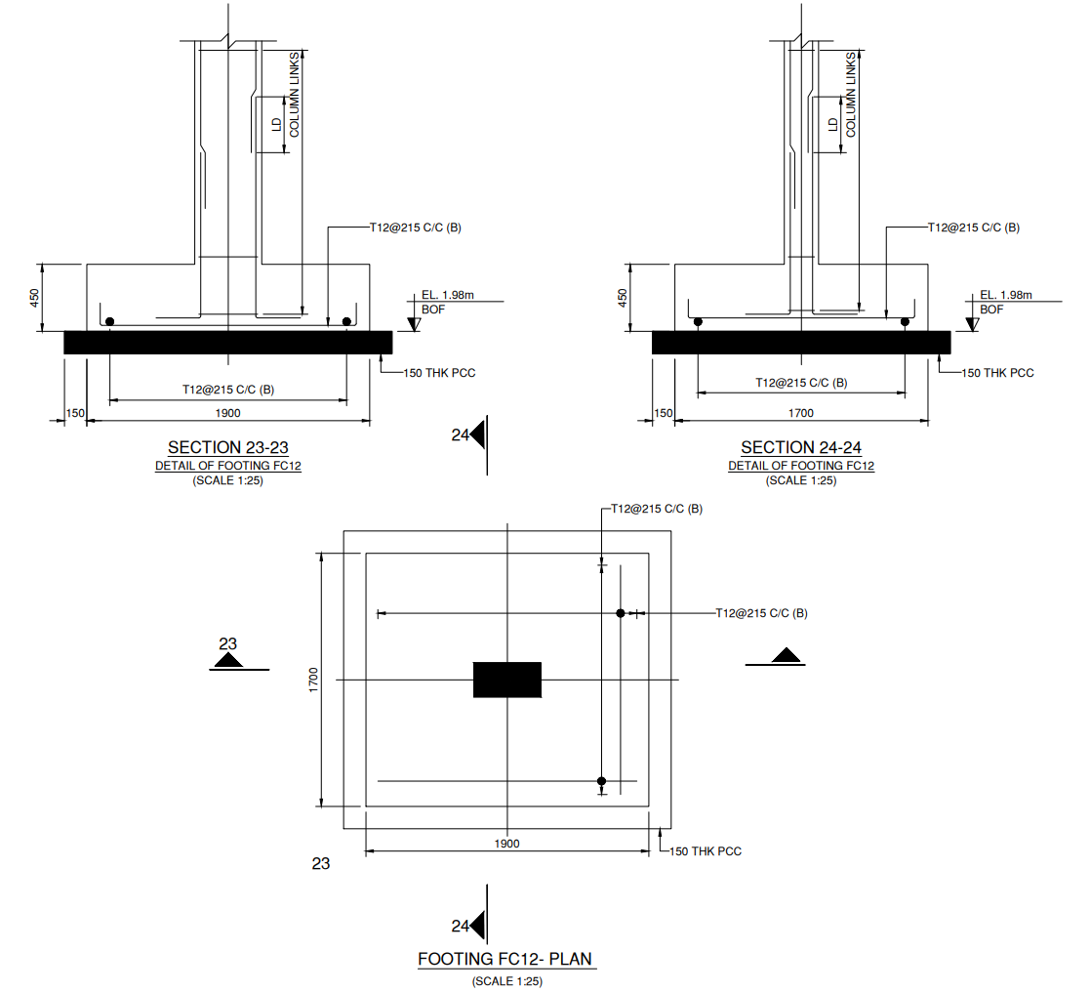
Figure 5.29: Detailed Reinforcement Plans and Cross-Sections of Footings (FC11 & FC12)

5.6 STRUCTURAL DESIGN OF DOG-LEGGED STAIRCASE
5.6.1 DESIGN PHILOSOPHY & GEOMETRICAL CONFIGURATION
Vertical pedestrian circulation across the G+2 residential framed building is provided by a reinforced concrete Dog-Legged Staircase located at the front left bay of the building (adjoining Grid Lines 1–2 and A–B). The staircase is designed as a waist-slab type in accordance with the Limit State Method of IS 456:2000 (Clause 33: Design of Stairs), IS 875 (Part 1 & Part 2) for gravity loads, and IS 13920:2016 for ductile reinforcement detailing.
A dog-legged staircase consists of two successive inclined flights traveling in opposite directions separated by an intermediate half-landing (mid-landing), with zero open well between the flights. Each flight is structurally supported on landing beams at its ends, spanning longitudinally as an inclined one-way slab.
1. Architectural Geometry & Dimensions (per Storey):
- Total Storey Height (H): 3.048 m = 3048 mm (10'-0")
- Height per Flight (h): $\frac{3048}{2}$ = 1524 mm ≈ 1500 mm (Rise from floor to mid-landing)
- Number of Risers per Flight (N_{r}): 10 risers
- Riser Dimension (R): $\frac{1500}{10}$ = 150 mm (6 inches)
- Number of Treads per Flight (N_{t}): N_{r} - 1 = 10 - 1 = 9 treads
- Tread Dimension (T): 250 mm (10 inches)
- Horizontal Going of Flight (G): 9 × 250 mm = 2250 mm (2.25 m)
- Width of Stair Flight (b): 1200 mm (1.20 m / 4'-0")
- Width of Bottom Landing: 1200 mm (1.20 m)
- Width of Mid-Landing (Top Landing): 1200 mm (1.20 m)
- Inclination of Flight (θ): tan θ = $\frac{R}{T}$ = $\frac{150}{250}$ = 0.60 ⟹ θ = 30.96°
Slope Factor = $\frac{\sqrt{\left(R^{2} + T^{2}\right)}}{T}$ = $\frac{\sqrt{\left({150}^{2} + {250}^{2}\right)}}{250}$ = $\frac{291.55}{250}$ = 1.166
2. Material Strengths & Design Constants:
- Grade of Concrete: M25 (f_{ck} = 25 N/mm²)
- Grade of Reinforcement Steel: Fe550 High-Yield Strength Deformed TMT bars (f_{y} = 550 N/mm²)
- Unit Weight of RCC (γ_{c}): 25.0 kN/m³
- Unit Weight of Plain Concrete / Mortar: 24.0 kN/m³
- Imposed / Live Load (LL): 3.0 kN/m² (As per IS 875 Part 2 for residential building staircases and exit corridors)
- Floor Finish Load (FF): 1.0 kN/m² (Granite / vitrified tile finish with cement mortar screed)
- Clear Concrete Cover: 20 mm (As per IS 456:2000 Clause 26.4.2 for mild/moderate exposure slabs)
5.6.2 SECTION PROPORTIONING & EFFECTIVE SPAN
1. Waist Slab Thickness:
In accordance with IS 456:2000 Clause 23.2.1, the depth of the slab is controlled by the serviceability deflection limit (basic span-to-effective depth ratio for simply supported one-way slab is 20, modified by tension steel factor ≈ 1.35 to 1.40, giving $\frac{L}{d}$ ≈ 25 to 28).
- Effective depth required: d ≈ $\frac{Span }{28}$ ≈ $\frac{4650}{28}$ ≈ 166 mm (for overall span). With landing slab continuity, end support restraints, and high-strength Fe550 steel, the standard waist slab thickness adopted is:
  - Overall Waist Slab Thickness (D): 125 mm (as detailed in RCDC CAD elevation)
  - Effective Depth (d): d = D - Clear Cover - $\left( \frac{Bar Diameter}{2}\right)$
= 125 - 20 - ($\frac{8}{2}$) = 101 mm ≈ 100 mm
2. Effective Span (IS 456:2000 Clause 33.1):
Where the flight is supported at its ends on landing beams spanning parallel to the risers:
- Effective span is taken as the center-to-center distance between supporting landing beams, or clear span plus effective depth, whichever is less.
- Clear Span between support beams:
Clear Span = Bottom Landing (1200 mm) + Going (2250 mm) + Top Landing (1200 mm) = 4650 mm = 4.65 m
- Supporting beam width at each end: b_{w} = 230 mm
- Center-to-center distance between beams:
l_{c/c} = Clear Span + 2 × $\left(\frac{b_{w}}{2}\right)$ = 4650 + 230 = 4880 mm = 4.88 m
- Clear span + d = 4650 + 101 = 4751 mm = 4.75 m
- Governing Effective Span (l_{eff}): 4.75 m (4750 mm)
5.6.3 LOAD COMPUTATIONS
Design calculations are performed for a unit width of stair slab (b = 1.0 m = 1000 mm).
1. Loads on Inclined Waist Slab (Flight Portion):
- Self-Weight of Waist Slab:
Weight along slope = D × 1.0 × γ_{c} = 0.125 × 1.0 × 25 = 3.125 kN/m
Weight converted to horizontal plan area = (3.125 × Slope Factor)
= 3.125 × 1.166 = 3.644 kN/m²
- Self-Weight of Triangular Steps:
Average thickness of steps = $\frac{R}{2}$ = 150 / 2 = 75 mm = 0.075 m
Weight per horizontal area = $\left(\frac{R}{2}\right)$ × 1.0 × γ_{c} = 0.075 × 1.0 × 25 = 1.875 kN/m²
- Floor Finish on Steps & Treads:
Weight = 1.0 kN/m²
- Total Characteristic Dead Load on Flight (w_{d,flight}):
w_{d,flight} = 3.644 + 1.875 + 1.000 = 6.519 kN/m²
- Characteristic Live Load on Flight (w_{l,flight}):
w_{l,flight} = 3.000 kN/m²
- Total Characteristic Working Load on Flight:
w_{flight} = w_{d,flight} + w_{l,flight} = 6.519 + 3.000 = 9.519 kN/m²
- Factored Design Load on Flight (w_{u,flight}):
w_{u,flight} = 1.5 × w_{flight} = 1.5 × 9.519 = 14.28 kN/m²
2. Loads on Horizontal Landing Slabs (Bottom & Top Landings):
- Self-Weight of Landing Slab (D = 125 mm):
w_{slab} = 0.125 × 1.0 × 25 = 3.125 kN/m²
- Floor Finish on Landing:
w_{ff} = 1.000 kN/m²
- Total Characteristic Dead Load on Landing (w_{d,landing}):
w_{d,landing} = 3.125 + 1.000 = 4.125 kN/m²
- Characteristic Live Load on Landing (w_{l,landing}):
w_{l,landing} = 3.000 kN/m²
- Total Characteristic Working Load on Landing:
w_{landing} = 4.125 + 3.000 = 7.125 kN/m²
- Factored Design Load on Landing (w_{u,landing}):
w_{u,landing} = 1.5 × w_{landing} = 1.5 × 7.125 = 10.69 kN/m²
5.6.4 ANALYSIS & FACTORED DESIGN MOMENT
The flight is idealized as a simply supported one-way slab spanning between the two landing beams over an effective span of l_{eff} = 4.75 m:
- Length of bottom landing segment: l₁ = 1.20 m
- Length of central inclined flight: l₂ = 2.25 m (going) + 0.10 m = 2.35 m
- Length of top landing segment: l₃ = 1.20 m
Equivalent Uniform Factored Load (w_{u,avg}) across the span:
w_{u,avg} = $\frac{[ (10.69 × 1.20) + (14.28 × 2.35) + (10.69 × 1.20) ] }{4.75}$
w_{u,avg} = $\frac{[ 12.83 + 33.56 + 12.83 ] }{4.75}$ = $\frac{59.22 }{4.75}$ = 12.47 kN/m per meter width

1. Maximum Factored Mid-Span Bending Moment (M_{u}):
Accounting for the partial rotational restraint provided by monolithic landing beam supports
(M_{u} ≈ $\frac{w × l²}{10}$ per standard code practice):
M_{u,mid} = $\frac{(w_{u,avg} × l_{eff}²)}{10}$ = $\frac{(12.47 × 4.75²)}{10}$ = $\frac{(12.47 × 22.56)}{10}$ = 28.13 kNm/m
(Note: Under an absolute conservative simply supported assumption, M_{u,max} = $\frac{w × l²}{8}$ = 35.17 kNm/m).
2. Limiting Moment of Resistance (M_{u,lim}):
For M25 concrete (f_{ck} = 25 N/mm²) and Fe550 steel (f_{y} = 550 N/mm²):
M_{u,lim} = 0.133 × f_{ck} × b × d² = 0.133 × 25 × 1000 × 100² = 33,250,000 Nmm = 33.25 kNm/m
Since M_{u,mid} (28.13 kNm/m) < M_{u,lim} (33.25 kNm/m), the section is under-reinforced, guaranteeing ductile failure through initial yielding of steel before concrete crushing.
5.6.5 REINFORCEMENT CALCULATION & DETAILING
1. Main Tensile Reinforcement (Along Span Direction):
Using the standard Limit State flexural design formula:
A_{st} = $\left[0.5 × \frac{f_{ck}}{f_{y}}\right]$ × [ 1 - $\frac{\sqrt{(1 - (4.59 × M_{u})}}{(f_{ck} × b × d²)}$ ] × b × d
A_{st} = $\left[0.5 × \frac{25}{550}\right]$ × [ 1 - $\frac{\sqrt{(1 - (4.59 × 28.13 ×{10}^{6})}}{(25 × 1000 × 100²)}$ ] × 1000 × 100
A_{st} = $0.02273$ × [ 1 - $\sqrt{(1-0.5164)}$ ] × 100000
A_{st} = $0.02273$ × [ 1 - $0.6954$ ] × 100000 = 692.3 mm²/m
Accounting for the non-uniform bending profile and 2D slab dispersion across landings per IS 456:2000 Clause 33.2, the waist slab is detailed with high-strength 8 mm diameter TMT bars (T8):
- Area of one 8 mm bar: a_{st} = ($\frac{π}{4}$) × 8² = 50.27 mm²
Reinforcement Provided:
- Main Bottom Tension Rebar: T8 @ 230 mm c/c continuously running along the bottom face of the inclined waist slab.
  - Area Provided: A_{st},prov = ($\frac{1000}{230}$) × 50.27 = 218.6 mm²/m
- Top Negative Rebar over Landing Supports: T8 @ 300 mm c/c provided at top faces over the supporting landing beams to resist support hogging moments.
  - Area Provided: 167.6 mm²/m

2. Distribution Reinforcement (Transverse Direction):
Per IS 456:2000 Clause 26.5.2.1, minimum distribution reinforcement for high-yield strength deformed bars (Fe550) is 0.12% of the gross cross-sectional area:
A_{st,dist,min} = 0.12% × b × D = 0.0012 × 1000 × 125 = 150.0 mm²/m
Using 8 mm diameter bars (T8, a_{st} = 50.27 mm²):
Spacing s = $\frac{(1000 × 50.27)}{150.0}$ = 335 mm
Maximum permissible spacing = min(5d, 450 mm) = min(500 mm, 450 mm) = 450 mm
Distribution Steel Provided:
- T8 @ 300 mm c/c tied transversely across the full 1200 mm flight width.
- Area Provided: A_{st,dist} = (1000 / 300) × 50.27 = 167.6 mm²/m > 150.0 mm²/m ⟹ SAFE & FULLY COMPLIANT
3. Kink & Rebar Extension Detailing (IS 13920:2016 & SP 34):
At the junction between the inclined waist slab and the horizontal landing slabs, sharp changes in member direction create outward bursting stresses:
- Bottom Rebar at Convex Kink (Landing-to-Flight junction): Tension reinforcement is never bent around the re-entrant angle as it would pull out and cause concrete spalling. Instead, bars from the flight and landing cross each other and extend an anchorage development length of at least 450 mm into the compression zone.
- Top Rebar at Concave Kink: Continuous reinforcement extends fully with standard anchorage into the landing slab.
- Anchorage / Lap Length Provided: 450 mm (as shown on the RCDC drawing, exceeding L_{d} = 47 × 8 = 376 mm).
5.6.6 SERVICEABILITY & SHEAR CHECKS
1. Check for Shear Stress (IS 456:2000 Clause 40):
- Maximum factored shear force at support face:
V_{u} = w_{u,avg} × $\left(\frac{l_{eff}}{2}\right)$ = 12.47 × ($\frac{4.75}{2}$) = 29.62 kN
- Nominal shear stress:
τ_{v} = $\frac{V_{u}}{(b × d)}$ = $\frac{29.62 × {10}^{3}}{(1000 × 100)}$ = 0.296 N/mm²
- For slab with overall thickness D = 125 mm:
Depth factor k = 1.30 (IS 456 Clause 40.2.1.1)
Basic permissible concrete shear strength (Table 19 for p_{t} ≈ 0.22%, M25): τ_{c} = 0.33 N/mm²
Permissible shear strength: τ_{c,perm} = k × τ_{c} = 1.30 × 0.33 = 0.429 N/mm²
- Since τ_{v} (0.296 N/mm²) < τ_{c,perm} (0.429 N/mm²), the slab is SAFE IN SHEAR without requiring shear stirrups.
2. Check for Deflection Control (IS 456:2000 Clause 23.2):
- Basic span-to-depth ratio for simply supported slab = 20
- Modification factor for tension reinforcement: F_{t} = 1.45
- Allowable $\left(\frac{L}{b}\right)$ ratio = 20 × 1.45 = 29.0
- Evaluating the inclined flight alone between virtual supports (Going = 2250 mm):
Actual ${\left(\frac{L}{b}\right)}_{flight}$ = $\frac{2250}{100}$ = 22.5 < 29.0 ⟹ SAFE AGAINST EXCESSIVE DEFLECTION
5.6.7 CONSOLIDATED STAIRCASE REINFORCEMENT SCHEDULE (TABLE 5.5)
The structural sizing, section properties, and reinforcement schedule for the dog-legged staircase are summarized in Table 5.5:
Table 5.5: Consolidated Dog-Legged Staircase Design Schedule
Component | Dimensions / Thickness | Concrete Grade | Steel Grade | Main Tension Steel | Distribution Steel | Anchorage / Lap Length
Inclined Waist Slab | 125 mm Thk (Width = 1200 mm) | M25 | Fe550 | T8 @ 230 mm c/c (Bottom) | T8 @ 300 mm c/c (Transverse) | 450 mm beyond kink point
Mid-Landing Slab | 125 mm Thk (Span = 1200 mm) | M25 | Fe550 | T8 @ 300 mm c/c (Bottom & Top) | T8 @ 300 mm c/c (Transverse) | 450 mm into support beam
Floor Landing Slab | 125 mm Thk (Span = 1200 mm) | M25 | Fe550 | T8 @ 300 mm c/c (Bottom & Top) | T8 @ 300 mm c/c (Transverse) | 450 mm into support beam
Steps (10 Risers, 9 Treads) | R = 150 mm, T = 250 mm | M25 | _ | Cast monolithically with waist slab | _ | _
Landing Support Beams | 230 mm × 430 mm | M25 | Fe550 | Per Beam Schedule (Floor / SMR) | Stirrups T8 @ 150 c/c | Standard beam anchorage

5.6.8 STRUCTURAL DRAWINGS & DETAILING PROFILES
- Illustrates the longitudinal profile of the 10-riser flight, 125 mm waist slab thickness, bottom tensile rebar T8 @ 230 mm c/c, transverse distribution steel T8 @ 300 mm c/c, support downstand beams (230 mm × 430 mm), and the 450 mm rebar extension detailing at kink transition points.
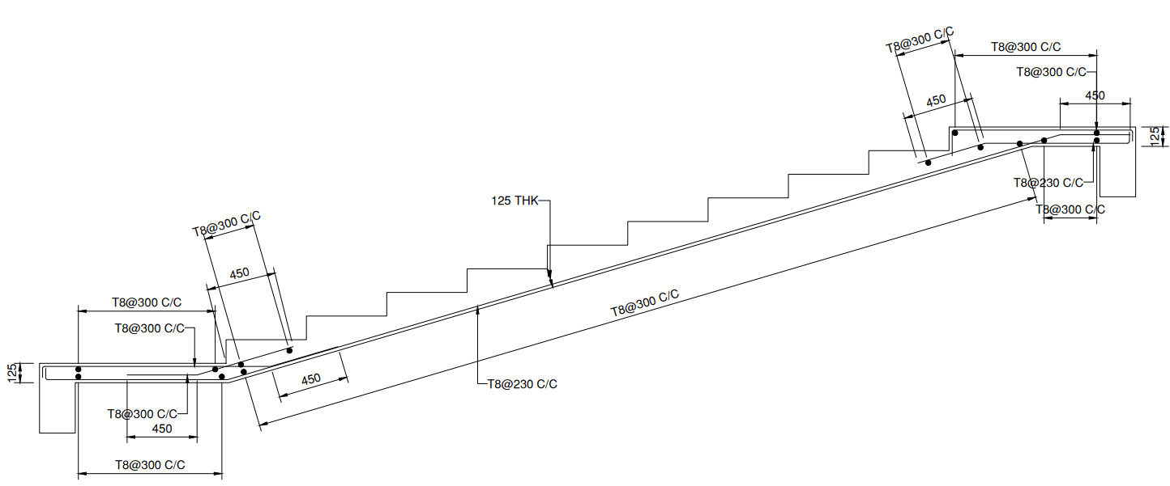
Figure 5.30: Structural Cross-Section and Reinforcement Elevation of Dog-Legged Staircase Flight
CHAPTER-6
QUANTITY SURVEYING & COST ESTIMATION

CHAPTER-7
STRUCTURAL DETAILING & DRAWINGS

